

Anthology Payroll for Microsoft Dynamics 365 Finance

Anthology Payroll User Guide for CA Localization QuickStart

Date: May 2024

[www.anthology.com](http://www.anthology.com/)

Table of Contents

1 Document Revision History 7

2 Introduction 9

2.1 Conventions and Definitions 9

2.2 Prerequisites and Conditions 10

2.3 Set User Preferences 10

3 Hiring Workers 12

3.1 Hire a New Worker 12

3.1.1 Create a new position record 12

3.1.2 Create a new worker record and assign the position 13

3.1.3 Add the worker to Anthology Payroll 16

3.1.4 Add CA Worker Information 20

3.1.5 Add additional payroll information for the worker 21

3.1.5.1 Add benefit/deductions 21

3.1.5.2 Add calculation variables 22

3.1.5.3 Add direct deposit accounts 24

3.1.5.4 Add starting vacation balance 25

3.2 Rehire a Worker 26

3.2.1 Reactivate the worker's past worker record 27

3.2.2 Create or reactivate the worker's position 28

3.2.3 Validate the worker's existing position record 30

3.2.4 Validate the worker's additional payroll information 31

4 Maintaining Worker Data 32

4.1 Manage Position Data 32

4.1.1 Modify Position Data 32

4.1.2 Change Positions 33

4.2 Manage Demographic Data 34

4.2.1 Manage Addresses 34

4.3 Manage Payroll Data 35

4.3.1 Manage Account (Direct Deposit) Information 35

4.3.2 Manage One-Time Deductions 36

4.3.3 Manage Worker Allowances 37

4.3.4 Manage Calculation Variables 39

4.3.5 Manage Garnishments 40

4.3.5.1 Verify Existing Garnishments 40

4.3.5.2 Assign Garnishment Benefit/deductions 41

4.3.5.3 Assign Garnishment Calculation Variables 42

4.3.6 Manage Pay Advances 45

4.3.6.1 Issue Pay Advance 45

4.3.6.2 Schedule an Advance Recovery 46

4.3.6.3 Modify an Existing Advance or Recovery Schedule 47

4.3.7 Import Wage Increments 47

4.3.7.1 Set up a Wage Increment Code 47

4.3.7.2 Import Wage Increments 49

4.3.7.3 Review or Change Wage Increments 50

4.3.7.4 Apply Wage Increments 51

4.3.8 Generate Wage Increment Steps 51

4.3.8.1 Set up a Wage Increment Code 52

4.3.8.2 Generate Wage Increments 53

4.3.8.3 Review or Change Wage Increments 53

4.3.8.4 Apply Wage Increments 53

4.3.9 Manage Entitlements 53

4.3.9.1 Adjust Entitlements 53

4.3.9.2 Add Rolling Entitlements 55

4.3.9.3 Adjust Rolling Entitlements 57

4.3.9.4 Import Cross-Company Transactions for Rolling Entitlements 59

4.3.9.5 Import Cross-Pay Group Transactions for Rolling Entitlements 61

5 Process Pay 63

5.1 Regular Pay Processing Tasks 63

5.1.1 Create Time from Rotation 63

5.1.2 Enter Time for a Worker 64

5.1.3 Approve Time 67

5.1.4 Create Earnings from Time Records 68

5.1.5 Enter Earnings Manually 69

5.1.5.1 Enter Expenses 70

5.1.6 Update Entitlements, Accumulators, and Generated Earnings 71

5.1.7 Check accumulated amounts 72

5.1.8 Generate Payments 73

5.1.9 Print Pay Register 75

5.1.10 Approve Payments 76

5.1.10.1 Create Bank Information 76

5.1.10.2 Prepare Pay Statements 77

5.1.10.3 Print Payments for a Pay Group 79

5.1.10.4 Approve Selected Payments 80

5.1.11 Download Files to Local Network 81

5.1.12 Generate Entitlements 82

5.1.13 Post Payments, Liability, Benefits, and AP Invoice 83

5.1.14 Approve Postings 84

5.1.15 Post to Project 85

5.1.16 Approve Project Postings 86

5.1.17 Close Pay Period 87

5.2 Occasional Pay Processing Tasks 88

5.2.1 Issue a Manual (Off-Cycle) Payment 88

5.2.2 Import Time and Shift Information 91

5.2.3 Adjust Time or Earnings after Pay is Processed 94

5.2.4 Import and Process Bonus Earnings 97

5.2.5 Correct Direct Deposit Errors 100

5.2.6 Import and Commit Benefit/Deduction Amounts 101

5.2.7 Revise Past Payments 103

5.2.8 Issue Gross-up Payments 105

5.2.8.1 Import Gross-up Payment Amounts 105

5.2.8.2 Commit Imported Gross-up Payment Amounts 106

5.2.8.3 Issue Gross-up Payments to a Single Worker or a Worker Group 107

5.2.9 Process Retroactive Pay 108

5.2.9.1 Set up a Retroactive Run 109

5.2.9.2 Generate Retroactive Earning Records 110

5.2.9.3 Review and Accept Retroactive Earning Records 111

5.2.10 Modify Posting Transactions 112

5.2.11 Modify Project Posting Transactions 113

5.2.12 Create Trial Payments 114

6 Year-End Tasks 117

6.1 Create T4s 117

6.1.1 Create T4 Listing Report 117

6.1.2 Create Draft T4 Slips 118

6.1.3 Create Final T4 Slips 120

6.1.4 View T4 Slips Summary 121

6.2 Amending T4s 122

6.2.1 Cancel a T4 122

6.2.2 Amend a T4 123

6.2.3 Reprint a T4 123

6.3 Create T4As 123

6.3.1 Create T4A Listing Report 123

6.3.2 Create Draft T4A Slips 124

6.3.3 Create Final T4A Slips 126

6.3.4 View T4A Slips Summary 128

6.4 Create RL-1s 128

6.4.1 Create RL-1 Listing Report 128

6.4.2 Create Draft RL-1 Slips 129

6.4.3 Create Final RL-1 Slips 131

6.4.4 View RL-1 Slips Summary 133

6.5 Import Statutory Deductions 133

7 Reporting 134

7.1 View WCB Reports 134

7.1.1 View WCB Quarterly Listing 134

7.1.2 View WCB Annual Listing 135

8 Terminating Workers 137

8.1 Check for Earnings after Termination Date 137

8.2 Terminate the Worker 138

8.3 Pay Out Entitlements 139

8.4 Enter Severance Pay 141

8.5 Schedule Garnishments for Final Payment 142

8.6 Process Final Payment 142

8.7 Create Record of Employment (ROE) Report 143

8.7.1 Change Contact Name of Employer 143

8.7.2 Create Record of Employment 144

8.7.3 View Record of Employment Listing Report 146

8.8 Upload ROE to Services Canada 147

8.8.1 Create and Submit a Draft Record of Employment Submission File 147

8.8.2 Create and Submit a Final Record of Employment 148

8.8.3 Resubmit a Record of Employment 149

9 Appendices 151

9.1 Appendix A: List of Benefit/deductions 151

9.2 Appendix B: List of Calculation Variables 156

9.3 Appendix C: List of Garnishment Benefit/deductions 161

9.4 Appendix D: List of Earnings Import File Fields 162

9.5 Appendix E: List of Time Import File Fields 164

9.6 Appendix F: List of Benefit/deduction Amounts Import Fields 165

9.7 Appendix G: List of Wage Increment Import Fields 167

9.8 Appendix H: List of Gross-up Payment Amount Import Fields 168

1 Document Revision History

|  |  |
| --- | --- |
| **Version** | **Changes** |
| 1.0 | Initial release version |

2 Introduction

This document details the processes and procedures for payroll administration in the CA localization of Anthology Payroll for Microsoft Dynamics 365 Finance. This document is specifically tailored towards the data contained within the CA localization of the QuickStart database. These procedures are specific to payroll procedures in the CA and include the following sections:

* WCB reporting
* Processing T4s and T4As
* Creating and issuing ROEs

2.1 Conventions and Definitions

This document uses the following conventions:

|  |  |
| --- | --- |
| bold | Refers to form names, field names, and clickable hyperlinks. |
| italics | Refers to specific data items and selectable options in form fields. |
| NOTES | Important details about the current procedure that may affect the expected outcome. |

This document assumes the following definitions:

|  |  |
| --- | --- |
| base payroll | The basic functionality of Anthology Payroll not including any localised content. |
| dialogue | A popup window that contains a minimal number of fields to manipulate. Is usually meant as confirmation with continuing with a process. Typically contains OK and Cancel buttons. |
| form | A page where data records can be viewed and manipulated. Usually contains an Overview tab where all records can be viewed and a General tab where all the fields of a single record can be viewed. |
| inquiry | A page where data records can only be viewed and not manipulated. Records can still be filtered. |
| journal | A page where data records can be viewed and manipulated in relation to other data records. Typically used for manual data entry or adjustment processes. |
| list | A viewing pane of all records of a particular type, such as Workers, Positions, or Pay groups. Usually, a record can be double-clicked to open its specific form. |
| navigation pane | The expandable list of hyperlinks located on the left side of the AX application window intended for navigation. |
| pane | A frame or segmented area of any window. Is usually accompanied by a descriptor. Also appears on the right side of the browser window to perform certain functions. |
| report | A printable, exportable view of specific data records that opens in a browser window. |
| ribbon | The toolbar at the top of the application window containing multiple tabs with clickable icons. |
| maintain effective date entries | A functional pane in most forms where data records can be edited with respect to effective dating. A change to existing records in the Maintain effective date entries pane creates a new copy of the record dated on the session date while the old record is expired one day prior. In previous versions of Anthology Payroll, this was called the Split view pane. |

For a reference of shortcut keys in Microsoft Dynamics, refer to this Microsoft article:

<https://docs.microsoft.com/en-us/dynamics365/unified-operations/fin-and-ops/get-started/shortcut-keys>

2.2 Prerequisites and Conditions

The following conditions are required before you can begin using the Canadian localization of Anthology Payroll for Microsoft Dynamics 365 Finance:

* Microsoft Dynamics 365 Finance must be licensed and installed
* Anthology Payroll for Microsoft Dynamics 365 Finance must be licensed and installed
* CA country extension for Anthology Payroll must be licensed and installed
* CA QuickStart database has been implemented according to appropriate documentation
* Latest Statutory Deductions Spreadsheet for CA must be imported
* Anthology Payroll has been set up according to the Anthology Payroll Canadian Localization Configuration Guide

2.3 Set User Preferences

In Microsoft Dynamics 365 Finance, you can set your preferences for the initial view mode of forms and your language and date formats. The language setting is important depending on the localization of Anthology Payroll you are using as it allows labels on forms to appear correctly in the format of your localization.

It is also recommended to set your default view mode to Edit mode as it reduces the number of steps during operation and mimics behavior in older versions of Dynamics. This guide is written in the context of already being in Edit mode on forms.

To set your user preferences:

1. In Microsoft Dynamics 365, click Settings > User options in the top-right corner of the page to open the Options page.

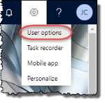



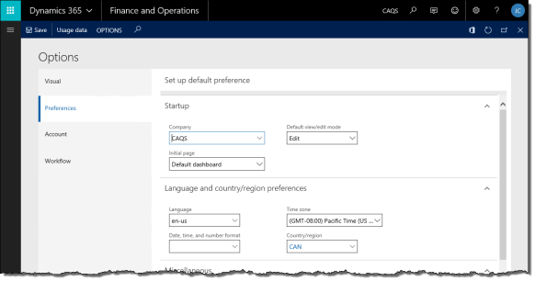

1. Click the Preferences tab.
2. Set your Default view/edit mode to Edit. This is optional, but recommended.
3. You can set your default Company to open upon logging in as well as the Initial page to display.
4. Set your Language, Date, time, and number format and Country/region to your specific local settings. You may choose to set your Time zone as well.
5. Click Save to save your changes.
6. Refresh your browser (F5) to enable your language and region preferences.

3 Hiring Workers

This section contains procedures on hiring and rehiring a worker.

3.1 Hire a New Worker

To hire a new worker, you must complete the following steps:

1. Create a new position record.
2. Create a new worker record and assign the position.
3. Add the worker to Anthology Payroll.
4. Add additional payroll information for the worker.
5. Add CA worker information.

Ensure you are in the appropriate company in Microsoft Dynamics 365 Finance.

3.1.1 Create a new position record

To create a new position:

1. In the navigation pane, click Common > Positions to open the Positions list.

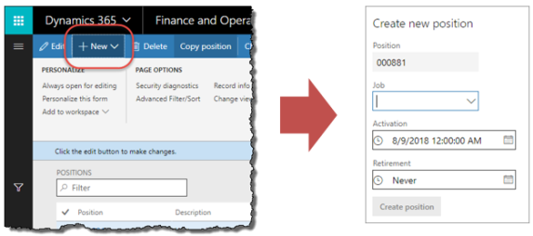

1. Click the New button on the ribbon to open the Create new position dialogue.

NOTE: If you click anywhere outside the dialogue, it will close without saving.

1. Enter the Job that this position is based on. The Position identifier is automatically generated.
2. Specify the position's Activation date if it is different from the current date. This can be a date in the future. Specify a Retirement date if there is one.

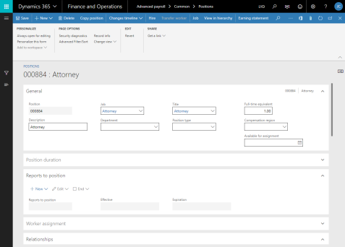

1. Click the Create position button to create the position. The Positions form for this position automatically opens.
2. In the General section of the position, specify the position's Department.
3. Expand the Financial dimension section of the Positions form.

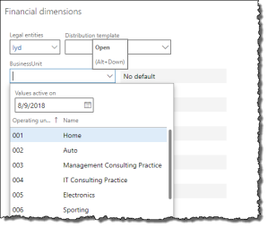

1. Specify any default financial dimensions that the worker in this position may have.
2. Click Save to save your changes.

3.1.2 Create a new worker record and assign the position

To create a new worker record:

1. In the navigation pane, click Common > Workers to open the Workers list. Click the New button on the ribbon to open the Create new worker pane.

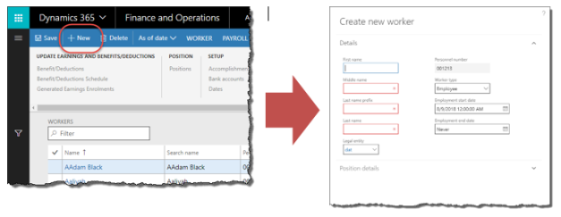

1. Enter the worker's First name, Middle name, Last name prefix and Last name, as applicable.
2. Verify that you are creating the worker in the correct Legal entity (company). Change as needed.
3. If the worker is a contractor, set the Worker type to Contractor.
4. Specify the worker's Employment start date if it is different from the current date. Specify an Employment end date if there is one.
5. Expand the Position details tab and check the Assign a position checkbox.
6. Specify the Position that was created in section 3.1.1.
7. Specify an Assignment start date if it is different from the current date. This can be a date in the future.

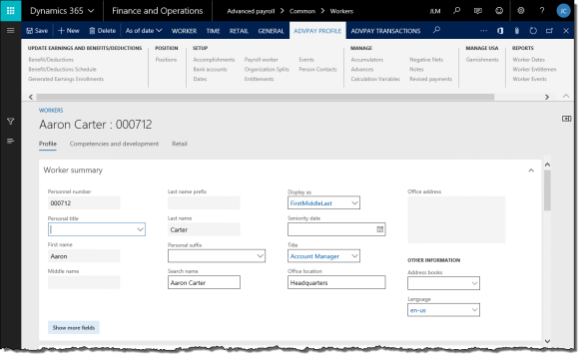

1. Click the Hire new worker button to create this worker in Microsoft Dynamics 365 Finance and assign the position to them. The worker's Worker form automatically opens.

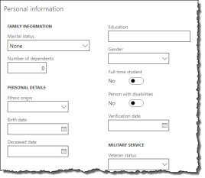

1. On the Worker form, verify the worker's Personal title, First name, Middle name, Last name prefix, and Last name.
2. Expand the Personal information section and enter the worker's Marital Status, Birth date and Gender, as needed.

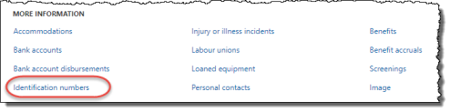



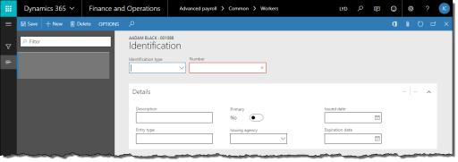

1. In the Personal information section, click Identification numbers to open the Identification form.

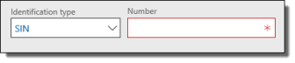

1. Select SIN for Identification type and enter the worker's social insurance number into the Number field.
2. Click Save to save your changes. Close the Identification form.
3. Add additional information as required for your implementation, such as Addresses and Contact information.
4. If your implementation emails direct deposit pay statements to workers, they must have an email address set up in the Contact information tab. The Description of this email address must match the configuration of the Direct deposit email default email communication parameter on the General definitions form.
5. Click Save to save your changes.

3.1.3 Add the worker to Anthology Payroll

Adding the worker to Anthology Payroll involves creating and updating a Worker positions record.

To add the worker to Anthology Payroll:

1. In the navigation pane, click Common > Workers to open the Workers list. Select the worker in the list. If the worker's start date is in the future, click Human resources > Common > Pending Workers to open the Pending workers list instead.

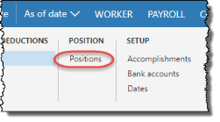

1. On the ribbon, click Anthology Payroll Profile tab > Positions to open the Worker positions form.
2. On the General tab of the Worker positions form, specify the following fields:

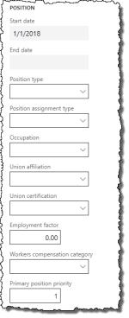

* + Occupation: specify however often your pay period is. This field is optional depending on your implementation requirements. Occupations can drive earning, benefit/deduction, time and entitlement rules. In the QuickStart database, all occupation codes are associated with the standard rules.
  + Union affiliation: specify however often your pay period is. This defines the worker's standard work hours and days.

1. Specify the following fields:

NOTE: you may not need to specify the rule group fields if your rules are controlled by the occupation code. This is specific to your implementation requirements.

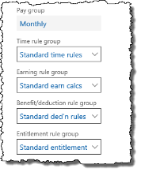

* + Pay group: specify however often your pay period is
  + Time rule group: specify Standard time rules
  + Earning rule group: specify Standard earn calcs
  + Benefit deduction rule group: specify Standard ded'n rules
  + Entitlement rule group: specify Standard entitlement or No entitlement, as required
  + Workers compensation category: specify the province/territory where the worker works

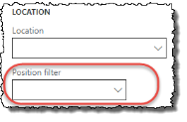

1. Specify the Position filter. This is the region where the worker works.

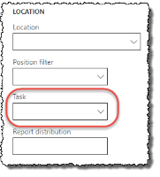

1. If your implementation uses projects and tasks, enter the Task assigned to this worker's position.

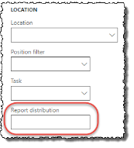

1. Enter the Report distribution field, if desired. This determines the order and grouping of the worker's pay statements when they are printed.

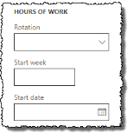

1. Enter the Rotation, Start week, and Start date fields as needed. These are used to automatically generate shifts for this position's worked days.

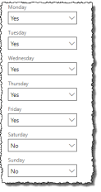

1. Enter the appropriate days in which the worker works in the Hours of work section. These days are used in allocating salary earnings and generating shifts based on the rotation.

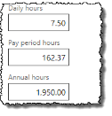

1. If the worker is hourly, enter their Daily, Pay period, and Annual hours worked. These amounts are optional. These hours override the defaults from the worker's Union affiliation.
2. If your implementation of Dynamics uses compensation plans in the HR module to store worker wage information, skip this step. See section 0.0.0.1 for details on configuring worker compensation. If your implementation of Dynamics records worker wage information together with their position in Anthology Payroll, enter the worker's wage information. Enter one of these (not both):

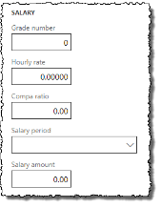

* + Hourly rate: specify the worker's hourly pay rate.
  + Salary period and Salary amount: specify the worker's salary amount and the periodicity of the amount.

1. If the worker's hire date is in the future, set the Active date to the appropriate date. Note that for future-dated records, you must select the Future view flag on the Overview tab to be able to see them.
2. Click Save to save your changes.

3.1.4 Add CA Worker Information

Depending on your implementation and the location of workers in your organization, you may need to enter some Canadian statutory reporting information for the hired worker.

To add CA worker information:

1. In the navigation pane, click Common > Anthology Payrollworkers to open the Anthology Payroll workers list. Select the desired worker.

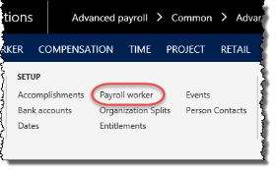

1. On the ribbon, click Anthology Payroll Profile tab > Payroll worker to open the Workers form.
2. On the Workers form, expand the General tab. Enter the following information as applicable:

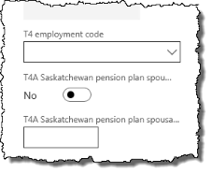

* + T4 employment code: Box 29 for T4 reporting, if applicable
  + T4A Saskatchewan pension plan spousal contributor flag: select if the worker's spouse has made contributions to the worker's pension plan for T4A reporting
  + T4A Saskatchewan pension plan spousal contributor SIN: enter the worker's spouse's Social Insurance Number if you selected the flag. This is reported on the T4A.

1. If your implementation is configured to email pay statements directly to workers:

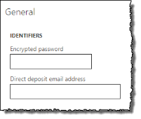

* + enter an Encrypted password. The direct deposit PDF files emailed to this worker are protected with this password.
  + enter the worker's Direct deposit email address. This overrides the worker's email in the global address book. Leave this field blank to use the worker's email in the global address book.

1. Click Save to save your changes.

3.1.5 Add additional payroll information for the worker

After creating and assigning the position record and adding the worker to Anthology Payroll, you must add additional payroll information for the worker. Additional payroll information includes:

* Benefits and deductions
* Calculation variables
* Starting vacation balances (entitlements), if applicable

3.1.5.1 Add benefit/deductions

To add benefit/deductions to the worker:

1. In the navigation pane, click Common > Anthology Payroll workers to open the Anthology Payroll workers list. Select the desired worker.

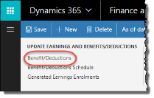

1. On the ribbon, click AthPay Profile tab > Benefit/Deductions to open the Worker benefit/deductions form.
2. On the Evaluate tab of the Worker benefit/deductions form, enter the worker's position assignment date in the Context date field, if it is not the current date. This can be a date in the future.

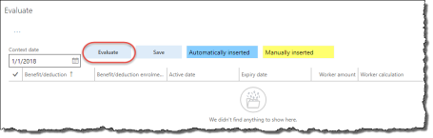

1. Click the Evaluate button to generate the worker's default list of benefits and deductions.
2. Modify the Benefit deduction enrolment for some of the added benefit/deductions. For a new worker:
   * Enrol the worker in their appropriate provincial tax.

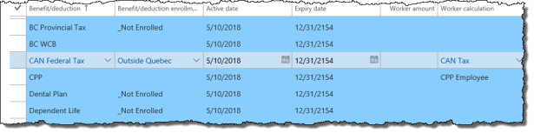

* + If the worker is working out of Quebec, select the appropriate enrolments for QPIP and QPP.
  + For garnishment benefit/deductions, please refer to section 4.3.5.
  + Enrol the worker in any additional benefit/deductions as appropriate for your implementation. See 9.1 Appendix A: List of Benefit/deductions for a list of the configured benefit/deductions in your implementation.

1. Click the Save button in the Evaluate section to save your changes.

3.1.5.2 Add calculation variables

Calculation variables represent CA payroll elements such as personal tax credits, and pensionable and insurable amounts.

To add calculation variables to the worker:

1. In the navigation pane, click Common > Anthology Payroll workers to open the Anthology Payroll workers list. Select the worker in the list.

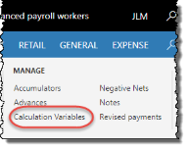

1. On the ribbon, click AthPay Profile tab > Calculation variables to open the Worker calculation variables form.
2. On the Evaluate tab of the Worker calculation variables form, enter the worker's position assignment date in the Context date field, if it is not the current date. This can be a date in the future.

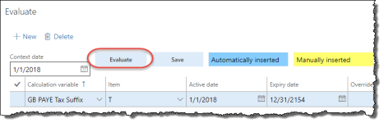

1. Click the Evaluate button to generate the worker's default list of calculation variables, if any. To add a new calculation variable, click New.

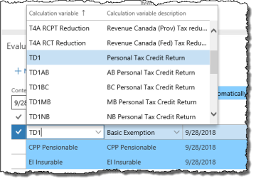

1. Add the TD1 Calculation variable and select the Basic Exemption Item. Enter the worker's exemption amount into the Override amount/rate field if it is different from the basic amount.
2. Add the corresponding provincial TD1 exemption Calculation variable and select the Basic Tax Exemption Item. Enter the worker's exemption amount into the Override amount/rate field if it is different from the basic amount.
3. Enter Override amount/rates for CPP Pensionable and/or EI Insurable amounts if they are different from the defaults.
4. Repeat for additional calculation variables that the worker may require according to your implementation. See 9.2 Appendix B: List of Calculation Variables for a list of the configured calculation variables in your implementation.
5. Click Save to save your changes.

3.1.5.3 Add direct deposit accounts

To add a direct deposit account for the worker:

1. In the navigation pane, click Common > Anthology Payroll workers to open the Anthology Payroll workers list. Select the worker in the list.

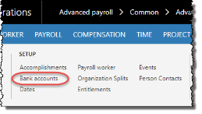

1. On the ribbon, click AthPay Profile tab > Bank accounts to open the Worker bank accounts form.

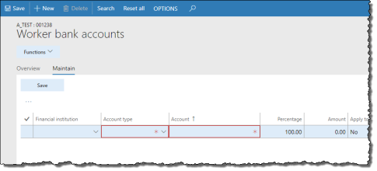

1. On the Maintain tab of the Worker bank accounts form, click New to create a new record.
2. Specify the worker's Financial institution. This includes the 5-digit branch number. If the worker's branch does not appear in the list, complete the following procedure before proceeding further:
   1. In the navigation pane, click Setup > Tables > Financial institutions > Financial institutions to open the Financial institutions form.
   2. On the Overview tab, click New to create a new record.
   3. On the General tab, enter the following:
      * Financial institution name: 3-digit identifier, followed by a dash, followed by the 5-digit branch number, or any identifying name. E.g: 123-10203
      * Financial institution description: name of the financial institution. E.g.: Bank of Montreal.
      * Short code: abbreviated description. E.g.: BMO
      * Bank number: 5-digit branch number
      * Transit number: 3-digit financial institution identifier
   4. Specify an Active date and Expiry date.
   5. Click Save to save your changes
3. Select the Account type.
4. Enter the worker's bank Account number.
5. If this worker has multiple accounts, enter a value for the Percentage of the worker's pay that is distributed to this account, or an Amount to specify a flat amount per pay statement that is distributed to this account. One account should have the Apply to remainder field set to Yes (and Percentage set to 0.00) such that all remaining pay beyond the percentage or amount is deposited into that account.
6. Select Yes for Prenotified?.
7. If the worker's hire date is in the future, set the Active date to the appropriate date. Note that for future-dated records, you must select the Future view flag on the Overview tab to be able to see them.
8. Click Save to save your changes.
9. Repeat to add additional accounts or close the form.

3.1.5.4 Add starting vacation balance

To add a starting vacation balance:

1. In the navigation pane, click Common > Anthology Payroll workers to open the Anthology Payroll workers list. Select the worker in the list.

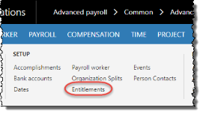

1. On the ribbon, click Anthology Payroll Profile tab > Entitlements to open the Worker entitlements form.

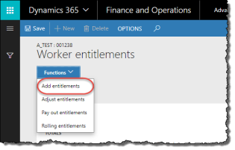



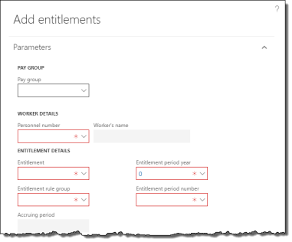

1. On the Worker entitlements form, click Functions > Add entitlements to open the Add entitlements pane.
2. On the Add entitlements pane, specify the Pay group and select the worker in the Personnel number field. If the worker does not appear in the field, make sure the worker was properly added to the pay group in section 3.1.3.
3. Select the Standard entitlement Entitlement rule group.
4. Select the Vacation Entitlement.
5. Specify the current year in the Entitlement period year field. Enter 1 as the Entitlement period number.
6. Enter a starting vacation balance in hours in the Accrued hours field. For example, to give someone 10 days of vacation, enter 75 hours (7.5 hours/day).
7. Specify an Addition reason code of Initial setup.
8. Click OK to set an initial balance on accrued vacation for this worker.
9. Close the Worker entitlements form.

3.2 Rehire a Worker

Rehiring a worker is largely the same process as hiring a new worker, except the worker record already exists in Anthology Payroll. Your task involves validating and updating the past information against the worker's new sign-on package.

The steps to rehire a worker are:

1. Reactivate the worker's past worker record and validate existing data.
2. Create a new position and assign it to the worker or reactivate and reassign past position to the worker.
3. Validate the worker's existing payroll records.
4. Validate the worker's additional payroll information.

3.2.1 Reactivate the worker's past worker record

To reactivate the worker's past worker record:

1. In the Human resources navigation pane, click Workers > Past workers to open the Past workers list.
2. Locate the worker in the list and double-click their record to open the Worker form.
3. Verify and update the following information:
   * Name
   * Personal title
   * Addresses
   * Contact information
   * Birth date
   * Gender
   * Government-issued identification

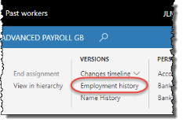

1. On the ribbon, click Worker tab > Employment history to open the Employment history form.

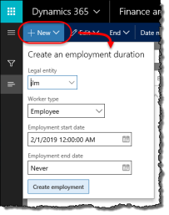

1. In the Employment history form, click the New button to open the Create an employment duration dialogue.
2. Specify the appropriate Legal entity.
3. Specify the worker's Employment start date if it is different from the current date. Specify an Employment end date if there is one.
4. Click Create employment to reactivate the worker's employment record.
5. Click Save and close the Employment history form.

3.2.2 Create or reactivate the worker's position

You can choose to create a new position and assign it to the worker or reactivate the worker's previous position. To create a new position, refer to section 3.1.1.

After creating a new position, to assign it to the existing worker:

1. In the Human resources navigation pane, click Workers > Past workers to open the Past workers list. Select the worker in the list.

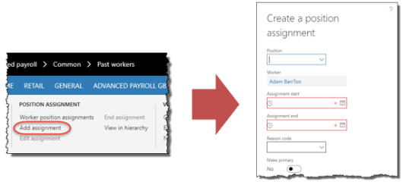

1. On the ribbon, click Worker tab > Add assignment to open the Create a position assignment pane.
2. Specify the Position.
3. Specify an Assignment start date if it is different from the current date.
4. Specify an Assignment end date if there is one.
5. Click Create position assignment to assign the position to the worker.

To reactivate the worker's past position:

1. In the navigation pane, click Common > Workers to open the Workers list. Select the worker in the list.

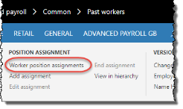

1. On the ribbon, click Worker position assignments to open the Position assignments form.

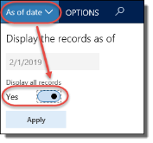

1. In the Position assignments form, click the As of date button to open the Display the records as of dialogue. Check Display all records and click Apply. All of the worker's past positions appear in the list.
2. Select the position that you want to reactivate to open it. Click in the Position column of the Position assignments form to open the Position form.
3. If the position was retired previously:
   1. Expand the Position duration section of the Position form and click New to open the Create a position duration dialogue.

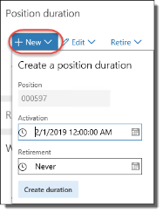

* 1. Specify the position's Activation date if it is different from the current date. Specify a Retirement date if there is one.
  2. Click Create duration to reactivate the position.

1. Expand the Worker assignment section of the position and click New to open the Create a worker assignment pane.

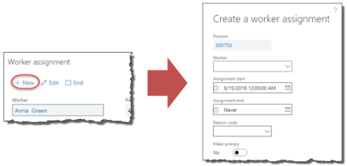

1. Select the rehired Worker.
2. Specify an Assignment start date if it is different from the current date. Specify an Assignment end date if there is one.
3. Select Make primary if this position is the worker's primary or only position.
4. Click Create worker assignment to assign the position to the worker.
5. Expand the Financial dimensions section and verify the information there.
6. Close the form.

3.2.3 Validate the worker's existing position record

To validate the worker's existing payroll record:

1. In the navigation pane, click Common > Anthology Payroll workers to open the Anthology Payroll workers list. Select the worker in the list.

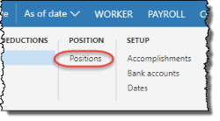

1. On the ribbon, click Anthology Payroll Profile tab > Positions to open the Worker positions form.
2. On the Positions form, click the General tab and verify the following information:
   * Pay group: specify however often your pay period is
   * Time rule group: specify Standard time rules
   * Earning rule group: specify Standard earn calcs
   * Benefit deduction rule group: specify Standard ded'n rules
   * Entitlement rule group: specify Standard entitlement or No entitlement, as required
   * Workers compensation category: specify the province/territory where the worker works
   * Position filter: specify the region where the worker works
   * Hourly rate: specify the worker's hourly pay rate.
   * Salary period and Salary amount: specify the worker's salary amount and how often they are paid this amount.

NOTE: You cannot specify both an Hourly rate and a Salary amount.

1. Click Save to save your changes.

3.2.4 Validate the worker's additional payroll information

Validating the worker's additional payroll information involves viewing the appropriate forms and validating the information currently found there. These procedures are the same as the ones outlined in section 3.1.5. See that section for steps on viewing and modifying additional payroll information.

4 Maintaining Worker Data

This section describes procedures on modifying and maintaining worker data. This data includes:

* Position data, such as the position filter and worker wages
* Demographic data, such as addresses, and contact information
* Payroll data, such as benefit/deductions and calculation variables

4.1 Manage Position Data

Worker position data must be updated when workers change occupations or receive pay increases. All position information is contained in a single form—the Worker positions form. The data that you may modify includes:

* Occupation
* Position filter, type, assignment type
* Wage rate
* Union affiliation
* Rule groups

4.1.1 Modify Position Data

To modify position data for a worker:

1. In the navigation pane, click Common > Anthology Payroll workers to open the Anthology Payroll workers list. Select the worker in the list.
2. On the ribbon, click Anthology Payroll Profile tab > Positions to open the Worker positions form.

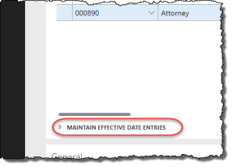

1. On the Overview tab, expand the Maintain effective date entries pane.
2. On the Effective dates tab of the Maintain effective date entries pane, click New to create a new record. This new position record is a copy of the previous record with a new Active date. Change this date to the date that the new policy takes effect. The previous record is automatically adjusted to expired one day before this date.
3. On the General tab of the Maintain effective date entries pane, modify any of the following information as required (see section 3.1.3 or the Anthology Payroll Help System for descriptions of the fields):
   * Occupation
   * Position filter
   * Position type
   * Position assignment type
   * Wage rate or salary information
   * Union affiliation
   * Rule groups
   * Workers compensation category
4. Click Save to save your changes.

4.1.2 Change Positions

Occasionally, a worker may change positions due to a lateral move or a promotion. In these cases, you must:

1. End the worker's old position.
2. Create a new position and assign it to the worker.
3. Update their position data.

You may also need to update the worker's payroll data if the new position belongs to a different pay group or if the worker is now eligible for additional benefits.

To end a worker's position:

NOTE: before ending the worker's position, ensure that the worker has no unprocessed earnings in the current pay period.

1. In the navigation pane, click Common > Workers to open the Workers list. Select the worker.

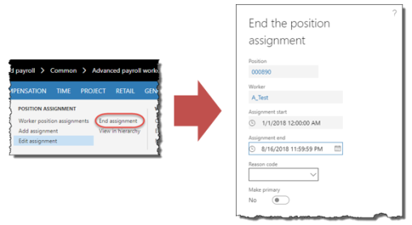

1. On the Worker tab of the ribbon, click the End assignment button to open the End the position assignment pane.
2. Specify an Assignment end date if it is not the current date.
3. Select a Reason code for the position ending.
4. Click Retire worker assignment to end the worker's position.

To create a new position and assign it to the worker, refer to section 3.1.1 and the first procedure in section 3.2.2.

To update the worker's position data, refer to section 3.1.3.

To update the worker's payroll data, refer to section 4.3 for the different types of payroll data.

4.2 Manage Demographic Data

Currently, demographic data only includes worker addresses.

4.2.1 Manage Addresses

To add a new address, refer to section 3.1.2.

To change a worker's address:

1. In the navigation pane, click Common > Anthology Payroll workers to open the Anthology Payroll workers list. Double-click the worker in the list to open the Worker form.
2. On the Worker form, expand the Addresses section.

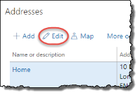



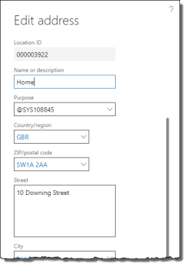

1. Select the address to modify and click the Edit button to open the Edit address pane.
2. On the Edit address pane, update the worker's address as desired.
3. Click OK to save your changes. Close the form.

4.3 Manage Payroll Data

Payroll data refers to worker data that relates specifically to how the worker is paid. In terms of the CA localization of Anthology Payroll, this includes:

* Bank Accounts
* Benefits and deductions
* Calculation variables
* Garnishments, which are managed as benefit/deductions
* One-time deductions
* Wage increments

4.3.1 Manage Account (Direct Deposit) Information

Worker account information can be modified to correct existing account information that is incorrect, or to make an effective-dated change to the worker's account information if they changed accounts and banks.

To add a new account, see section 3.1.5.3.

To correct a worker's account information:

1. In the navigation pane, click Common > Anthology Payroll workers to open the Anthology Payroll workers list. Select the worker in the list.
2. On the ribbon, click Anthology Payroll Profile tab > Bank accounts to open the Worker bank accounts form.
3. Select the worker's account to correct and click the Maintain tab.
4. Modify any of the following fields:
   * Financial institution name: 3-digit identifier, followed by a dash, followed by the 5-digit branch number (example)
   * Account type: Checking or Savings
   * Account: worker's 8-digit account number
   * Percentage: amount per payment to deposit to this account. Used in account splits.
   * Apply to remainder: deposit any remaining payment amount after account splits to this account.
5. Click Save to save your changes. Close the form.

To make an effective-dated change to a worker's account information:

1. In the navigation pane, click Common > Anthology Payroll workers to open the Anthology Payroll workers list. Select the worker in the list.
2. On the ribbon, click Anthology Payroll Profile tab > Bank accounts to open the Worker bank accounts form.
3. Select the worker's current bank account to change and expand the Maintain effective date entries pane.
4. In the Maintain effective date entries pane, select the current, active bank account and click New to create a new effective-dated record. This opens the Maintain tab on the Worker bank accounts form and creates a new record with identical attributes as the selected record with an Active date of the current date.
5. Modify any of the following fields on this new record:
   * Financial institution name: 3-digit identifier, followed by a dash, followed by the 5-digit branch number (example)
   * Account type: Checking or Savings
   * Account: worker's 8-digit account number
   * Percentage: amount per payment to deposit to this account. Used in account splits.
   * Apply to remainder: deposit any remaining payment amount after account splits to this account.
   * Active date: date when the new account is to take effect. This can be a date in the future. The current worker account record is automatically set to expire one day before this date.
6. Click Save to save your changes. Close the form.

4.3.2 Manage One-Time Deductions

Some deductions are one-time deductions and are assigned to workers on an individual basis as needed.

To assign a one-time deduction to a worker:

1. In the navigation pane, click Common > Anthology Payroll workers to open the Anthology Payroll workers list. Select the worker in the list.

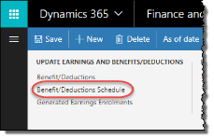

1. On the ribbon, click Anthology Payroll Profile tab > Benefit/Deductions Schedules to open the Worker benefit/deduction schedules form.
2. On the Overview tab, click New to create a new record.

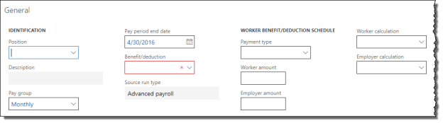

1. On the General tab, specify the desired Benefit/deduction code.
2. Specify the Worker amount. This is the amount deducted from the worker. This amount can be negative, resulting in an additional payment to the worker.
3. Specify a Pay period end date. This defines the pay period when the amount is to be deducted. For the current pay period, leave the default date.
4. If the benefit/deduction is associated with a benefit/deduction sequence, you can choose to override the Calculation sequence number and Depletion sequence for the deduction to determine when during processing the deduction is calculated and depleted from the worker's pay respective to other deductions. These overrides are typically used for court-ordered wage garnishments that have specific priorities.
5. Click Save to save your changes.

The deduction is automatically taken from the worker's next (or future) payment.

4.3.3 Manage Worker Allowances

Worker allowances are special benefit earnings that your company may give to workers on a regular basis, such as car allowances or gym memberships. Your implementation may be configured to display these as earnings on the worker's pay statement.

In Anthology Payroll, allowances are generally configured as generated earnings, which are earnings based on other earnings. There are two types of generated earnings: enrolled and non-enrolled. Non-enrolled generated earnings are automatically awarded to all workers with the appropriate rule group, while enrolled generated earnings must be assigned to individual workers before they receive them.

To manage a worker's generated earning enrollments:

1. In the navigation pane, click Common > Anthology Payroll workers to open the Anthology Payroll workers list. Select the worker in the list.

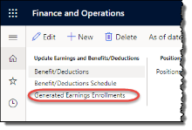

1. On the ribbon, click Anthology Payroll Profile tab > Generated Earnings Enrollments to open the Generated earning enrollments form.
2. On the Overview tab, click New to create a new record.

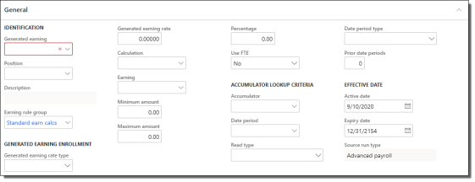

1. On the General tab, specify the desired Generated earning code for the allowance.
2. If the worker has multiple positions and this allowance is specific to one of their positions, specify the Position field.
3. Verify the worker's Earning rule group. The rule group determines how the allowance amount is calculated.
4. Specify the Generated earning rate type. Amount for dollar amounts or Hours for hour amounts that are later multiplied against a rate.
5. To override the default configuration of the allowance for this worker's enrollment specify any of the following, as desired:
   * Generated earning rate: multiplier rate or flat amount of the generated earning. Hours-based earnings are multiplied by this rate and amount-based earnings use this rate as the flat amount.
   * Calculation: calculation code that calculates the amount of the generated earning
   * Earning: earning code to be generated. Depending on configuration, this code appears on the worker's pay statement.
   * Minimum amount: minimum amount for the worker to be paid each time this earning is generated
   * Maximum amount: maximum amount for the worker to be paid each time this earning is generated
   * Percentage: percentage multiplier against the Calculation, if the worker is only to receive a portion of the calculated amount. Default is 100%.
   * Use FTE: Yes to apply the worker's full-time equivalency value to give only a portion of the generated earning. No, otherwise.
6. Set the Active date to when the allowance takes effect, usually the worker's hire date.
7. Click Save to save your changes.

4.3.4 Manage Calculation Variables

To add new calculation variables for a worker, see section 3.1.5.2.

|  |
| --- |
| Refer to 9.2 Appendix B: List of Calculation Variables for a listing of all calculation variables and descriptions of their use. |

Existing calculation variables that you may want to change are:

* Taxable benefits
* Non-standard vacation accrual rates
* Personal tax credits

To modify a worker's existing calculation variables:

1. In the navigation pane, click Common > Anthology Payroll workers to open the Anthology Payroll workers list. Select the worker in the list.

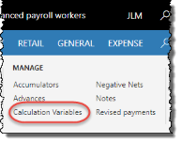

1. On the ribbon, click Anthology Payroll Profile tab > Calculation variables to open the Worker calculation variables form.
2. On the Overview tab, select the calculation variable to modify. Expand the Maintain effective date entries pane.
3. On the Effective dates tab of the Maintain effective date entries pane, click New to create a new record. This new record is a copy of the previous record with a new Expiry date. The previous record is automatically expired on current date.
4. On the General tab of the Maintain effective date entries pane, modify any of the following fields as required (refer to aforementioned appendix):
   * Item: calculation variable item name
   * Override amount: value for the variable if non-default
   * Use default: if No, the calculation variable uses the Override amount
   * Expiry date
5. To expire a calculation variable, modify only the Expiry date.
6. Click Save to save your changes.

4.3.5 Manage Garnishments

Managing garnishments involves several procedures:

1. Check a worker's existing garnishments to view which are currently active or were active in the past.
2. Assign the appropriate garnishment benefit/deduction to the worker.
3. Assign and set the appropriate calculation variables to the worker according to the type of garnishment.

There are three garnishment order benefit/deductions included in the Statutory Deductions Spreadsheet. Each benefit/deduction has a different priority of deduction when calculating a worker's garnishment contribution amount. In descending priority of deduction, the benefit/deductions are:

* Garnishment Order 1
* Garnishment Order 2
* Garnishment Order 3

Determining the appropriate priority for the garnishment order depends on any existing garnishments the worker may have.

9.3 Appendix C: List of Garnishment Benefit/deductions contains a reference of the garnishment benefit/deductions and applicable calculation variables.

4.3.5.1 Verify Existing Garnishments

If you are assigning garnishments to a new hire, you can skip this section.

To view a worker's existing garnishment orders:

1. In the navigation pane, click Common > Anthology Payroll workers to open the Anthology Payroll workers list. Select the worker in the list.
2. On the ribbon, click Anthology Payroll Profile tab > Benefit/deductions to open the Worker benefit/deductions form.
3. Filter by *Garn* in the Benefit/deduction field to view only garnishment-related benefit/deductions.

If the worker has existing garnishment benefit/deductions that are still active, determine whether the new garnishment has a higher or lower priority than the existing garnishment and determine the appropriate priority.

If the worker has no existing garnishments, it is recommended to select Garnishment Order 2 for the new garnishment. This allows future garnishments for the worker to be prioritized against this one.

After determining the garnishment priority and any existing garnishment benefit/deductions, it is recommended to look up the worker's accumulators to verify if the worker had previous expired garnishments with the same garnishment priority. Corresponding accumulators for previous expired garnishments must be reset before setting up a new garnishment of the same priority.

To view a worker's garnishment accumulators:

1. In the navigation pane, click Common > Anthology Payroll workers to open the Anthology Payroll workers list. Select the worker in the list.
2. On the ribbon, click Anthology Payroll Profile tab > Accumulators to open the Worker accumulators form.
3. Filter by *Garn* in the Accumulators field to view only garnishment-related accumulators.

Locate the Garnishment# Ongoing accumulator, where # is the order priority you have determined for the new garnishment. This accumulator tracks the total amount that the worker has paid throughout the history of the garnishment and must be reset when a new garnishment of the same priority is assigned to the worker. If there is no such accumulator(s), skip to the next section (section 4.3.5.2).

To reset accumulators for previous expired garnishments:

1. Select the Garnishment# Ongoing Accumulator, where # is the order priority you have determined for the new garnishment.

NOTE: Ensure that you are not selecting an accumulator that corresponds to an existing and active garnishment benefit/deduction for this worker. Deleting such an accumulator will interfere with the operation of the existing garnishment order.

1. Delete (click Delete) the worker accumulator.
2. Create (click New) a new worker accumulator.
3. Specify the same Accumulator name that was just deleted (Garnishment# Ongoing) with a Date period of Ongoing.
4. Specify the Date period year and Date period number. Verify that the Accumulated amount is 0.
5. Click Save to save your changes.

4.3.5.2 Assign Garnishment Benefit/deductions

After determining the garnishment order priority and verifying the worker's accumulators, you can assign the garnishment benefit/deduction to the worker. There are three general garnishment order benefit/deduction codes, 3 additional arrears codes for each of the garnishments, and a garnishment administration fee code.

If the worker has no existing garnishments, it is recommended to select Garnishment Order 2 for the new garnishment. This allows future garnishments for the worker to be prioritized against this one.

The arrears deductions (Garn# Arrears) are used when a new garnishment order for arrears is received for a worker with a pre-existing garnishment order. When assigning an arrears deduction, ensure that the order priority number (#) matches the garnishment order number currently assigned to the worker. For example, a worker with Garnishment Order 2 should receive Garn2 Arrears.

The administration fee benefit/deduction allows employers to deduct a nominal administration fee for processing garnishments in certain provinces. Enrolments for the administration fee are only available for provinces where the fee is allowed.

To assign garnishment orders to a worker:

1. In the navigation pane, click Common > Anthology Payroll workers to open the Anthology Payroll workers list. Select the worker in the list.
2. On the ribbon, click Anthology Payroll Profile tab > Benefit/deductions to open the Worker benefit/deductions form.
3. On the Evaluate tab, click New to create a new record.
4. Select the Benefit/deduction:
   * Garnishment Order 1: garnishment order with the highest priority
   * Garnishment Order 2: garnishment order with medium priority
   * Garnishment Order 3: garnishment order with the lowest priority
   * Garn1 Arrears: additional arrears order for Garnishment Order 1
   * Garn2 Arrears: additional arrears order for Garnishment Order 2
   * Garn3 Arrears: additional arrears order for Garnishment Order 3
   * Garnishment Admn Fee: a nominal administration fee for processing garnishment orders. Only applicable in certain provinces.

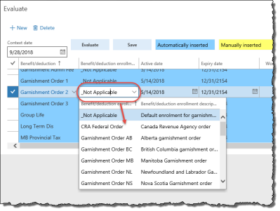

1. Specify the Benefit deduction enrolment:
   * For Garnishment Orders #:
     + CRA Federal Order: federal garnishment orders issued by Canada Revenue Agency
     + Support Order XX: family support/maintenance orders. XX is the 2-character identifier for jurisdiction.
     + Garnishment Order XX: third party garnishment orders. XX is the 2-character identifier for jurisdiction.
   * For Garn# Arrears, specify the Garn Arrears XX Benefit deduction enrolment, where # is the corresponding garnishment order number and XX is the 2-character identifier for jurisdiction.
   * For Garnishment Admn Fee, specify the Garn Admin Fee XX Benefit deduction enrolment, where XX is the 2-character identifier for jurisdiction.
2. Verify that the Worker calculation changes according to the enrolment specified.
3. If the garnishment order has a unique garnishee number and a vendor account has been set up for it in Accounts Payable, select the vendor account in the Worker AP vendor field. Enter the garnishee number in the AP vendor worker reference field.
4. Specify an Active date and Expiry date. These must accurately reflect the time period to which the order applies. Third party garnishment orders are often valid for only one year, while family support orders are often valid for a number of years based on the age of the dependent child.
5. Click Save and close the form.

4.3.5.3 Assign Garnishment Calculation Variables

After assigning garnishment benefit/deductions, the associated worker calculation variables must be assigned.

Most garnishment-related calculation variables are prefixed with Garn#, where # is the order priority (1, 2, or 3). This order priority number corresponds to the garnishment order number of the benefit/deduction. For example, a worker with the Garnishment Order 2 benefit/deduction should be assigned calculation variables prefixed with Garn2*.

All calculation variables should be set with Override amount/rate values as each garnishment order is different. Ensure the Use default field is set to No.

Each of the different types of garnishments—CRA Federal Order, Garnishment Order, or Support Order—require a specific set of calculation variables as each order is calculated differently.

To assign calculation variables to a worker:

1. In the navigation pane, click Common > Anthology Payroll workers to open the Anthology Payroll workers list. Select the worker in the list.
2. On the ribbon, click Anthology Payroll Profile tab > Calculation Variables to open the Worker calculation variables form.
3. On the Overview tab, click New to create a new record.
4. Use the table below to determine the Calculation variables to assign and the Override amount/rates to set according to the type of garnishment. Ensure the Use default field is set to No:

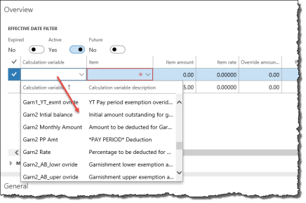

| Garnishment Type | Calculation Variable | Description of Use |
| --- | --- | --- |
| CRA federal orders | Garn# Intial Balance | outstanding balance in the initial notice of garnishment |
| One of the following (3): | |
| Garn# Monthly Amount | amount of the garnishment to be deducted every month |
| Garn# PP Amt | the amount of the garnishment to be deducted every pay period |
| Garn# Rate | percentage to deduct from each payment (e.g.: 10 for 10%) |
| Family support / maintenance orders | One of the following (3): | |
| Garn# Monthly Amount | amount of the garnishment to be deducted every month |
| Garn# PP Amt | amount of the garnishment to be deducted every pay period |
| Garn# Rate | percentage to deduct from each payment (e.g.: 10 for 10%) |
| For outstanding arrears on a support order (3): | |
| Garn#_Arears Balance | initial arrears outstanding amount, where XX is the province of issue |
| Garn#_Arears Fixed | specific monthly amount to be deducted in addition to the regular monthly payment. Applies only to Manitoba and Saskatchewan. |
| Garn#_Arears Rate | specific monthly rate to be deducted in addition to the regular monthly payment (e.g.: 10 for 10%). Applies only to Nova Scotia. |
| Third-party garnishment orders | Garn# Intial Balance | outstanding balance in the initial notice of garnishment |
| Dependents | worker's number of dependents. If the worker has no dependents, do not assign this variable. |
| One of the following (3): | |
| Garn# Monthly Amount | amount of the garnishment to be deducted every month |
| Garn# PP Amt | amount of the garnishment to be deducted every pay period |
| Garn# Rate | percentage to deduct from each payment (e.g.: 10 for 10%) |
| Optional calculation variables (3): | |
| Garn#_XX_lowr ovride | court-ordered lower exemption amount on the worker's garnishment, where XX is the province of issue |
| Garn#_XX_uper ovride | court-ordered upper exemption amount on the worker's garnishment, where XX is the province of issue |
| Garn#_XX_exmt ovride | exemption override rate on the worker's garnishment, where XX is the province of issue |

1. Specify an Active date and Expiry date. These must accurately reflect the time period to which the order applies. Third party garnishment orders are often valid for only one year, while family support orders are often valid for a number of years based on the age of the dependent child.
2. Click Save to save your changes.

See 9.3 Appendix C: List of Garnishment Benefit/deductions for a reference of the garnishment benefit/deductions and applicable calculation variables.

4.3.6 Manage Pay Advances

Pay advances can be issued to workers and then scheduled to be recovered at a later date.

4.3.6.1 Issue Pay Advance

To issue a pay advance to a worker:

1. In the navigation pane, click Common > Anthology Payroll workers to open the Anthology Payroll workers list. Select the worker in the list.

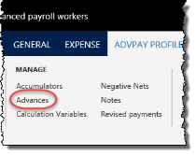



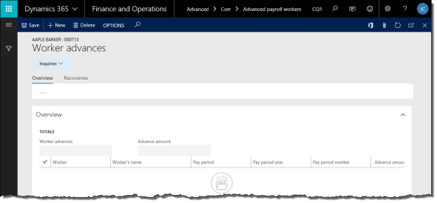

1. On the ribbon, click Anthology Payroll Profile tab > Advances to open the Worker advances form.
2. On the Overview tab, click New to create a new record.
3. On the General tab, select the Pay period, Pay period year, and Pay period number representing when the pay advance is issued. Verify the worker's Pay group.
4. Specify the Advance amount to be paid.
5. Specify whether the advance is Recovered outside of the system. If Yes, the Recovered field automatically changes to Yes.
6. Specify whether the advance was Issued outside of the system.
7. If the advance is not recovered outside of the system, the form will prompt you to schedule an advance recovery before closing it (next section).

When the pay advance is created, Anthology Payroll will automatically pick it up as the worker's earnings to be paid in the next regular payment. Alternatively, you may issue a manual payment (5.2.1) to the worker and select the appropriate payment type (i.e.: Off-cycle) to pick up the pay advance. Pay advances appear in their own section on the Benefits/deductions tab of the Manual payment entry journal.

4.3.6.2 Schedule an Advance Recovery

If a pay advance is not recovered outside of Anthology Payroll (i.e.: manually), you must schedule a recovery period in which Anthology Payroll will recover the pay advance. Pay advances are treated the same as benefit/deductions, in which they are recovered automatically from regular payment.

To schedule an advance recovery:

1. On the Worker advances form, select the advance to recover and click the Recoveries tab.

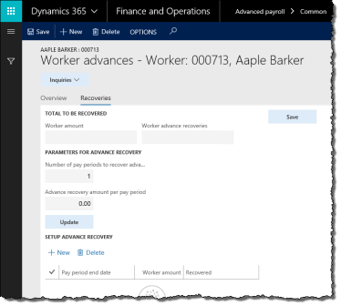

1. The Worker amount shows the amount to be recovered. One advance recovery record is created by default with the full amount of the advance. If the advance recovery record does not appear, click Update to create it.
2. To specify the number of pay periods over which to recover the advance amount and calculate the recovery amount per pay period:
   1. Enter 0 for Advance recovery amount per pay period.
   2. Enter the Number of pay periods to recover advance.
   3. Click Update to generate the advance recovery schedule.
3. To specify the recovery amount per pay period and calculate the number of pay periods required:
   1. Enter 0 for Number of pay periods to recover advance.
   2. Enter the Advance recovery amount per pay period.
   3. Click Update to generate the advance recovery schedule.
4. To specify both the recovery amount per pay period and the number of pay periods and calculate the resulting Worker amount:
   1. Enter the Number of pay periods to recover advance.
   2. Enter the Advance recovery amount per pay period.
   3. Click Update to generate the advance recovery schedule.

NOTE: you will receive an alert if Worker amount is less than the amount to be recovered

1. If required, modify the Pay period end dates in the recovery schedule table to change the date of each recovery.
2. Click Save to commit the advance recovery schedule.
3. Close the form.

4.3.6.3 Modify an Existing Advance or Recovery Schedule

You can modify an advance or its recovery schedule provided it is not already marked as recovered.

To modify an existing advance or recovery schedule:

1. On the Worker advances form, select the advance to modify.
2. On the General tab, adjust the data fields as desired. Click Save to save your changes.
3. To modify the recovery schedule, click the Recoveries tab and select the recovery periods in the table to modify.
4. Change recovery fields as desired. To delete records, select them and click Delete.
5. Click Save and you will be returned to the Overview tab.
6. Click Save to save your changes.

4.3.7 Import Wage Increments

Wage increments are predetermined pay increases that occur at a defined time. There are two methods to manage wage increments for workers:

* creating a spreadsheet of wage increments and importing them
* generating wage increment steps from a predefined set of criteria

Both methods require setup of a wage increment code prior to importing or generating the wage increments. This section details the method of importing wage increments.

Wage increments are individual transaction records that record a change to a worker's salary or hourly rate. Whether they are imported or generated, they must then be applied to workers or their positions to enact the effective-dated change.

4.3.7.1 Set up a Wage Increment Code

All wage increments must be associated with a wage increment code, regardless of whether they are generated or imported.

To set up a wage increment code:

1. In the navigation pane, click Setup > Tables > Salary > Wage increments to open the Wage increments form.

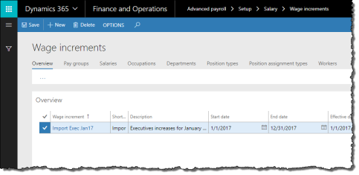

1. On the Overview tab, click New to create a new record.
2. On the General tab, enter the Wage increment name and Description. The Short code defaults to the first five characters of the name.
3. Enter the Start date and End date of the wage increment. Workers and positions must be active within this date range to be considered for eligibility.
4. Enter the Minimum amount and Maximum amount. These amounts are annualized (hourly and salary) outer boundaries of the wage increment amount. Wage increments that fall outside these boundaries are still generated, but not automatically applied.
5. Select the Salary type of the workers to be considered for this wage increment.
6. Set any of the following run parameters:
   * Use import file only: Yes/No whether you import wage increments for this code. Set to Yes to indicate this wage increment code is for imported wage increments. This disables certain fields on this form as they are not used for imported wage increments.
   * Terminated: Yes/No whether workers or positions that terminate within the date range are considered for the wage increment
7. Specify an Effective date. All wage increment changes use this date as their active date.
8. Further refine the eligibility criteria of the wage increment on the following tabs:
   * Pay groups: only workers in the selected pay groups are eligible
   * Salaries: only workers with the selected salary codes are eligible
   * Occupations: only workers in the selected occupations are eligible
   * Departments: only workers in the selected departments are eligible
   * Position types: only workers with the selected Position types on their Worker positions form are eligible
   * Position assignment types: only workers with the selected Position assignment types on their Worker positions form are eligible
   * Workers: only selected workers are eligible
9. Click Save to save your changes.

4.3.7.2 Import Wage Increments

You may import wage increments from a CSV, TXT or DAT file into Anthology Payroll. The import file must follow strict specifications, which are defined in 9.7 Appendix G: List of Wage Increment Import Fields. Before importing wage increments, ensure that you have set up the wage increment code you are importing for (section 4.3.7.1). You can only import for one code at a time.

After importing the wage increment records, you must commit the records to Anthology Payroll.

To import wage increments from an import file:

1. In the navigation pane, click Periodic > Other > Wage increments > Import wage increments to open the Import wage increments pane.

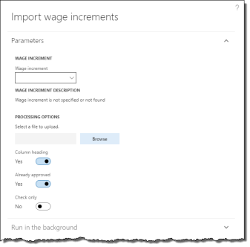

1. Specify the Wage increment code you are importing for. Verify the Wage increment description is what you are importing for.
2. Browse and select the import file.
3. Select or deselect any processing options:
   * Column heading: deselect if the first row in the import file is not column headings
   * Already approved: deselect if imported wage increment records must be approved/reviewed before applying to workers and positions. This requires a separate process (see section 4.3.7.3).
   * Check only: select to verify the import file only. No wage increment records are imported.
4. Click OK to import the file. An alert appears with a summary of the import process.

To commit imported wage increments:

1. In the navigation pane, click Periodic > Other > Wage increments > Commit import wage increments to open the Wage increment imports journal.
2. Specify the Wage increment code that wage increments were imported for. Uncommitted, imported wage increment records appear in the list. Note any records that state No for the Valid field.
3. Review the list of imported wage increments to verify that the data imported correctly. Modify any wage increment records as required. Ensure to resolve the wage increment records that state No for the Valid field. These records cannot be committed until they are revalidated.
4. Select any records that you have modified and click Revalidate to check their validity.
5. When all desired wage increment records are valid, select the records you want to commit and click Commit wage increments to commit them to Anthology Payroll. An alert appears to verify the procedure.

4.3.7.3 Review or Change Wage Increments

After generating or importing/committing wage increments, you must review them and manually select which wage increments to apply. If you imported wage increments and selected the Already approved flag during the import process, you do not need to review the wage increments further, but you may still choose to.

After reviewing/changing wage increment records, you can apply them and create the appropriate effective-dated changes on worker and worker position records.

To review or change wage increments:

1. In the navigation pane, click Periodic > Other > Wage increments > Review/change wage increments to open the Review/change wage increments journal.

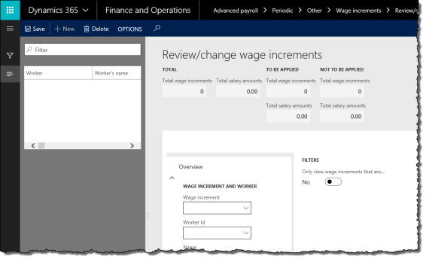

1. Specify the Wage increment code of the wage increments to review or change. If desired, specify a Worker Id to view only that worker's wage increments.
2. Change any of the following fields as desired. You can only change wage increments that have not yet been applied:
   * New effective date
   * New salary
   * New step number
   * New salary period
   * New salary amount
   * New hourly rate
3. Review the list of wage increments and determine which you would like to apply. Set the Apply flag to Yes for these wage increments.
4. Click Save to save your changes.

4.3.7.4 Apply Wage Increments

After you are satisfied with the wage increments and have verified them, you can apply them to worker and position records and enact the effective-dated changes.

To apply wage increments:

1. In the navigation pane, click Periodic > Other > Wage increments > Apply wage increments to open the Apply wage increments pane.

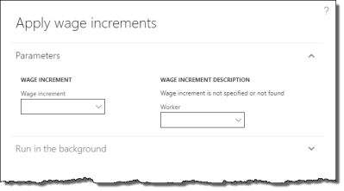

1. Specify the Wage increment code of the wage increments to apply. Verify the Wage increment description corresponds to the desired wage increment.
2. If desired, specify a Worker to apply only wage increments for that worker.
3. Click OK to apply wage increment changes to workers and worker positions. An alert appears with a summary of the application process.

4.3.8 Generate Wage Increment Steps

Wage increments are predetermined pay increases that occur at a defined time. There are two methods to manage wage increments for workers:

* creating a spreadsheet of wage increments and importing them
* generating wage increment steps from a predefined set of criteria

Both methods require setup of a wage increment code prior to importing or generating the wage increments. This section details the method of generating wage increment steps.

Wage increments are individual transaction records that record a change to a worker's salary or hourly rate. Whether they are imported or generated, they must then be applied to workers or their positions to enact the effective-dated change.

4.3.8.1 Set up a Wage Increment Code

All wage increments must be associated with a wage increment code, regardless of whether they are generated or imported.

See section 4.3.7.1 for additional details.

To set up a wage increment code:

1. In the navigation pane, click Setup > Tables > Salary > Wage increments to open the Wage increments form.
2. On the Overview tab, click New to create a new record.
3. On the General tab, enter the Wage increment name and Description. The Short code defaults to the first five characters of the name.
4. Enter the Start date and End date of the wage increment. Workers and positions must be active within this date range to be considered for eligibility.
5. Enter the Minimum amount and Maximum amount. These amounts are annualized (hourly and salary) other boundaries of the wage increment amount. Wage increments that fall outside these boundaries are still generated, but not automatically applied.
6. Select the Salary type of the workers to be considered for this wage increment.
7. Set any of the following run parameters:
   * Next step: Yes/No whether workers or positions associated with salary grids are to advance to the next step as a result of this wage increment. Workers currently at the top step of their salary grids are not affected by wage increments.
   * Terminated: Yes/No whether workers or positions that terminate within the date range are considered for the wage increment
   * Use import file only: Yes/No whether you import wage increments for this code. Set this to No to indicate that this wage increment code is for generated wage increments.
   * Usage period type: Yes/No whether to follow usage periods when considering workers or positions to advance to the next step in a salary grid. Usage periods are predefined lengths of time that workers must remain in a salary step before advancing to the next.
8. Enter one of:
   * Percentage amount: increment or decrement wages by a percentage
   * Hourly rate and/or Salary period and Salary amount: new rates and amounts for hourly workers or salaried workers or both
9. Specify an Effective date. All wage increment changes use this date as their active date.
10. Further refine the eligibility criteria of the wage increment on the following tabs:
    * Pay groups: only workers in the selected pay groups are eligible
    * Salaries: only workers with the selected salary codes are eligible
    * Occupations: only workers in the selected occupations are eligible
    * Departments: only workers in the selected departments are eligible
    * Position types: only workers with the selected Position types on their Worker positions form are eligible
    * Position assignment types: only workers with the selected Position assignment types on their Worker positions form are eligible
    * Workers: only selected workers are eligible
11. Click Save to save your changes.

4.3.8.2 Generate Wage Increments

Wage increments may be generated at any time, provided you have set up the wage increment code (section 4.3.7.1). Generating wage increments is separate from importing wage increments (section 4.3.7.2). You cannot generate and import wage increments for the same wage increment code.

To generate wage increments:

1. In the navigation pane, click Periodic > Other > Wage increments > Generate wage increments to open the Generate wage increments pane.

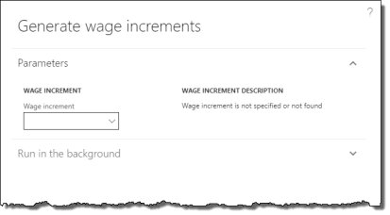

1. Select the Wage increment code to generate.
2. Click OK to generate the wage increments.

4.3.8.3 Review or Change Wage Increments

See section 4.3.7.3.

4.3.8.4 Apply Wage Increments

See section 4.3.7.4.

4.3.9 Manage Entitlements

Entitlements are worker banks of time or earnings that can accrue and consume during their employment. Entitlement banks grow as a result of time worked or in periodic increments, and decrease as result of time or earnings taken, expiration, or being paid out. Workers may have multiple entitlement banks that accumulate and deplete according to different policies.

This section contains procedures for managing a worker's entitlements during their employment. For paying out a worker's accrued time (vacation, overtime, etc.) upon their termination, see section 8.3.

4.3.9.1 Adjust Entitlements

You may adjust a worker's entitlement balance as required provided you have not yet updated entitlements (section 5.1.6) in the current pay period. If you have started the pay process, any adjustments to entitlements may impact the worker's payment.

To adjust a worker's entitlement bank balance:

1. In the navigation pane, click Common > Anthology Payroll workers to open the Anthology Payroll workers list. Select the worker.

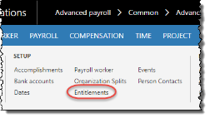

1. On the ribbon, click Anthology Payroll Profile tab > Entitlements to open the Worker entitlements form.

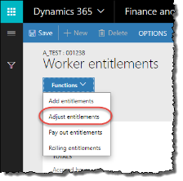



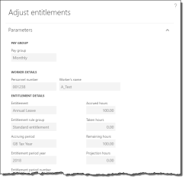

1. On the Worker entitlements form, select the entitlement to adjust and click Functions > Adjust entitlements to open the Adjust entitlements pane.
2. Change the Accrued hours, Taken hours, or both as desired.
3. Specify an Adjustment reason code of Correction or alternative as appropriate.
4. Click OK to adjust the entitlement bank.

4.3.9.2 Add Rolling Entitlements

Rolling entitlements are entitlements that are configured with a rolling taking period. The taking period is a moving window of time that replenishes according to how much time has lapsed since the bank was last decremented according to a context date, which is usually the current date. Typically, rolling entitlements have an initial bank amount.

For example, a worker may have a bank of 15 days to consume over a rolling period of one year. If the worker takes 5 consecutive days out of the bank starting from January 5th, 2014, the worker will have a remaining balance of 10 days until January 6th, 2015. On that date, he or she will have a balance of 11 days. On January 7th, 2015, the worker will have 12 days, and so on until the bank returns to a full balance of 15 days on January 10th, 2015, presuming the worker has not taken additional days from the bank during the rolling period.

To add a rolling entitlement bank to a worker and give them a starting balance:

1. In the navigation pane, click Common > Anthology Payroll workers to open the Anthology Payroll workers list. Select the worker.
2. On the ribbon, click Anthology Payroll Profile tab > Entitlements to open the Worker entitlements form.

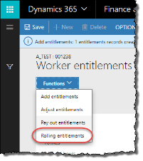



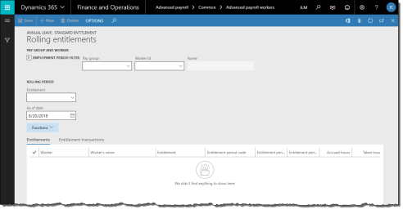

1. On the Worker entitlements form, click Functions > Rolling entitlements to open the Rolling entitlements form.

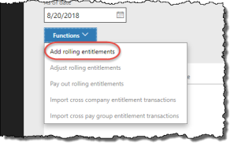



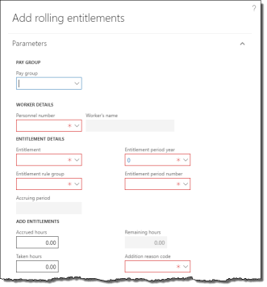

1. On the Rolling entitlements form, re-enter the Worker Id and Pay group.
2. Click Functions > Add rolling entitlements to open the Add rolling entitlements pane.
3. On the Add rolling entitlements pane, specify the Pay group and select the worker in the Personnel number field.
4. Select the Entitlement to add.
5. Select the worker's Entitlement rule group that contains the rules for this particular entitlement.
6. Specify the Entitlement period year and Entitlement period number in which the starting balances should appear. The Accruing period will automatically populate.
7. Enter a starting entitlement balance in the Accrued field. The unit (hours, days, etc.) may differ according to the entitlement.
8. Select an Addition reason code appropriate for the addition (e.g.: Initial setup).
9. Click OK to add the entitlement for the worker.
10. Close the form.

After an entitlement bank has been granted to a worker, its attributes can no longer be modified. Be sure all selected attributes are correct before granting the entitlement. Only the entitlement balance can be adjusted after the entitlement is granted.

4.3.9.3 Adjust Rolling Entitlements

To adjust the balance of a worker's rolling entitlement:

1. In the navigation pane, click Common > Anthology Payroll workers to open the Anthology Payroll workers list. Select the worker.
2. On the ribbon, click Anthology Payroll Profile tab > Entitlements to open the Worker entitlements form.
3. On the Worker entitlements form, click Functions > Rolling entitlements to open the Rolling entitlements form.



1. On the Rolling entitlements form, enter the worker's Pay group, Entitlement to adjust and the As of date (current date).
2. On the Entitlements tab, select the entitlement to adjust and click Functions > Adjust rolling entitlements to open the Adjust rolling entitlements pane.

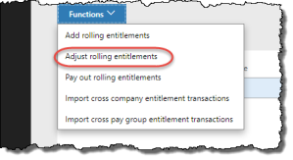



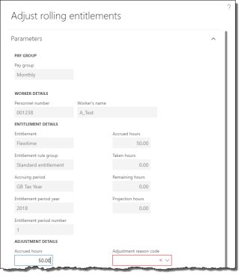

1. On the Adjust rolling entitlements pane, change the Accrued and Taken fields as required. The unit (hours, days, etc.) may differ according to the entitlement. To specify a negative balance if the entitlement allows, the Taken amount must be greater than the Accrued.
2. Specify an Adjustment reason code appropriate for the adjustment (e.g.: Correction).
3. Enter the Transaction date of the entitlement adjustment. The adjustment takes place on this date and is required for rolling entitlements.
4. Click OK to complete the adjustment.

4.3.9.4 Import Cross-Company Transactions for Rolling Entitlements

When a worker changes companies in your organization or if they hold positions in multiple companies, you may need to import their entitlement transactions from one company to another, provided that those companies use the same rolling entitlement bank. When that worker takes time from their entitlement bank, the transaction should be imported to other companies to reflect the worker's current entitlement balance.

NOTES: the same entitlement bank must already exist in both companies for the import process to succeed.

To import entitlement transactions from one company to another:

1. Ensure you are in the company you want to import transactions to (destination).
2. In the navigation pane, click Common > Anthology Payroll workers to open the Anthology Payroll workers list. Select the worker.
3. On the ribbon, click Anthology Payroll Profile tab > Entitlements to open the Worker entitlements form.
4. On the Worker entitlements form, click Functions > Rolling entitlements to open the Rolling entitlements form.
5. On the Rolling entitlements form, re-enter the Worker Id and Pay group.
6. Enter the As of date (context date) to view the worker's rolling entitlements. The balances of rolling entitlements are affected by this date. Select the worker's rolling entitlement for which to import transactions.

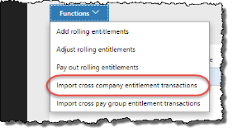



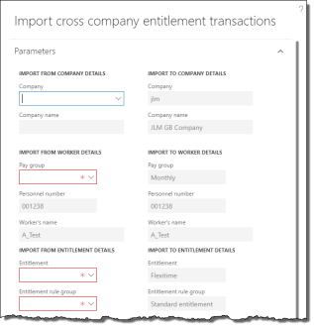

1. Click Functions > Import cross company entitlement transactions to open the Import cross company entitlement transactions pane.
2. On the Import cross company entitlement transactions pane, select the Company to import transactions from (source).
3. Select the Pay group to import from. The entitlement rules for the rolling entitlement must be set up for this pay group in both the source and destination companies.
4. Select the Entitlement rule group and the Entitlement to import.
5. Specify the Entitlement period year and Entitlement period number of the entitlement to import. The Accruing period will automatically populate. All transactions within this period are imported to the destination company for the worker.
6. Click OK to import the entitlement transactions.

When transactions are imported, any payment and earning references on those transactions are automatically removed and the reason code is set to a system-generated reason indicating which company it was imported from.

4.3.9.5 Import Cross-Pay Group Transactions for Rolling Entitlements

When a worker changes pay groups in your organization or if they hold positions in multiple pay groups in the same company, you may need to import their entitlement transactions from one pay group to another, provided that those pay groups use the same rolling entitlement bank. When that worker takes time from their entitlement bank, the transaction should be imported to other pay groups to reflect the worker's current entitlement balance.

To import entitlement transactions from one pay group to another:

1. In the navigation pane, click Common > Anthology Payroll workers to open the Anthology Payroll workers list. Select the worker.
2. On the ribbon, click Anthology Payroll Profile tab > Entitlements to open the Worker entitlements form.
3. On the Worker entitlements form, click Functions > Rolling entitlements to open the Rolling entitlements form.
4. On the Rolling entitlements form, re-enter the Worker Id and Pay group.
5. Enter the As of date (context date) to view the worker's rolling entitlements. The balances of rolling entitlements are affected by this date. Select the worker's rolling entitlement for which to import transactions.

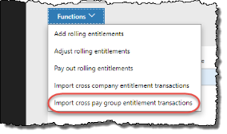



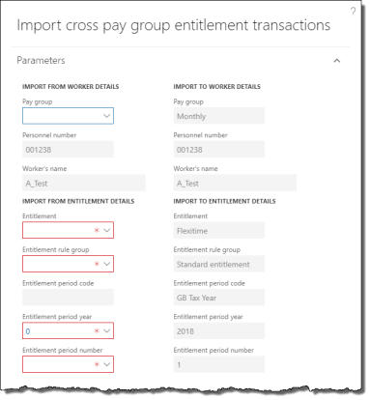

1. Click Functions > Import cross pay group entitlement transactions to open the Import cross pay group entitlement transactions pane.
2. On the Import cross pay group entitlement transactions pane, select the Pay group to import transactions from (source). The entitlement rules for the rolling entitlement must be set up for both the source and destination pay groups.
3. Select the Entitlement rule group and the Entitlement to import.
4. Specify the Entitlement period year and Entitlement period number of the entitlement to import. The Accruing period will automatically populate. All transactions within this period are imported to the destination pay group for the worker.
5. Click OK to import the entitlement transactions.

When transactions are imported, any payment and earning references on those transactions are automatically removed and the reason code is set to a system-generated reason indicating which pay group it was imported from.

5 Process Pay

This section contains procedures on how to process regular pay every pay period. Before starting the regular pay process, ensure that you have:

* Updated all worker data

5.1 Regular Pay Processing Tasks

The regular pay process must be run for each pay group according to the appropriate pay period and each step is intended to be run in succession.

All of the necessary functions and forms for processing pay can be accessed from the ribbon on the Pay Groups list. The Pay Groups list is accessed from the navigation pane:

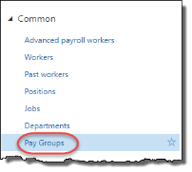

Some dialogue boxes for functions in the pay process contain process counts for transactions in previous pay processes in the same pay period. These counts are a quick snapshot of the status of transactions in the current pay period for the function you are currently running. They are intended to provide more visibility into the status of transactions in the current pay period and allow you to quickly identify if anything has changed in an earlier step of the current pay process that you may not be aware of.

5.1.1 Create Time from Rotation

The create time from rotation procedure generates hours from workers with shifts/rotations. Time generated this way is automatically approved. If you have no hourly workers, you can skip to section 5.1.4.

To create time from rotation:

1. In the navigation pane, click Common > Pay Groups to open the Pay Groups list. Select the pay group in the list.

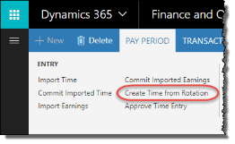



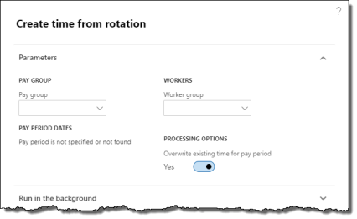

1. On the ribbon, click Pay Period tab > Create Time from Rotation to open the Create time from rotation pane.
2. In the Create time from rotation pane, ensure the Overwrite existing time for pay period option is checked.
3. If required, specify a Worker group to run this process only for a subset of workers in the group for this pay group. This requires worker groups to be configured.
4. Click OK to create time records from rotations.
5. A popup message appears with a summary of the time records created.

5.1.2 Enter Time for a Worker

Sometimes, time must be entered manually for a worker. Use this procedure to enter exception time, such as overtime, vacation, or unpaid leave. Before time can be entered manually, you must first unapprove the time records that conflict with the exception time as those records were automatically generated and generated time is approved by default.

To unapprove time records:

1. In the navigation pane, click Common > Pay Groups to open the Pay Groups list. Select the pay group in the list.

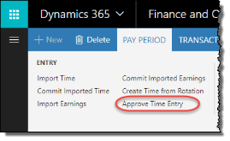



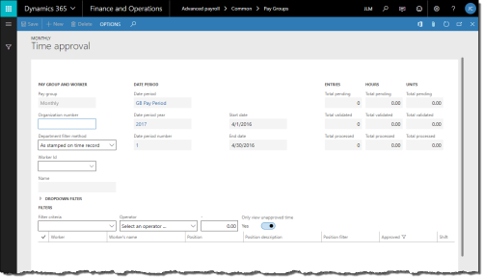

1. On the ribbon, click Pay Period tab > Approve Time Entry to open the Time approval journal.
2. Verify the End date of the date period corresponds to the desired (current) pay period.
3. To view only time records for a specific worker, specify a Worker ID.
4. Uncheck the Only view unapproved time option to view all approved time created from the Create time from rotation procedure.

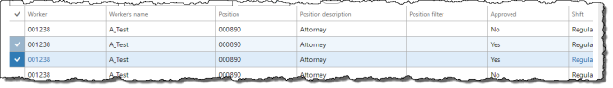

1. In the Details pane, select the time records for the dates that you wish to unapprove. These are the time records for which you will modify to capture exception time. Alternatively, click the checkbox at the top-left corner of the Details pane to select all records if there is a possibility you may modify additional ones.

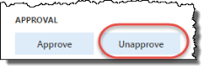

1. Click Unapprove to unapprove the selected time.

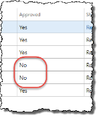

1. In the Details pane, verify that the desired time records display No in the Approved field.
2. Close the journal.

To enter time manually for a worker:

1. On the ribbon, click Transaction tab > Enter Time to open the Worker time journal.

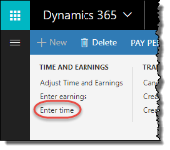



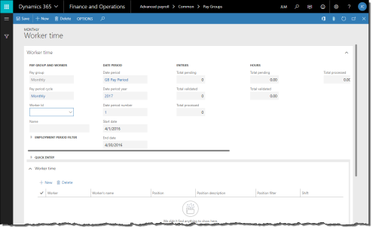

1. To view only time records for a specific worker, specify a Worker ID.
2. To modify a record, select it and modify the following fields as desired:
   * Shift: change the shift that the worker worked
   * Work date: change the date of the hours worked
   * Start time: change the time of day when the shift started
   * Work hours: change the number of hours the worker worked

NOTE: Only time records that are not approved can be modified.

1. To create new time records, click New to create a new record. Specify the following fields for new records:
   * Worker
   * Shift
   * Work date
   * Start time
   * Work hours

NOTE: A popup message will warn you when two time records are in conflict.

1. To delete a record, select it and click Delete.
2. Repeat as necessary for additional time records.
3. Click Save to save your changes.

5.1.3 Approve Time

Skip this step if you did not unapprove time or manually enter any time records.

To approve time:

1. In the navigation pane, click Common > Pay Groups to open the Pay Groups list. Select the pay group in the list.
2. On the ribbon, click Pay Period tab > Approve Time Entry to open the Time approval journal.
3. By default, the Time approval journal shows all unapproved time for the current pay period in the Details pane. Verify the time records are accurate.

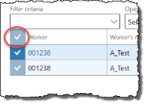

1. By default, all unapproved time is already selected. If required, select all unapproved time records by clicking the checkbox in the top-left corner of the Details pane.

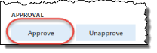

1. Click Approve to approve all selected time records.
2. Close the form.

5.1.4 Create Earnings from Time Records

The Time to earnings process creates the necessary earnings records from approved time records. This process also creates earnings for salaried workers. Earnings records are required to calculate pay.

To create earnings from time records:

1. In the navigation pane, click Common > Pay Groups to open the Pay Groups list. Select the pay group in the list.

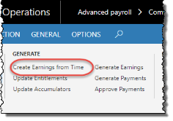



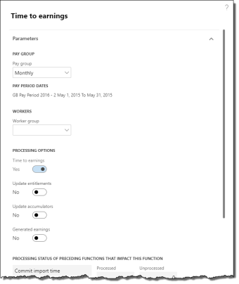

1. On the ribbon, click Pay Period tab > Create Earnings from Time to open the Time to earnings pane.
2. Verify the Pay period dates are accurate.
3. If required, specify a Worker group to run this process only for a subset of workers in the group for this pay group. This requires worker groups to be configured.
4. The Time to earnings option is automatically selected. Do not select any other options.
5. Ensure that there are no unprocessed records in previous pay processes. Click OK to create the earnings records.
6. A popup message appears with a summary of the earnings records created.

5.1.5 Enter Earnings Manually

Some earnings must be entered manually as they are not part of regular earnings. For example, earnings that represent expenses and job allowances must be entered manually for a specific worker on any given pay period.

This step also describes how to review earning records before processing them. Existing earning records can also be modified provided that accumulators have not yet been updated for this pay period (see section 5.1.6).

To enter earnings manually:

1. In the navigation pane, click Common > Pay Groups to open the Pay Groups list. Select the pay group in the list.

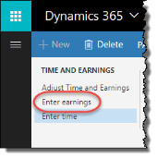



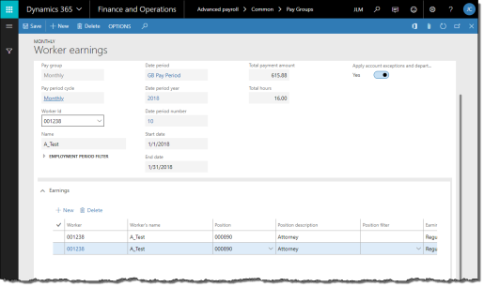

1. On the ribbon, click Transaction tab > Enter Earnings to open the Worker earnings journal.
2. To view only earning records for a specific worker, specify a Worker ID.
3. Change the Rate of pay if the earning is to be paid a different rate for them.
4. See the following sub-procedures according to the type of earning.

5.1.5.1 Enter Expenses

To enter expenses:

1. In the Worker earnings journal, click New to create a new record.
2. Specify the Worker.

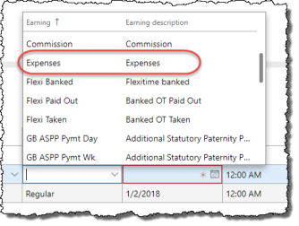

1. Select Expenses in the Earning field.
2. Specify the Earning date, ensuring that it falls within the pay period.
3. Specify the Pay amount of the expense.

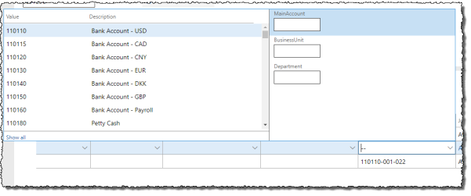

1. Scroll to the right and specify the appropriate Ledger account dimensions for the expense if it does not appear automatically.
2. Repeat as required for additional expenses.
3. Click Save to save your changes.

5.1.6 Update Entitlements, Accumulators, and Generated Earnings

The next step in the payroll process is to update entitlements, accumulators, and generated earnings. After this step is performed, time and earning records can no longer be directly modified—changes to time or earning records must be made in the Time/earning adjustments journal where changes are recorded using effective dating.

To update entitlements, accumulators, and generated earnings:

1. In the navigation pane, click Common > Pay Groups to open the Pay Groups list. Select the pay group in the list.

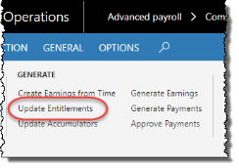

1. On the ribbon, click Pay Period tab > Update Entitlements to open the Entitlement updates pane.
2. Verify the Pay period dates are accurate.

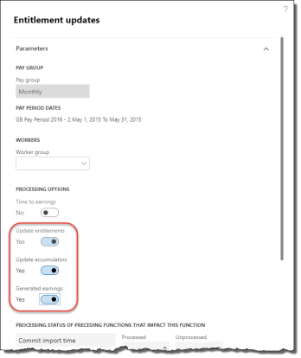

1. The Update entitlements option is automatically selected. Select the Update accumulators and Generated earnings options.
2. If required, specify a Worker group to run this process only for a subset of workers in the group for this pay group. This requires worker groups to be configured.
3. Ensure that there are no unprocessed records in previous pay processes. Click OK to update entitlements, accumulators, and generated earnings.
4. A message popup appears with a summary of the updates.

5.1.7 Check accumulated amounts

If your implementation is configured with the benefit/deductions and generated earnings checks that detect whether workers have been properly assigned the correct benefit/deduction codes and generated earnings enrollments based on their accumulator values in the pay period, you can run this process to perform the validation. This process checks the workers' accumulated amounts against your benefit/deduction and generated earnings setup to ensure that workers have been assigned the proper benefit/deductions and generated earnings they have accumulated amounts for, and returns a warning when this assignment is missing.

This step is optional during the pay process, but your system may be configured to make this checking step mandatory. This process requires that benefit/deductions and generated earnings checks be configured first.

To check accumulated amounts:

1. In the navigation pane, click Common > Pay Groups to open the Pay Groups list. Select the pay group in the list.

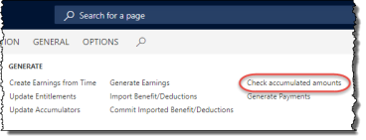



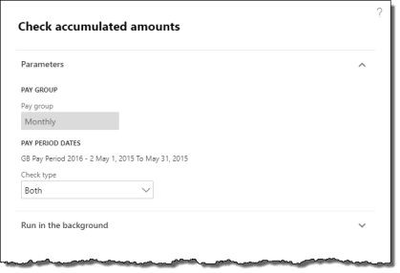

1. On the ribbon, click Pay Period tab > Check accumulated amounts to open the Check accumulated amounts pane.
2. Verify the Pay period dates are accurate.
3. To check only Benefit/deductions or Generated earnings, select the appropriate option in the Check type field. Otherwise, to check both, leave the option as Both.
4. Click OK to check accumulated amounts.

If exceptions were found during the checking process, you must pause the pay process and update worker benefit/deductions and/or generated earnings enrollments (see section 4.3) before proceeding with payment generation. This setup is done on the Worker benefit/deductions and Generated earning enrollments forms.

5.1.8 Generate Payments

The next step is generating payments. Payment generation involves calculating gross earnings, total deductions, and net earnings.

To generate payments:

1. In the navigation pane, click Common > Pay Groups to open the Pay Groups list. Select the pay group in the list.

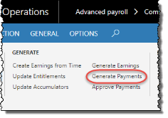



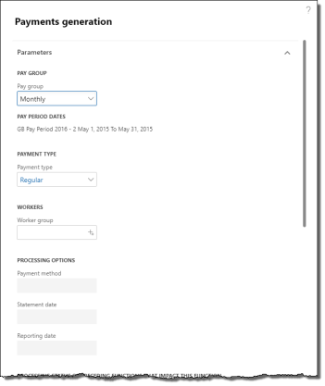

1. On the ribbon, click Pay Period tab > Generate Payments to open the Payments generation pane.
2. Verify the Pay period dates are accurate.
3. If required, specify a Worker group to run this process only for a subset of workers in the group for this pay group. This requires worker groups to be configured.
4. If you set a Worker group, you can change the Payment method, Statement date, and Reporting date as desired. These will override the defaults for this pay group and pay period. The standard validation rules apply for the Statement date and Reporting date.
5. Leave the Payment type as Regular.
6. Ensure that there are no unprocessed records in previous pay processes. Click OK to generate payments.

5.1.9 Print Pay Register

After generating payments, the pay register can be printed and reviewed. The pay register contains the pay details of every payment generated for every worker in the pay group. This step is optional.

To print the pay register:

1. In the navigation pane, click Common > Pay Groups to open the Pay Groups list. Select the pay group in the list.

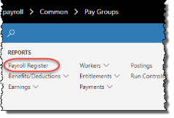



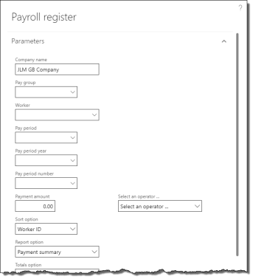

1. On the ribbon, click General tab > Payroll Register to open the Payroll register pane.
2. By default, the current pay period is selected. Change the Pay period year and Pay period number to change which pay period to display.
3. Select a Sort option to change how records are ordered in the report.
4. Select an appropriate Report option as desired to display totals and summary information on the report.
5. Select a Totals option to include or exclude displaying zero-value payments in the report.
6. Click OK to view the report.

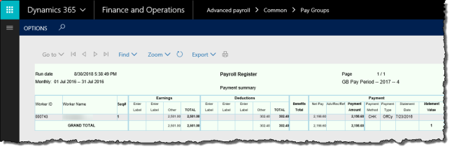

1. In the report window, you can choose to print or export the report to another format (MS Word or Excel, for example).
2. Review the pay register and verify the accuracy of the payments and deductions. Totals by pay element are on the final pages.
3. Close the report window.

5.1.10 Approve Payments

When the payments are accurate, the following payment approval processes can be completed:

* create bank information, such as direct deposit EFT files
* prepare pay statements and generate payment print history
* produce worker cheque and direct deposit pay statement reports for the pay group
* produce individual cheque and direct deposit pay statements for specific workers (optional)

5.1.10.1 Create Bank Information

This payment approval process creates the EFT file for direct deposit payments. The EFT file can be submitted to your company's financial institution as a separate process.

To produce payments for individual workers, see section 5.1.10.4.

This function cannot be run as a batch process.

To create bank information:

1. In the navigation pane, click Common > Pay Groups to open the Pay Groups list. Select the pay group in the list.

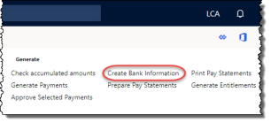



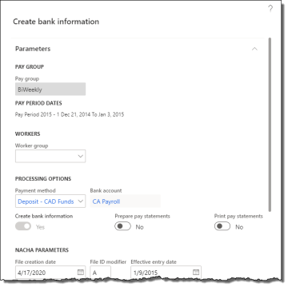

1. On the ribbon, click Pay Period tab > Create Bank Information to open the Create bank information pane.
2. If required, specify a Worker group to run this process only for a subset of workers in the group for this pay group. This requires worker groups to be configured.
3. Specify the Payment method. The payment method must be a direct deposit method.
4. To run subsequent payment approval processes after creating the bank file, select the Prepare pay statements and Print pay statements functions as desired. These are optional and can be run separately.
5. Click OK to produce the bank file.

To download the direct deposit export file to your local computer, see section 5.1.11.

5.1.10.2 Prepare Pay Statements

This payment approval process populates the payment print history for each worker in the pay group and prepares their pay statements for printing.

To produce payments for individual workers, see section 5.1.10.4.

This function can be run as a batch process for off-loaded processing and improved performance.

To prepare pay statements:

1. In the navigation pane, click Common > Pay Groups to open the Pay Groups list. Select the pay group in the list.

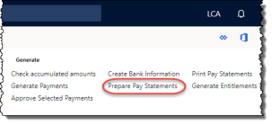



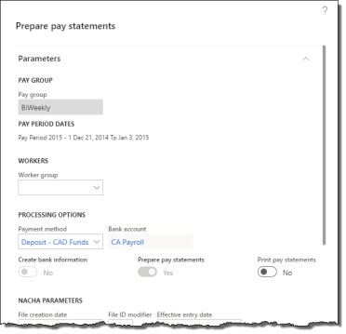

1. On the ribbon, click Pay Period tab > Prepare Pay Statements to open the Prepare pay statements pane.
2. If required, specify a Worker group to run this process only for a subset of workers in the group for this pay group. This requires worker groups to be configured.
3. Specify the Payment method.
4. To run subsequent payment approval processes after preparing pay statements, select the Print pay statements functions as desired. This is optional and can be run separately.
5. Click OK to prepare the necessary back-end data for the pay group's payments for the pay period.

5.1.10.3 Print Payments for a Pay Group

Payments can only be printed after they have been prepared. Payments can be printed for an entire pay group at once, or individually.

To produce payments for individual workers, see section 5.1.10.4.

This function cannot be run as a batch process.

To print cheque or direct deposit payments:

1. In the navigation pane, click Common > Pay Groups to open the Pay Groups list. Select the pay group in the list.

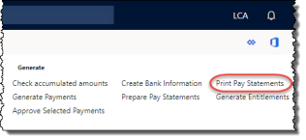



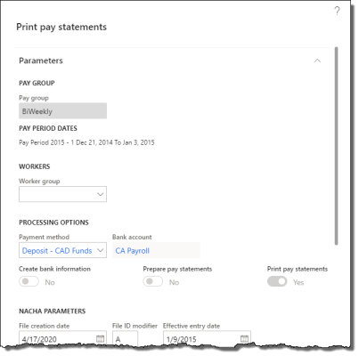

1. On the ribbon, click Pay Period tab > Print Pay Statements to open the Print pay statements pane.
2. If required, specify a Worker group to run this process only for a subset of workers in the group for this pay group. This requires worker groups to be configured.
3. Specify the Payment method.
4. Click OK to print the pay statements. If you selected a cheque-based payment method, the Cheque print pane appears. If you selected a direct deposit-based payment method, the Direct deposit print pane appears.
5. Verify the Bank account and click OK to print the pay statements to your desired format according to your printer settings.

5.1.10.4 Approve Selected Payments

Anthology Payroll provides a journal for approving individual payments and producing the associated EFT files or cheques and pay statements. This journal can also be used to reprint and retransmit cheque and direct deposit pay statements respectively.

If you have already created the bank file and printed payments for the entire pay group, you do not need to approve payments individually and can skip this procedure.

To approve individual payments for specific workers:

1. In the navigation pane, click Common > Pay Groups to open the Pay Groups list. Select the pay group in the list.

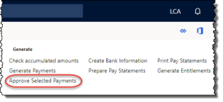



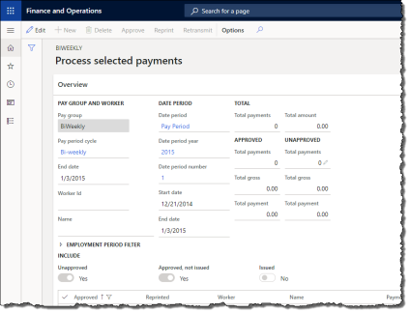

1. On the ribbon, click Pay Period tab > Approve Selected Payments to open the Process selected payments journal.
2. Select records to approve and process, as desired. All selected records must be of the same payment method (cheque or direct deposit). If you selected cheque-based payments, the Cheque print pane appears. If you selected direct deposit-based payments, the Direct deposit print pane appears.
3. Verify the Bank account and click OK to approve the payments. Cheque-based payments can be printed from a print dialogue. Direct deposit-based payments produce an EFT bank file and the pay statements can be printed from a print dialogue.
4. If your implementation is set up to email direct deposit PDF files, this procedure creates the files and distributes them according to your setup. You may still be prompted to print pay statements in the event that workers do not have email addresses set up or any email addresses are incorrect.

To download the direct deposit export file to your local computer, see section 5.1.11.

5.1.11 Download Files to Local Network

Export files (XML, CSV, etc.) that are produced by Anthology Payroll are typically stored on the server in a pre-configured location. In Dynamics 365, the server may be located on the cloud and not easily accessible. Instead, you can download the export files through the browser to your local environment and process them further.

To download export files to your local computer:

1. In the navigation pane, click Periodic > Download files to local network to open the Download files to local network form.

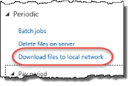



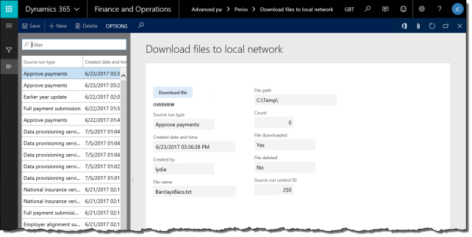

1. In the list, locate and select the direct deposit file you just created.
2. Click Download file to download the file to your local computer through the browser. File or export this file according to your implementation's requirements.

5.1.12 Generate Entitlements

After payments are approved, you can increment and update entitlements in preparation of the next pay period.

To generate entitlements:

1. In the navigation pane, click Common > Pay Groups to open the Pay Groups list. Select the pay group in the list.

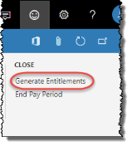



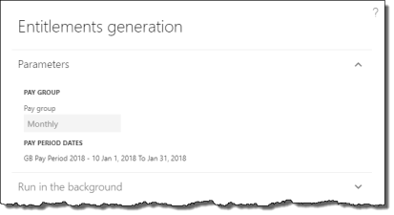

1. On the ribbon, click Pay Period tab > Generate Entitlements to open the Entitlements generation pane.
2. Click OK to generate entitlements.
3. A popup message appears with a summary of the entitlements generated.

5.1.13 Post Payments, Liability, Benefits, and AP Invoice

When one or more payments have been approved in the current pay period, you must post the payment and benefits information to the General ledger and the benefits information to Accounts payable before you are able to close the pay period. Additionally, if your entitlements are set up to generate liabilities, they must also be posted to the General ledger. Transactions do not appear in the general ledger or accounts payable until they are approved.

To post payments, liability, benefits, and AP invoice:

1. In the navigation pane, click Common > Pay Groups to open the Pay Groups list. Select the pay group in the list.

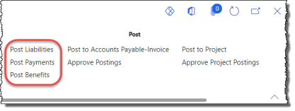



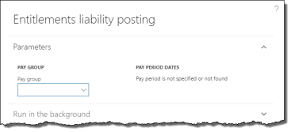

1. On the ribbon, click Pay Period tab > Post Liabilities to open the Entitlements liability posting pane.
2. Select the additional posting processes as desired to run them all in sequential order. Select Payments posting, Benefits posting, AP invoice posting, and Project posting as needed.
3. Ensure that there are no unprocessed records in previous pay processes. Click OK to prepare transaction postings for the General Ledger and Accounts Payable. A popup message appears with a summary of the postings.

5.1.14 Approve Postings

Postings must be approved before they appear in the General ledger and Accounts payable modules.

To modify transaction postings before approving them, see section 5.2.10.

To approve postings:

1. In the navigation pane, click Common > Pay Groups to open the Pay Groups list. Select the pay group in the list.

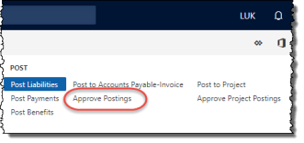



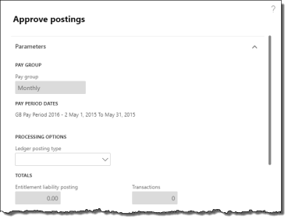

1. On the ribbon, click Pay Period tab > Approve Postings to open the Approve postings pane.
2. Specify the Ledger posting type to indicate which transactions to post. To post all types, leave this field blank. Review the Totals and verify they are accurate.
3. Ensure that there are no unprocessed records in previous pay processes. Click OK to approve the postings.
4. Repeat as required for other Ledger posting types.

Pay processing is now complete. If you have implemented the Project management and accounting module, you may proceed to approving project postings.

5.1.15 Post to Project

If your implementation is configured with project integration, earning transactions should be posted to the Project management and accounting module. First, project posting transactions must be generated and then approved to be transmitted to the other module. Project postings require a separate approval process.

If you have already completed this function as part of other transaction postings generated previously, you can skip this procedure.

To post transactions to project journals:

1. In the navigation pane, click Common > Pay Groups to open the Pay Groups list. Select the pay group in the list.

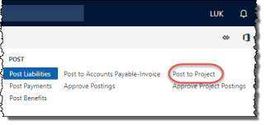



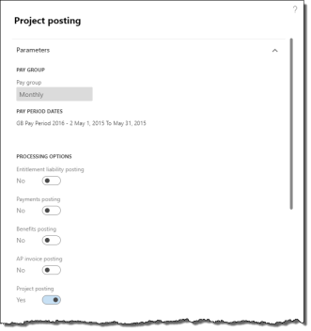

1. On the ribbon, click Pay Period tab > Post to Project to open the Project posting pane.
2. Click OK to post earning transactions to projects. A popup message appears with a summary of the postings.

All hours-based earnings are posted to the hours journal. All unit-based and amount-based earnings are posted to the expenses journal.

Any invalid information in worker earnings or deductions logs an exception during this process. An exception does not prevent the project posting transaction from being created, but it must be corrected before it can be approved by the following procedure. Corrections to project postings may be done in the Project postings journal.

5.1.16 Approve Project Postings

After generating project posting transactions, they must be approved before they are posted to the Project management and accounting module. Any exceptions generated during the previous process can be corrected before approval. If you have not yet generated project posting transactions, see the final step in section 5.1.13.

To modify project posting transactions before approving them, see section 5.2.11.

To approve project postings and create associated vouchers and journals:

1. In the navigation pane, click Common > Pay Groups to open the Pay Groups list. Select the pay group in the list.

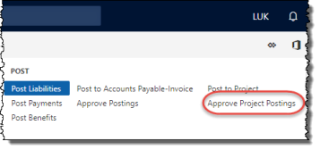



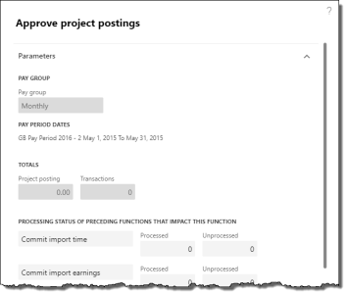

1. On the ribbon, click Pay Period tab > Approve project postings to open the Approve project postings pane.
2. Review the Totals and verify they are accurate.
3. Ensure that there are no unprocessed records in previous pay processes. Click OK to post all the project transactions for the specified period to the Project management and accounting module, creating the necessary vouchers and journals. A popup message appears with a summary of the postings.

5.1.17 Close Pay Period

As the final step in the pay process, you must close the current pay period and start the next.

1. In the navigation pane, click Common > Pay Groups to open the Pay Groups list. Select the pay group in the list.

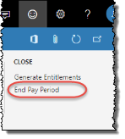



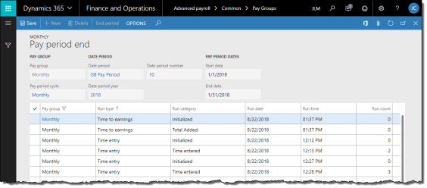

1. On the ribbon, click Pay Period tab > End Pay Period to open the Pay period end journal. If the pay period is not yet ready to be closed, a number of exceptions may be logged and displayed.
2. The form shows a summary of the tasks taken during this pay period. The tasks can be reviewed as desired. If the End period button is greyed out, there are still outstanding tasks that must be completed before the pay period can be closed.
3. Click End period to close the current pay period and start the next one.

5.2 Occasional Pay Processing Tasks

This section describes pay processing tasks that are occasionally performed outside of the regular pay period processing.

5.2.1 Issue a Manual (Off-Cycle) Payment

In certain cases, a manual payment must be issued to a worker outside of a normal pay process. Usually, these payments involve non-standard payments like bonuses, refunds or corrections. They can also be used to issue regular pay early to a terminated worker. Manual payments can only be issued to one worker at a time.

Before issuing a manual payment, any exception time or earning records must be entered manually for the worker in question. For exception time, see section 5.1.2. For exception earnings, see section 5.1.5.

To issue a manual payment:

1. In the navigation pane, click Common > Pay Groups to open the Pay Groups list. Select the pay group to which the worker belongs.

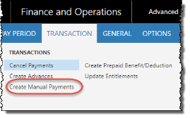



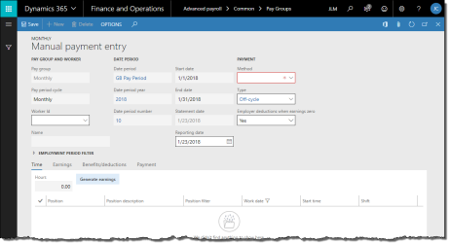

1. On the ribbon, click Transaction tab > Create Manual Payments to open the Manual payment entry journal.
2. Specify the Worker ID.
3. Change the Reporting date if this payment is to be reported in a different pay period.
4. Change the payment Method and Type as required. The Type indicates which earnings and benefit/deductions are processed by the payment (i.e.: Off cycle).
5. If TimeLogiq scheduling is implemented, you can click the Import time from TimeLogiq button to bring time in from TimeLogiq. This populates the Time tab with the worker's time records recorded in the TimeLogiq scheduling module.
6. For hourly workers, review the time records displayed in the Time tab.

NOTE: If any of the time records are incorrect, you must correct them in the Worker time journal (section 5.1.2) or the Time/earning adjustments journal (section 5.2.3)

1. Click Generate earnings to create earning records.

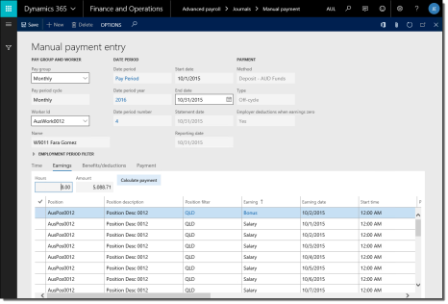

1. Review the earnings records on the Earnings tab.

NOTE: If any of the earning records are incorrect, you must correct them in the Worker earnings journal (section 5.1.5) or the Time/earning adjustments journal (section 5.2.3).

1. On the Earnings tab, click Calculate payment to apply benefits and deductions to the earnings and produce a payment.

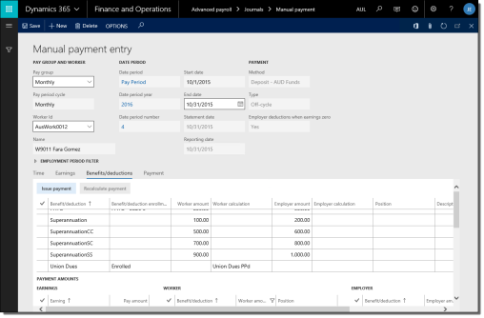

1. Review the benefit/deductions on the Benefits/deductions tab. You can override benefit/deductions for this payment by modifying existing records, deleting, or adding new records. If you changed or added any benefit/deductions, you must click Recalculate payment to refresh the results.
2. Click Issue payment to create the manual payment.

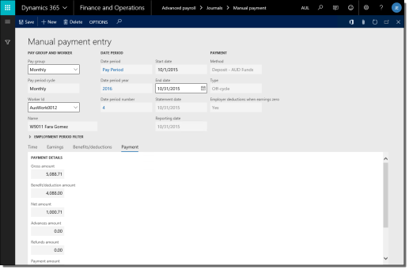

1. Review the gross-to-net results on the Payment tab.

After the manual payment has been issued, it must be approved to generate a pay statement/cheque/direct deposit file. You can approve it immediately (section 5.1.10) or wait until the next pay period process.

5.2.2 Import Time and Shift Information

Depending on how your implementation is configured, you may need to import time transactions from a time and attendance system to Anthology Payroll for the purposes of processing pay. Anthology Payroll accepts imports in comma-separated values (CSV) format. The first line in the CSV should contain column headers. At minimum, the import file must contain: worker identification (e.g.: Worker ID), date information, number of hours worked or units produced, and a shift code.

NOTE: ensure that the last line in your import file is an empty row or the last record may not import correctly.

Please refer to 9.5 Appendix E: List of Time Import File Fields for a reference of the columns required in the import file. For more information on importing time, refer to the Import Time into Anthology Payroll whitepaper provided by Anthology Inc.

If you have implemented TimeLogiq scheduling alongside Anthology Payroll, this function is also how you bring in time records from TimeLogiq for pay processing in Anthology Payroll.

To import time transactions from a CSV file:

1. Generate a spreadsheet containing the time transactions according to the required format and save it as a CSV file to the local disk.
2. In the navigation pane, click Common > Pay Groups to open the Pay Groups list. Select the pay group in the list.

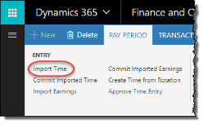



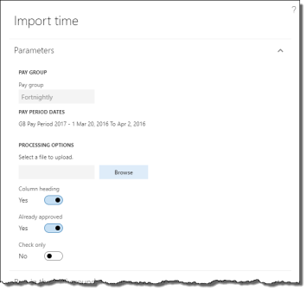

1. On the ribbon, click Pay Period tab > Import Time to open the Import time pane.
2. If TimeLogiq (formerly StaffRight) scheduling is implemented, deselect the Use TimeLogiq option that is checked by default.
3. Browse for the file and select the time spreadsheet.
4. Deselect Already approved if you want to manually approve the time transactions in a separate process after the import.
5. Click Check only if you only want to verify that the import file is valid and do not want to import the time records.
6. Click OK to import the time transactions.

|  |
| --- |
| To import time transactions from TimeLogiq scheduling:   1. In the navigation pane, click Common > Pay Groups to open the Pay Groups list. Select the pay group in the list. 2. On the ribbon, click Pay Period tab > Import Time to open the Import timepane. 3. Check the Use TimeLogiq option to import time records from TimeLogiq. 4. Specify an Import option of the type of time transactions to import from TimeLogiq. 5. If desired, specify a Worker to import time for an individual worker from TimeLogiq. 6. If desired, specify a Worker group to import time for a specific group of workers from TimeLogiq. This requires worker groups to be configured. 7. Click OK to import the time transactions. |

After importing time, you must commit them to Anthology Payroll. The commit process also gives you a chance to change or remove records if they were imported in error. To commit imported time:

1. In the navigation pane, click Common > Pay Groups to open the Pay Groups list. Select the pay group in the list.

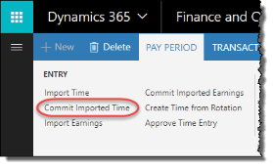



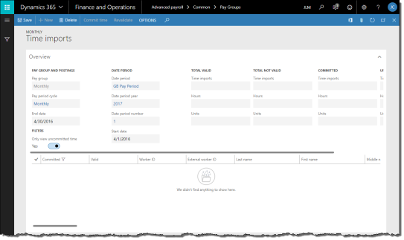

1. On the ribbon, click Pay Period tab > Commit Imported Time to open the Time imports journal.
2. By default, all uncommitted time transactions are selected. Review the imported time records as desired and deselect the time that you do not want committed. Make any necessary edits to individual time records. You may even delete any records that you do not want to keep. Click Revalidate to save your changes.

NOTE: records imported by the Anthology Payroll API (application programming interface) cannot be deleted in this journal.

1. Click Commit time to save the imported time to Anthology Payroll. Close the form.

After committing the time transactions, you can view them or modify them as desired. The procedure to do this is described in section 5.1.2. After making any necessary modifications, imported time can be processed just like time generated from rotations. Proceed with the normal pay process or issue a manual payment for affected workers (section 5.2.1).

5.2.3 Adjust Time or Earnings after Pay is Processed

When an adjustment (re: correction) must be made to time or earnings after accumulators have been updated (section 5.1.6) or the pay period has closed (section 5.1.17), you must use the Time/earnings adjustments form to properly track the change.

To adjust time or earnings after pay has been processed:

1. In the navigation pane, click Common > Anthology Payroll workers to open the Anthology Payroll workers list. Select the worker in the list.

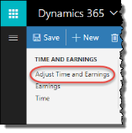



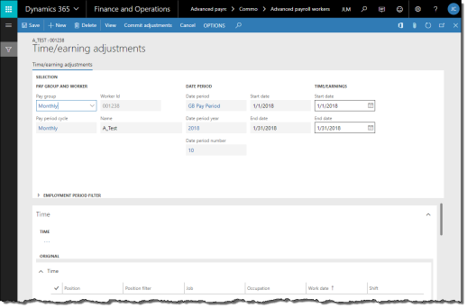

1. On the ribbon, click Anthology Payroll Transactions tab > Adjust Time and Earnings to open the Time/earning adjustments journal.

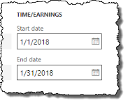

1. In the Time/Earnings section, specify a date range of the pay period in which the correction must be made.
2. If the worker has time records:
   1. On the Time tab, click View to view the worker's time for that pay period.

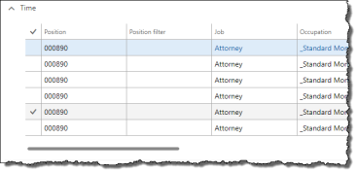

* 1. Identify any time records that must be corrected. Change the appropriate fields. The affected fields may be any of the following:
     + Work date
     + Shift
     + Start time
     + Work hours
  2. Alternatively, you can click New to create a new record and update the above fields.
  3. When changes are made to time records, the changes to records appear in the Adjusted pane.

1. If the worker has earning records:
   1. On the Earnings tab, click View to view the worker's earnings for that pay period.

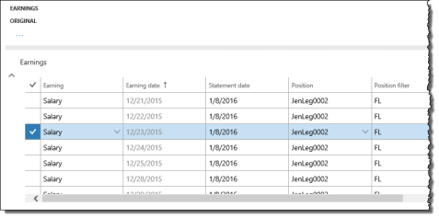

* 1. Identify any earnings that must be corrected. Change the appropriate fields. The affected fields may be any of the following:
     + Earning
     + Earning date
     + Hours
     + Rate of pay
     + Pay amount
  2. Alternatively, you can click New to create a new record and update the above fields.
  3. When changes are made to earning records, the changes to records appear in the Adjusted pane.

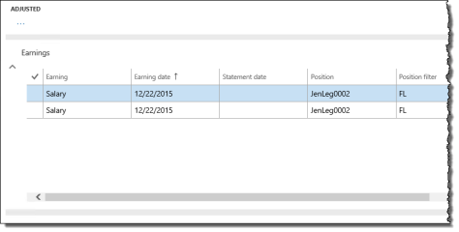

1. Verify that the appropriate records are changed in the Adjusted pane of the form.
2. If necessary, click Cancel to clear the form and start over. When complete, click Commit adjustments to save your changes. Close the form.

5.2.4 Import and Process Bonus Earnings

Bonus earnings can be imported into Anthology Payroll through a comma-separated values (CSV) file and then processed separately from regular pay. The first line in the CSV should contain column headers. At minimum, the import file must contain: worker identification (e.g.: Worker ID), date information, earning amount, and earning code.

Please refer to 9.4 Appendix D: List of Earnings Import File Fields for a reference of the columns required in the import file. For more information on importing earnings, refer to the Import Earnings into Anthology Payroll whitepaper provided by Anthology Inc.

It is recommended to process bonuses after a regular pay run. Taxes on bonus earnings typically depend on the worker's pay period salary to derive the annual salary amount.

To import bonus earnings from a CSV file:

1. Generate a spreadsheet containing the bonus earnings according to the required format and save it as a CSV file to the local disk.
2. In the navigation pane, click Common > Pay Groups to open the Pay Groups list. Select the pay group in the list.

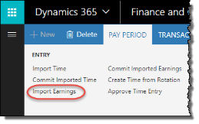



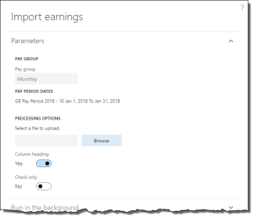

1. On the ribbon, click Pay Period tab > Import Earnings to open the Import earnings pane.
2. Browse for the file and select the bonus earnings spreadsheet.
3. Click Check only if you only want to verify that the import file is valid and do not want to import the earnings records.
4. Click OK to import the bonus earnings.

After importing the earnings, you must commit them to Anthology Payroll. The commit process also gives you a chance to change or remove earnings if they were imported in error. To commit imported earnings:

1. In the navigation pane, click Common > Pay Groups to open the Pay Groups list. Select the pay group in the list.

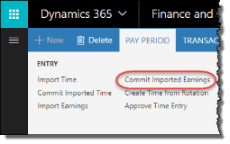



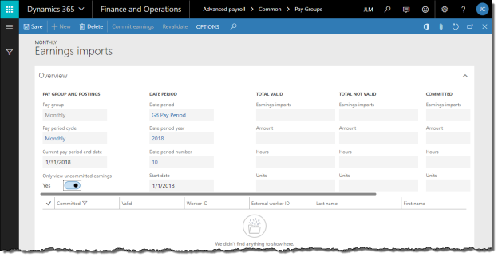

1. On the ribbon, click Pay Period tab > Commit Imported Earnings to open the Earnings imports journal.
2. By default, all uncommitted earnings are selected. Review the imported earning records as desired and deselect the earnings that you do not want committed. Make any necessary edits to individual earning records. You may even delete any records you do not want to keep. Click Revalidate to save your changes.

NOTE: records imported by the Anthology Payroll API (application programming interface) cannot be deleted in this journal.

1. Click Commit earnings to save the imported earnings to Anthology Payroll. Close the journal.

After committing the earnings, you can view them or modify them as desired. The procedure to do this is described in section 5.1.5. Imported earnings can be processed just like regular pay period earnings.

To process bonus earnings:

1. Update accumulators and entitlements (section 5.1.6).

NOTE: Do not update generated earnings unless the regular pay process has completed. This may cause generated earnings to generate twice if the bonus earnings are processed before regular pay.

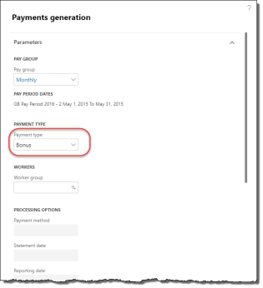

1. Generate payments (section 5.1.8) and select a Payment type of Bonus.
2. If required, specify a Worker group to run this process only for a subset of workers in the group for this pay group. This requires worker groups to be configured.
3. If you set a Worker group, you can change the Payment method, Statement date, and Reporting date as desired. These will override the defaults for this pay group and pay period. The standard validation rules apply for the Statement date and Reporting date.
4. Continue with the rest of the payroll process from section 5.1.8 onwards to print cheques, submit direct deposits and post transactions to other AX modules.

5.2.5 Correct Direct Deposit Errors

Occasionally, a worker may inadvertently provide incorrect direct deposit information and this is not discovered until payments are generated or the electronic funds transfer (EFT) file is submitted to the financial institution and an error report is returned. To resolve this, you must cancel the original payment, correct the bank account information and create a manual payment and approve it, and obtain and submit the new EFT file. If the error is discovered before the EFT has been submitted to the financial institution, there is no need to issue a manual payment.

To correct direct deposit errors:

1. In the navigation pane, click Common > Pay Groups to open the Pay Groups list. Select the pay group in the list.

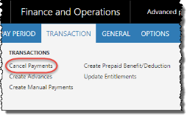

1. On the ribbon, click Transaction tab > Cancel Payments to open the Cancel payments journal.

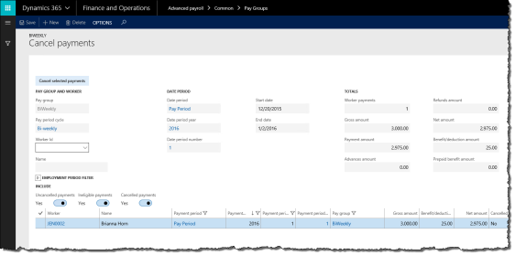

1. On the Cancel payments journal, specify the Worker ID of the worker in question.
2. If desired, filter the list of payments by Uncancelled payments, Ineligible payments, or Cancelled payments.
3. Select the worker's payment and click Cancel selected payments to revert payment. A popup message appears with a summary of the cancelled payment.
4. See section 4.3.1 for the procedure on modifying the worker's direct deposit information.
5. See section 5.2.1 for the procedure on issuing a manual payment.
6. See section 5.1.10.4 for the procedure on approving payments and submitting the EFT file.

5.2.6 Import and Commit Benefit/Deduction Amounts

Benefit and deduction amounts can be imported from a CSV. If there are numerous miscellaneous benefit/deductions to be entered, importing them may save time and work. Refer to 9.6 Appendix F: List of Benefit/deduction Amounts Import Fields for a reference of the columns required in the import file.

If benefit/deductions are being imported, they must be done before generating payments (section 5.1.8) as these imported amounts may impact taxes in the current period.

Imported benefit/deductions are imported as one-time deductions and appear in the Worker benefit/deduction schedules form for each associated worker.

To import benefit/deduction amounts:

1. Generate a spreadsheet containing the benefit/deduction amounts according to the required format and save it as a CSV file to the local disk.
2. In the navigation pane, click Common > Pay Groups to open the Pay Groups list. Select the pay group in the list.

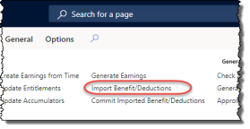



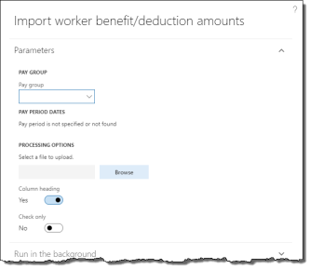

1. On the ribbon, click Pay Period tab > Import Benefit/Deductions to open the Import worker benefit/deduction amounts pane.
2. Browse for the file and select the benefit/deduction amounts spreadsheet.
3. Click Check only if you only want to verify that the import file is valid and do not want to import records.
4. Click OK to import the benefit/deduction amounts.

After importing the benefit/deduction amounts, you must commit them to Anthology Payroll. The commit process also gives you a chance to change or remove amounts if they were imported in error. To commit imported benefit/deductions:

1. In the navigation pane, click Common > Pay Groups to open the Pay Groups list. Select the pay group in the list.

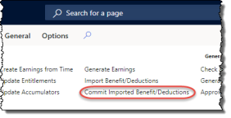



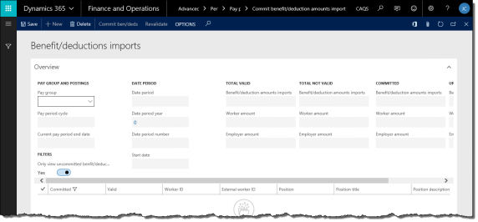

1. On the ribbon, click Pay Period tab > Commit Imported Benefit/Deductions to open the Benefit/deductions imports journal.
2. By default, all uncommitted benefit/deduction amounts are selected. Review the imported benefit/deduction amount records as desired and deselect the ones that you do not want committed. Make any necessary edits to individual amount records. You may even delete any records you do not want to keep. Click Revalidate to save your changes.

NOTE: records imported by the Anthology Payroll API (application programming interface) cannot be deleted in this journal.

1. Click Commit ben/deds to save the imported benefit/deduction amounts to Anthology Payroll. Expand the form window if necessary to see the button. Close the journal.
2. Proceed with payment generation and other regular pay period processing tasks (section 5.1.8).

5.2.7 Revise Past Payments

Anthology Payroll provides a function for recalculating a past payment due to retroactive benefit or deduction changes, such as benefit/deduction setup corrections.

Revised payments do not alter any existing payments and do not cancel or produce checks or direct deposits, but instead create refund or recovery amounts to be reconciled in the current pay period.

To generate revised payments:

1. In the navigation pane, click Common > Anthology Payroll workers to open the Anthology Payroll workers list. Select the worker in the list.

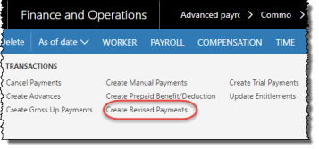



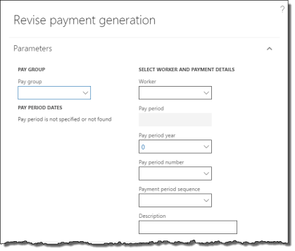

1. On the ribbon, click Anthology Payroll Transactions tab > Create Revised Payments to open the Revise payment generation pane.
2. Specify a Pay group to generate revised payments for.
3. Specify a Worker to generate revised payments for. Leave this field blank to revise payments for the entire Pay group.
4. Specify the Pay period year and Pay period number of the past pay period containing the payment to revise. All payments from that point onward are subsequently recalculated. You can only revise payments for pay periods that are no more than one year in the past from the current pay period.
5. Specify a Payment period sequence of the past payment if the past pay period contained multiple payments.
6. Enter a Description for the revised payment generation for your own tracking purposes.
7. Click OK to generate revised payments.

Payments that are revised contain either refunds to the worker or recovery amounts for the employer. Refunds can be paid out to the worker in the current pay period through the regular pay process (section 5.1.10) or through a manual payment (section 5.2.1). Recovery amounts are recovered as benefit/deductions on the worker's next payment.

5.2.8 Issue Gross-up Payments

Gross-up payments are payments to workers where you can specify the exact net amount they receive after deductions. Anthology Payroll then calculates the gross earnings amount before deductions and gives them to specified workers. You may use this functionality to issue a $1000 bonus to a worker after deductions, for example.

You can issue gross-up payments to one worker at a time or import gross-up payment amounts for multiple workers within a worker group.

5.2.8.1 Import Gross-up Payment Amounts

If you are issuing gross-up payments for multiple workers in the same pay group, these amounts must be imported from an external file. Additionally, a worker group must be set up for the workers you are importing amounts for.

Please refer to 9.8 Appendix H: List of Gross-up Payment Amount Import Fields for the import file specification for gross-up payment amounts.

If you are issuing a gross-up payment to a single worker, see section 5.2.8.3.

To import gross-up payment amounts:

1. In the navigation pane, click Journals > Gross up payments > Import gross up target amounts to open the Import gross up target amounts pane.

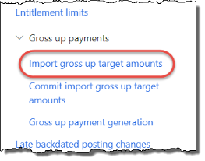



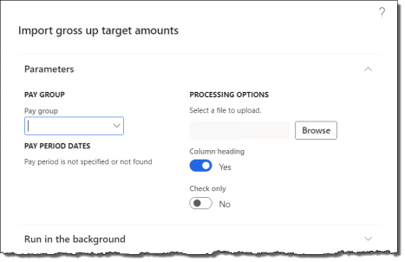

1. Specify the Pay group you are importing for. Verify the Pay period dates for the pay group.
2. Browse and select the import file.
3. Select or deselect any processing options:
   * Column heading: deselect if the first row in the import file is not column headings
   * Check only: select to verify the import file only. No gross up payment amount records are imported.
4. Click OK to import the file. An alert appears with a summary of the import process.

5.2.8.2 Commit Imported Gross-up Payment Amounts

After importing gross-up payment amounts, you must commit them to Anthology Payroll. The commit process also gives you a chance to change or remove records if they were imported in error. To commit imported gross-up payment amounts:

1. In the navigation pane, click Journals > Gross up payments > Commit import gross up target amounts to open the Gross up target amounts imports journal.

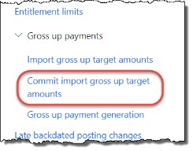



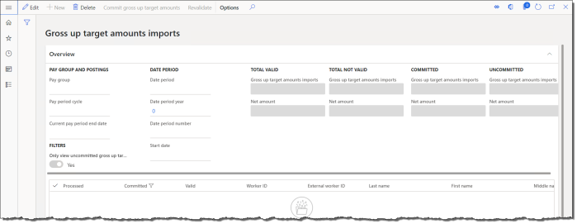

1. Specify the Pay group to display pending imported gross-up payment amounts.
2. By default, all uncommitted payment amounts are selected. Review the imported gross-up payment records as desired and deselect those that you do not want committed. Make any necessary edits to individual records. You may even delete any records you do not want to keep, provided they are not processed yet. Click Revalidate to save your changes.
3. Click Commit gross up target amounts to save the imported gross-up amounts to Anthology Payroll. Close the journal.

5.2.8.3 Issue Gross-up Payments to a Single Worker or a Worker Group

Gross-up payments can be issued to a single worker at a time, or to all workers belonging to a worker group. To issue gross-up payments to a worker group, the group must be configured beforehand and gross-up payment amounts must first be imported (see section 5.2.8.1) and committed (see section 5.2.8.2) for the group. All workers in a worker group must belong to the same pay group.

To issue gross-up payments:

1. In the navigation pane, click Journals > Gross up payments > Gross up payment generation to open the Gross up payment generation pane.

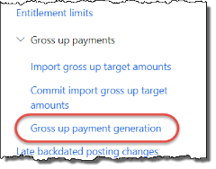



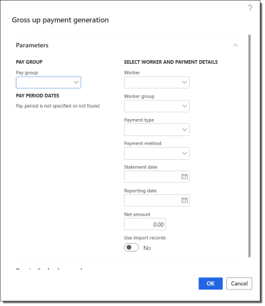

1. Specify the Pay group. Verify the Pay period dates are correct for the current pay period.
2. Specify an individual Worker or a Worker group.
3. Select the Gross Up Payment Payment type.
4. Enter a Reporting date override as desired.
5. If you are issuing a payment to a single worker, enter the Net amount to issue to them. This is the amount the worker is paid after deductions. If you are issuing payments to multiple workers, select the Use import records option.
6. Click OK to generate the gross up payment(s).

After gross-up payments are issued, they must be approved to generate the pay statements. You can approve them individually (see section 5.1.10.4) or wait until the next pay period process.

5.2.9 Process Retroactive Pay

Retroactive pay consists of reconciliatory earnings that can be calculated for workers who have received a pay rate increase that occurs in the past. The earnings for the pay rate increase are calculated retroactively and then paid out in the current pay period.

Processing retroactive pay requires multiple procedures including the following:

* Set up a retroactive run
* Generate retroactive earning records
* Review retroactive earning records

5.2.9.1 Set up a Retroactive Run

A retroactive run calculates the retroactive earnings that the worker is owed (or owing) due to a pay rate change in the past. The calculation is based on existing earning transactions and any earning differences are generated and paid out in the current pay period.

To set up a retroactive run:

1. In the navigation pane, click Setup > Tables > Payroll > Retroactive runs to open the Retroactive runs form.

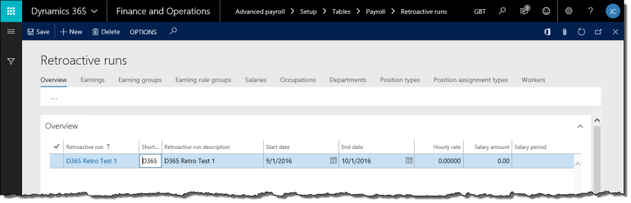

1. On the Overview tab, click New to create a new record.
2. On the General tab, enter a name for the Retroactive run. Enter a Retroactive run description as desired.
3. Enter the Start date and End date of the period for which to calculate retroactive earnings. The date range should include all earning dates to review for potential rate changes. If the date range includes dates with no earnings (such as future dates), retroactive pay is not calculated for those dates.
4. Select the Earning date type, which determines what time is stamped on the retroactive earnings.
5. Select the Salary type for the earnings to be generated.
6. Select Yes for Include accumulator based to include accumulator-based earnings in the retroactive pay calculation.
7. Enter the Minimum amount and Maximum amount of the retroactive earning. If you are decreasing a rate, ensure the minimum is an appropriate negative value.
8. Specify any of the following as needed:
   * Earning: if specified, retroactive earning transactions are generated with this code. Leave blank to generate retroactive earning transactions with the original earning code, or the retroactive earning code configured during implementation
   * Earning date: if specified, all retroactive earnings are stamped with this date. The Earning date type must be set to Use summary date if using this date.
   * Department: if specified, retroactive earning transactions are generated with this department. Leave blank to generate retroactive earning with the original earning's department.
   * Ledger account: if specified, retroactive earning transactions are charged to this account. Leave blank to charge retroactive earning transactions to the original earning's account.
9. Specify one of the following:
   * a new Hourly rate to override earning records that have an hourly rate

NOTE: when using an Hourly rate override, ensure to select the appropriate earning codes in the next step. For example, it is illogical to apply a $25 hourly rate to a $1/hour earning code for evening shift premiums.

* + a Percentage amount to override all types of earning records. Earnings are multiplied by the percentage specified. For example, to specify a 5% increase, enter 105. To specify a 5% decrease, enter 95.
  + no Salary overrides to use only the effective-dated salary changes on worker position records.

1. Determine the filter criteria for this retroactive run. On each tab corresponding to the type of data to filter by, select the items that are applicable to this retroactive run. You can select multiple items from multiple tabs. Selected earnings can be based on:
   * Earning codes
   * Earning groups
   * Earning rule groups
   * Salaries
   * Occupations
   * Departments (Organizations)
   * Position types
   * Position assignment types
   * Workers

NOTE: if no selections are made for a data type, the retroactive run will apply to all entries of that type.

1. Click Save to save your changes.

5.2.9.2 Generate Retroactive Earning Records

To generate retroactive earning records:

1. In the navigation pane, click Periodic > Other > Retroactive earnings > Retroactive earnings generation to open the Retroactive earnings generation pane.

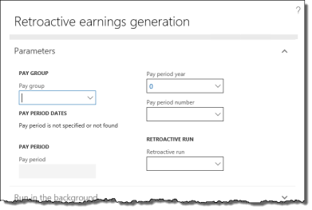

1. Specify the Pay group to generate retroactive earnings for.
2. Verify the Pay period number and Pay period year in which to generate retroactive earnings. The year and number correspond to the current pay period, but you may change it to a future one.
3. Specify the Retroactive run code to execute and click OK to generate the retroactive earnings.

5.2.9.3 Review and Accept Retroactive Earning Records

To review and accept (or delete) retroactive earning records:

1. In the navigation pane, click Periodic > Other > Retroactive earnings > Approve/change retroactive earnings to open the Worker retroactive earnings journal.

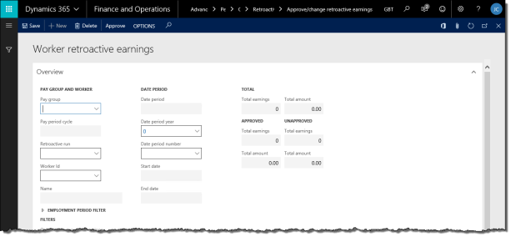

1. Specify a Pay group. All retroactive earning records for this pay group appear in the list. Totals appear at the top.
2. To filter the list on a single retroactive run or a worker, specify the Retroactive run or Worker Id respectively.
3. Select the desired earnings to approve and click Approve to commit them as earning records on the specified Earning date. You may modify fields as required.
4. To delete earnings, select them and click Delete to delete them.
5. Close the form.

After accepting the earning records, they will appear as part of the normal pay process in the current pay period. Proceed with the rest of the normal pay process (section 5.1.6).

5.2.10 Modify Posting Transactions

Posting transactions can be modified prior to approving them to be posted. Previously, this function was part of the pay process, but now it can be performed at any time in the pay period. Posting transactions must still be approved before they are posted to the General ledger and Accounts payable modules (see section 5.1.14).

To modify posting transactions:

1. In the navigation pane, click Common > Pay Groups to open the Pay Groups list. Select the pay group in the list.

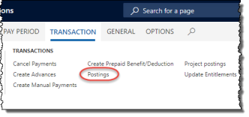



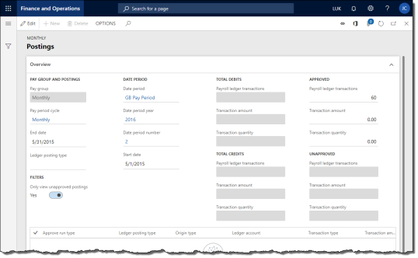

1. On the ribbon, click Transaction tab > Postings to open the Postings journal.
2. To filter the list of posting transactions by type, specify a Ledger posting type.
3. Change the Ledger account for any transactions as needed. Only posting transactions that are not yet approved and posted can be modified.
4. To delete a transaction record, select it in the list and click Delete. A dialogue popup confirms your action.
5. Click Save to save your changes.

5.2.11 Modify Project Posting Transactions

Project posting transactions can be modified prior to approving them to be posted. Previously, this function was part of the pay process, but now it can be performed at any time in the pay period. Project posting transactions must still be approved before they are posted to the Project management and accounting module (see section 5.1.16).

To modify project posting transactions:

1. In the navigation pane, click Common > Pay Groups to open the Pay Groups list. Select the pay group in the list.

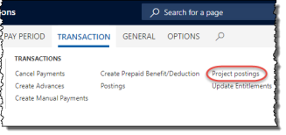



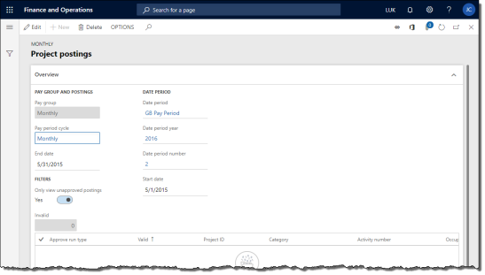

1. On the ribbon, click Transaction tab > Project postings to open the Project postings journal.
2. For any transaction records marked as invalid (Valid field is No), verify the following fields are correct:
   * Project ID
   * Category
   * Activity number

Change these fields accordingly and click Save to save your changes. The journal will attempt to re-validate your changes. Repeat until there are no more invalid records.

1. To delete a transaction record, select it in the list and click Delete. A dialogue popup confirms your action.
2. Click Save to save your changes.

5.2.12 Create Trial Payments

Trial payments are a sandbox functionality where you can create fictional payments to workers using manually entered data or, depending on how far along you are in the pay process of the current pay period, actual transactional data records in Anthology Payroll. You can only create trial payments for one worker at a time and for the current pay period.

You can use trial payments to model "what if" scenarios regarding worker salary changes and your benefit/deduction and accumulator setup.

To create a trial payment:

1. In the navigation pane, click Common > Anthology Payroll workers to open the Anthology Payroll workers list. Select the worker in the list.

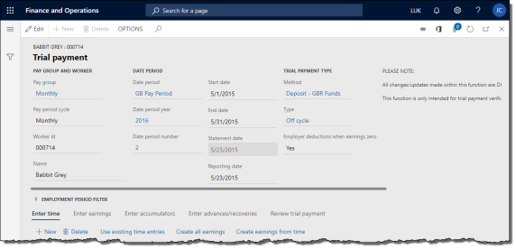

1. On the Anthology Payroll Transactions tab, click Create Trial Payments to open the Trial payment journal.
2. If desired, change the End date to the next pay period if the current has already been processed.
3. Change the payment Method and Type as required. The Type indicates which earnings and benefit/deductions are processed by the payment.
4. On the Enter time tab, you can (entering time is optional):
   * click Use existing time entries to copy existing time records for this worker in this pay period to the journal. This overwrites any current data on the tab.
   * click New to create a new time record
   * change any time records as desired
   * click Create all earnings to generate earning records from the time records on the Enter time tab and add to them any salary earnings from the worker's salary information (if any) and proceed to the Enter earnings tab
   * click Create earnings from time to generate earning records from only the time records on the Enter time tab and proceed to the Enter earnings tab
   * skip entering time altogether and proceed to entering earnings on the Enter earnings tab
5. On the Enter earnings tab, you can:
   * click Use existing earning entries to copy existing earning records for this worker in this pay period to the journal. This overwrites any current data on the tab.
   * click New to create a new earning record
   * change any earning records as desired
   * click Update accumulators to update accumulators with the effects of the earnings on this tab and proceed to the Enter accumulators tab
6. On the Enter accumulators tab, you can:
   * click Use existing accumulator entries to copy existing accumulator values for this worker in this pay period to the journal, if the accumulator update process has been run for this period. This overwrites any current data on the tab.
   * click New to create a new accumulator amount
   * change any accumulator amounts as desired
7. On the Enter advances/recoveries tab, you can (entering advances/recoveries is optional):
   * click Use existing advance entries to copy existing pay advance amounts for this worker in this pay period to the journal. This overwrites any current data on the tab.
   * click Use existing advance recovery entries to copy existing advance recovery amounts for this worker in this pay period to the journal. This overwrites any current data on the tab.
   * click New to create a new advance or recovery amount
   * change any advance or recovery amounts as desired
8. Click Calculate trial payment on either the Enter accumulators or Enter advances/recoveries tab to calculate the benefit/deduction amounts and apply gross-to-net calculations.
9. On the Review trial payment tab, you can:
   * click New to create new benefit/deduction amounts
   * modify any benefit/deduction amounts as desired
   * click Recalculate trial payment button to recalculate gross-to-net after modifying benefit/deduction amounts
   * review the benefit/deductions taken and the worker's net pay
10. Close the form when finished. No data in the Trial payments journal is preserved.

6 Year-End Tasks

This section contains procedures for annual maintenance tasks.

6.1 Create T4s

T4s can be generated when the last pay period of the tax year is closed. T4s are generated from existing payroll data. There are various processes around T4s:

* Create T4 listing report
* Create draft T4 slips
* Create final T4 slips
* View T4 slips summary

6.1.1 Create T4 Listing Report

The T4 listing report shows a summary of worker T4 data for a specified year. The report can be reviewed and printed as desired. Successfully running the listing report is also a good indication that T4s can be properly run.

To create a T4 listing report:

1. In the navigation pane, click Reports > Other > T4 slips listing to open the T4 slips listing pane.

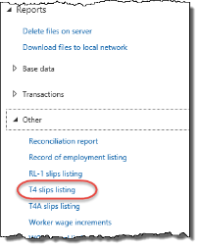



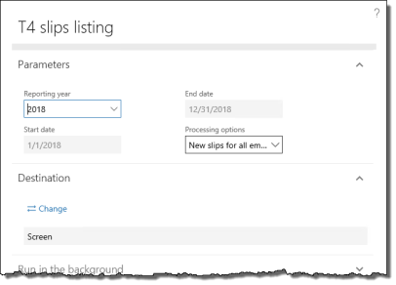

1. Specify the Reporting year.
2. Select which T4s to list in the Processing options field.
3. Click OK to view the report in a new browser window.

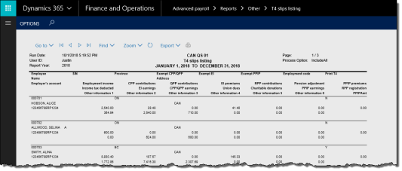

6.1.2 Create Draft T4 Slips

You can create draft T4s to test that T4s can be generated correctly and print them for reference if needed. You can create draft T4 slips and a test T4 XML file for uploading to CRA.

To create draft T4 slips:

1. In the navigation pane, click Periodic > Year end > T4s > T4 slips (draft only) to open the T4 slips (draft only) pane.

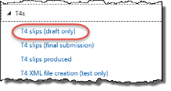



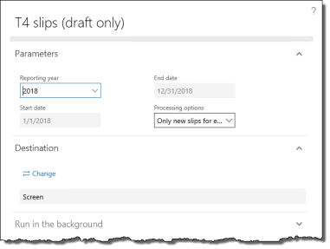

1. Specify the Reporting year.
2. Change the Sort order as desired.
3. Select which T4s to list in the Processing options field.
4. Click OK to view the T4 slips in a new browser window.

To create a test T4 XML file:

1. In the navigation pane, click Periodic > Year end > T4s > T4 XML file creation (test only) to open the T4 XML file creation (test only) pane.

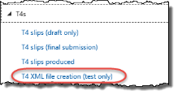



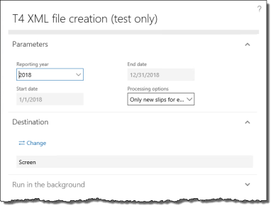

1. Specify the Reporting year.
2. Select which T4s to list in the Processing options field.
3. Click OK to generate a test T4 XML file.

To download the XML file to your local computer, see section 5.1.11.

6.1.3 Create Final T4 Slips

The T4 slips (final submission) process includes creating a printable report containing all T4 slips and the T4 XML file intended for upload to CRA. Note that each time this procedure is executed, a set of XML files is created. If you have run this procedure multiple times in a single tax year, ensure you select the correct set of XML files to submit to CRA.

To create final T4 slips:

1. In the navigation pane, click Periodic > Year end > T4s > T4 slips (final submission) to open the T4 slips (final submission) pane.

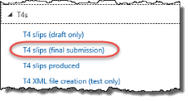



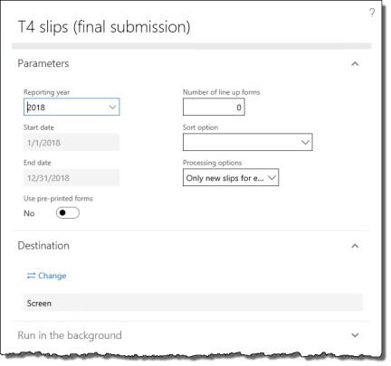

1. Specify the Reporting year.
2. Change the Sort order as desired.
3. Select which T4s to list in the Processing options field.
4. Click OK to view the T4 slips in a new browser window and generate the T4 XML file.
5. Print or export the T4 slips as desired.

To download the XML file to your local computer, see section 5.1.11.

6.1.4 View T4 Slips Summary

The T4 slips summary provides a view of the metadata on worker T4s. From here, you can view the number of slips produced, whether they are draft or final, the date and time they were produced, and much of the contents of each slip according to worker.

To view the T4 slips summary:

1. In the navigation pane, click Periodic > Year end > T4s > T4 slips produced to open the T4 slips produced journal.

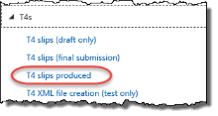



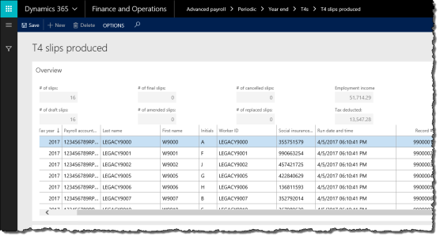

1. On the T4 slips produced journal, view the status of T4 records in the table. Select a record to view further details in the lower pane. Click the tabs to view more information.

6.2 Amending T4s

The T4 submission process to CRA is only intended to be performed once per tax year, but sometimes, errors can be made or late changes may be required. This section covers some procedures for cancelling, amending , and reprinting T4s in a tax year when you have already created T4s for your workers and submitted them to CRA.

6.2.1 Cancel a T4

To file an amended T4, you do not need to cancel the previously submitted one. Only cancel T4s that were filed in error and do not need to be filed.

To cancel a previously submitted T4:

1. In the navigation pane, click Periodic > Year end > T4s > T4 slips produced to open the T4 slips produced journal. Locate the T4 that should be cancelled.
2. Select the record and specify a Change type of Create a cancelled slip.
3. Save and close the journal.
4. In the navigation pane, click Periodic > Year end > T4s > T4 slips (final submission) to open the T4 slips (final submission) pane.
5. Specify the Reporting year.
6. Select Only include new cancellations for existing slips in the Processing options field.
7. Click OK to view the T4 slips in a new browser window and generate the T4 XML file.

To download the XML file to your local computer, see section 5.1.11.

6.2.2 Amend a T4

T4 amendments do not require the previously submitted T4 to be cancelled.

To amend a previously submitted T4:

1. In the navigation pane, click Periodic > Year end > T4s > T4 slips produced to open the T4 slips produced journal. Locate the T4 that should be amended.
2. Select the record and specify a Change type of Create an amended slip.
3. Save and close the journal. Ensure the pay changes required for that worker are complete for the tax year.
4. In the navigation pane, click Periodic > Year end > T4s > T4 slips (final submission) to open the T4 slips (final submission) pane.
5. Specify the Reporting year.
6. Select Only include new amendments for existing slips in the Processing options field.
7. Click OK to view the amended T4 slips in a new browser window and generate the T4 XML file.

To download the XML file to your local computer, see section 5.1.11.

6.2.3 Reprint a T4

If a worker has lost their T4 slip and requires a replacement, you can reprint an existing T4. This procedure does not create an additional XML file for submission, but does display the T4 for reprinting.

To reprint a previously submitted T4:

1. In the navigation pane, click Periodic > Year end > T4s > T4 slips produced to open the T4 slips produced journal. Locate the T4 that should be reprinted.
2. Select the record and specify a Change type of Create a replacement (print only).
3. Save and close the journal.
4. In the navigation pane, click Periodic > Year end > T4s > T4 slips (final submission) to open the T4 slips (final submission) pane.
5. Specify the Reporting year.
6. Select Only include new print replacements for existing slips in the Processing options field.
7. Click OK to view the T4 slips in a new browser window and print them as desired.

6.3 Create T4As

T4As are required when the last pay period of the tax year is closed and you have paid out non-standard income, such as pension, bonuses, annuities, etc. T4As are automatically generated from existing payroll data. There are various processes around T4As:

* Create T4A listing report
* Create draft T4A slips
* Create final T4A slips
* View T4A slips summary

6.3.1 Create T4A Listing Report

The T4A listing report shows a summary of worker T4A data for a specified year. The report can be reviewed and printed as desired. Successfully running the listing report is also a good indication that T4As can be properly run.

To create a T4A listing report:

1. In the navigation pane, click Reports > Other > T4A slips listing to open the T4A slips listing pane.

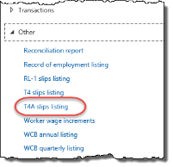



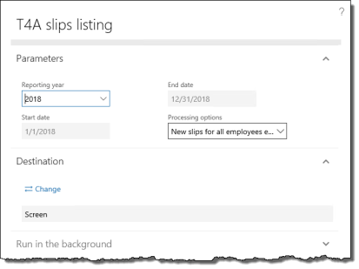

1. Specify the Reporting year.
2. Select which T4As to list in the Processing options field.
3. Click OK to view the report in a new browser window.

6.3.2 Create Draft T4A Slips

You can create draft T4As to test that T4As can be generated correctly and print them for reference if needed. You can create draft T4A slips and a test T4A XML file for uploading to CRA.

To create draft T4A slips:

1. In the navigation pane, click Periodic > Year end > T4As > T4A slips (draft only) to open the T4A slips (draft only) pane.

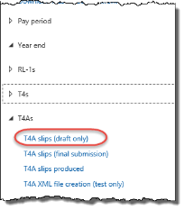



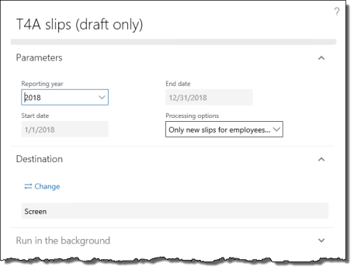

1. Specify the Reporting year.
2. Change the Sort order as desired.
3. Select which T4As to list in the Processing options field.
4. Click OK to view the T4A slips in a new browser window.

To create a test T4A XML file:

1. In the navigation pane, click Periodic > Year end > T4As > T4A XML file creation (test only) to open the T4A XML file creation (test only) pane.

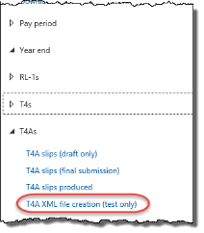



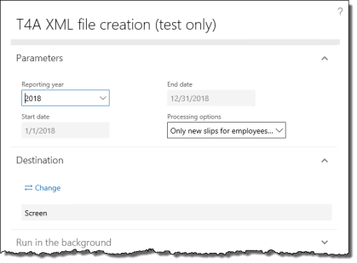

1. Specify the Reporting year.
2. Select which T4As to list in the Processing options field.
3. Click OK to generate a test T4A XML file.

To download the XML file to your local computer, see section 5.1.11.

6.3.3 Create Final T4A Slips

The T4A slips (final submission) process includes creating a printable report containing all T4A slips and the T4A XML file intended for upload to CRA.

To create final T4A slips:

1. In the navigation pane, click Periodic > Year end > T4As > T4A slips (final submission) to open the T4A slips (final submission) pane.

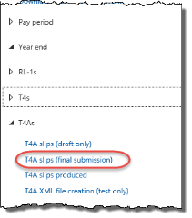



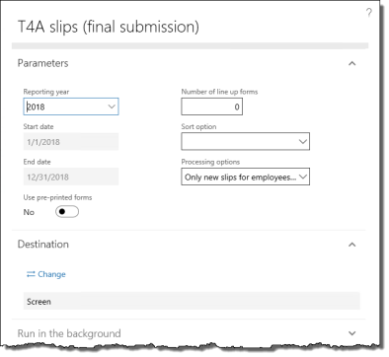

1. Specify the Reporting year.
2. Change the Sort order as desired.
3. Select which T4As to list in the Processing options field.
4. Click OK to view the T4A slips in a new browser window and generate the T4A XML file.
5. Print or export the T4A slips as desired.

To download the XML file to your local computer, see section 5.1.11.

6.3.4 View T4A Slips Summary

The T4A slips summary provides a view of the metadata on worker T4As. From here, you can view the number of slips produced, whether they are draft or final, the date and time they were produced, and much of the contents of each slip according to worker.

To view the T4A slips summary:

1. In the navigation pane, click Periodic > Year end > T4As > T4A slips produced to open the T4A slips produced journal.

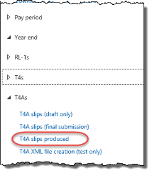

1. On the T4A slips produced journal, view the status of T4A records in the table. Select a record to view further details in the lower pane. Click the tabs to view more information.

6.4 Create RL-1s

If you process pay for workers in Quebec, you must file RL-1s when the last pay period of the tax year is closed. RL-1s are automatically generated from existing payroll data. There are various processes around RL-1s:

* Create RL-1 listing report
* Create draft RL-1 slips
* Create final RL-1 slips
* View RL-1 slips summary

6.4.1 Create RL-1 Listing Report

The RL-1 listing report shows a summary of worker RL-1 data for a specified year. The report can be reviewed and printed as desired. Successfully running the listing report is also a good indication that RL-1s can be properly run.

To create a RL-1 listing report:

1. In the navigation pane, click Reports > Other > RL-1 slips listing to open the RL-1 slips listing pane.

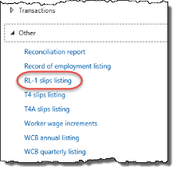



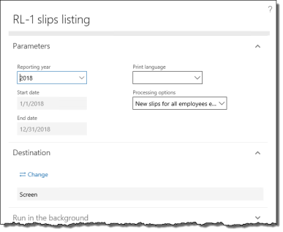

1. Specify the Reporting year.
2. Select which RL-1s to list in the Processing options field.
3. Select a Print language.
4. Click OK to view the report in a new browser window.

6.4.2 Create Draft RL-1 Slips

You can create draft RL-1s to test that RL-1s can be generated correctly and print them for reference if needed. You can create draft RL-1 slips and a test RL-1 XML file for uploading to Revenu Quebec.

To create draft RL-1 slips:

1. In the navigation pane, click Periodic > Year end > RL-1s > RL-1 slips (draft only) to open the RL-1 slips (draft only) pane.

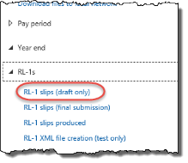



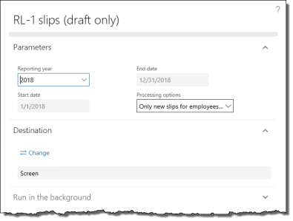

1. Specify the Reporting year.
2. Select which RL-1s to list in the Processing options field.
3. Click OK to view the RL-1 slips in a new browser window.

To create a test RL-1 XML file:

1. In the navigation pane, click Periodic > Year end > RL-1s > RL-1 XML file creation (test only) to open the RL-1 XML file creation (test only) pane.

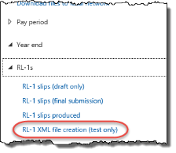



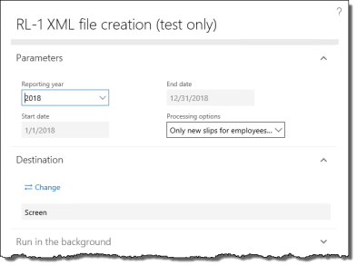

1. Specify the Reporting year.
2. Select which RL-1s to list in the Processing options field.
3. Click OK to generate a test RL-1 XML file.

To download the XML file to your local computer, see section 5.1.11.

6.4.3 Create Final RL-1 Slips

The RL-1 slips (final submission) process includes creating a printable report containing all RL-1 slips and the RL-1 XML file intended for upload to Revenu Quebec.

To create final RL-1 slips:

1. In the navigation pane, click Periodic > Year end > RL-1s > RL-1 slips (final submission) to open the RL-1 slips (final submission) pane.

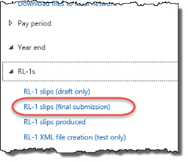



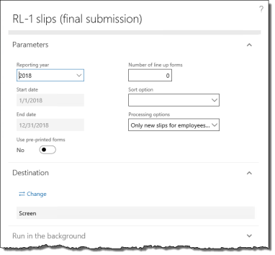

1. Specify the Reporting year.
2. Change the Sort order as desired.
3. Select which RL-1 to list in the Processing options field.
4. Click OK to view the RL-1 slips in a new browser window and generate a test RL-1 XML file.
5. Print or export the RL-1 slips as desired.

To download the XML file to your local computer, see section 5.1.11.

6.4.4 View RL-1 Slips Summary

The RL-1 slips summary provides a view of the metadata on worker RL-1s. From here, you can view the number of slips produced, whether they are draft or final, the date and time they were produced, and much of the contents of each slip according to worker.

To view the RL-1 slips summary:

1. In the navigation pane, click Periodic > Year end > RL-1s > RL-1 slips produced to open the RL-1 slips produced journal.

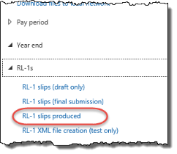

1. On the RL-1 slips produced journal, view the status of RL-1 records in the table. Select a record to view further details in the lower pane. Click the tabs to view more information.

6.5 Import Statutory Deductions

Every year, Anthology Inc. produces and releases a spreadsheet containing the updated statutory tax deductions for the coming tax year for every localization of Anthology Payroll. If your implementation uses these statutory deductions for your given jurisdiction, you may wish to download and import the spreadsheet.

Contact Anthology Inc. for the latest version of the Statutory Deductions Spreadsheet. Installation instructions are included with the spreadsheet.

7 Reporting

This section contains procedures for viewing statutory and non-statutory reports.

7.1 View WCB Reports

WCB reports can be viewed and printed for quarterly or annual reporting.

7.1.1 View WCB Quarterly Listing

The WCB quarterly listing displays WCB-assessable income in the quarter for all workers in a specified province/territory and/or WCB category.

To view the quarterly WCB report:

1. In the navigation pane, click Reports > Other > WCB quarterly listing to open the WCB quarterly listing pane.

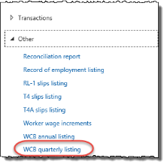



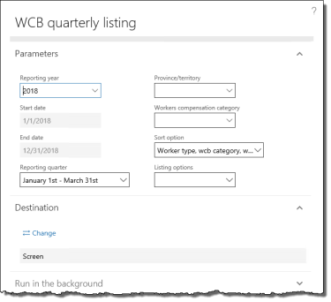

1. Specify the Reporting year.
2. Specify the Reporting quarter to run the report for.
3. Specify the Province/territory and/or Workers compensation category to filter the report by, as desired.
4. Select a Sort order as desired.
5. Click OK to view the report in a new browser window.

7.1.2 View WCB Annual Listing

The WCB annual listing displays WCB-assessable income in the year for all workers in a specified province/territory and/or WCB category.

To view the annual WCB report:

1. In the navigation pane, click Reports > Other > WCB annual listing to open the WCB annual listing pane.

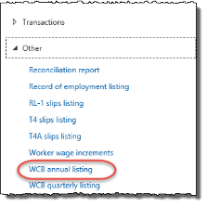



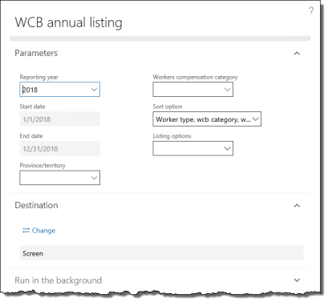

1. Specify the Reporting year.
2. Specify the Province/territory and/or Workers compensation category to filter the report by, as desired.
3. Select a Sort order as desired.
4. Click OK to view the report in a new browser window.

8 Terminating Workers

This section contains procedures for terminating a worker. Use these procedures when you receive notification from Human Resources that a worker is terminating. Ensure that you have the worker's termination date and details of any severance terms.

The general termination process is:

1. Check for earnings after termination date
2. Terminate the worker
3. Pay out entitlements
4. Enter severance pay
5. Process final payment
6. Create Record of Employment (ROE) report
7. Upload ROE to Services Canada

8.1 Check for Earnings after Termination Date

Anthology Payroll does not allow you to pay a worker for earnings that are dated after the worker's termination date. Earnings can have the same date as the termination date.

To negate earnings dated past termination dates, use the Time/earning adjustments journal (section 5.2.3). Use the following exceptions:



* In the Time/Earnings section, specify a Start date of the day after the worker's termination date. Specify an End date of the current pay period end date.
* Ignore the Time tab.

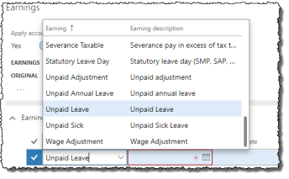

* If any salary earnings appear on the Earnings tab, change the Earning code for those earnings to Unpaid Leave.
* If any other earnings dated after the termination date appear on the Earnings tab (i.e.: generated earnings), then either delete them or change the Earning date for them to the worker's termination date, as appropriate. You may also need to adjust the Pay amount of those earnings.

8.2 Terminate the Worker

If the worker is terminating from all companies, you must terminate the worker record. If the worker is terminating from one company, but may still be active in other companies, you must end the worker's position assignment in the company they are terminating from.

To terminate the worker from all companies:

1. In the navigation pane, click Common > Anthology Payroll workers to open the Anthology Payroll workers list. Select the worker to terminate.

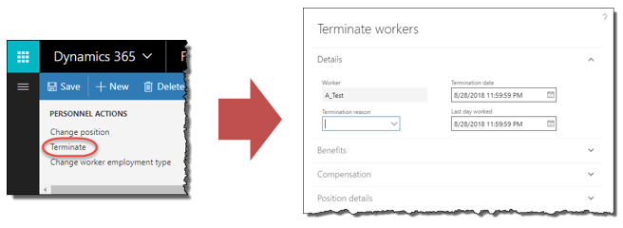

1. On the Work tab of the ribbon, click the Terminate button to open the Terminate workers pane.
2. Specify the Termination date and the Last day worked if they are not the current date.
3. Select a Termination reason.
4. Specify termination options for the Compensation and Benefits management sections as desired, depending on your implementation requirements.
5. If you want to retire the position, check the Retire position checkbox in the Position details section and specify the Retirement date. Set this date to the same date as the Termination date. This means the position would no longer be available to be assigned to a worker. If you expect the worker to be rehired in the future, you may not want to retire the position.
6. Click Terminate workers to terminate the worker from all companies. You do not need to end the worker's position assignment (below).

To end the worker's position assignment from a single company:

1. Ensure you are in the correct company in which the worker's position is ending.
2. Refer to the first procedure in section 4.1.2 for the procedure on ending the worker's position.

The worker will still be active and can be assigned positions in other companies.

8.3 Pay Out Entitlements

Workers may have outstanding entitlements that must be paid out or overdrawn entitlements that must be recovered.

Additionally, since vacation entitlements are awarded for the year at the beginning of the year, the entitlement bank may require adjustment before being paid out. This is typical for workers that are terminated mid-year.

To adjust entitlement balances before paying them out:

1. In the Human resources navigation pane, click Common > Past Workers to open the Past Workers list. Select the worker.

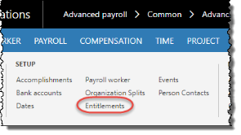

1. On the ribbon, click Anthology Payroll Profile tab > Entitlements to open the Worker entitlements form.



1. On the Worker entitlements form, select the entitlement to adjust and click Functions > Adjust entitlements to open the Adjust entitlements pane.
2. Change the Accrued hours, Taken hours, or both as desired.
3. Specify an Adjustment reason code of Termination.
4. Click OK to adjust the entitlement bank and proceed to the next procedure.

To pay out vacation or overtime entitlement balances:

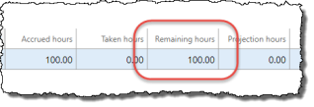

1. On the Worker entitlements form, verify if the worker has any Remaining hours (or Remaining amount) on any of their entitlements. If there are none, then no further action needs to be taken, but you should check to see if the worker has overdrawn entitlements.

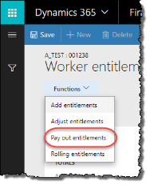



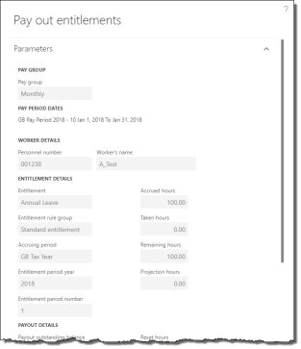

1. If the worker has Remaining hours, select the entitlement to pay out and click Functions > Pay out entitlements to open the Pay out entitlements pane.
2. Ensure that Payout outstanding balance is set to Yes.
3. Specify a Payout reason code of Termination.
4. Verify the Pay period end date as the current pay period. If the current pay period has already been processed and you want to include this earning in the next pay period, change this date to the next pay period end date.
5. Click OK to pay out the worker's entitlement balance and create the earnings records for the worker.
6. Repeat for any additional entitlement balances the worker may have.

8.4 Enter Severance Pay

Severance pay is simply entered as an earning on the Worker earnings journal. Not all terminations have severance pay.

To enter a severance earning:

1. In the Human resources navigation pane, click Common > Past Workers to open the Past Workers list. Select the worker.

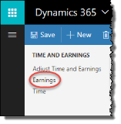

1. On the ribbon, click Anthology Payroll Transactions tab > Earnings to open the Worker earnings journal.
2. On the Earnings tab, click New to create a new record.

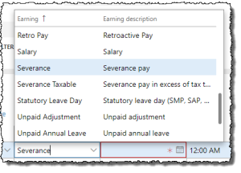

1. Specify Severance for the Earning field.
2. Specify the worker's termination date in the Earning date field.
3. In the Pay amount field, specify the amount of severance pay.
4. Click Save to save your changes. The severance pay earning will appear on the worker's final pay statement.

8.5 Schedule Garnishments for Final Payment

If the worker has no garnishments, skip this section. To determine the garnishments that a worker may have, see section 4.3.5.1.

Often, garnishment orders specify that if an individual is terminated before fulfilling the garnishment order, he or she must have a different rate of garnishment on his or her final payment. This rate of garnishment, if required, is unique to each order.

To set up a one-time garnishment deduction that satisfies the termination requirement of the garnishment order:

1. In the navigation pane, click Common > Past Workers to open the Past Workers list. Select the worker.
2. On the ribbon, click Anthology Payroll Profile tab > Benefit/Deductions Schedules to open the Worker benefit/deduction schedules form.
3. On the Overview tab, click New to create a new record.
4. Select the worker's current garnishment order in the Benefit/deduction field.

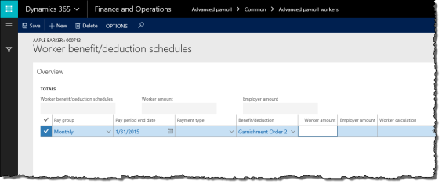

1. Enter the garnishment amount in the Worker amount field.
2. Change the Pay period end date to the end date of the worker's last pay period.
3. Repeat as required for additional garnishments.
4. Click Save to save your changes.

The scheduled deduction will replace the garnishment benefit/deduction that is otherwise taken normally on the worker's final payment.

8.6 Process Final Payment

The procedure for processing the final payment is the same for issuing a manual payment for the worker. Verify the worker's earnings and time records are up-to-date and see section 5.2.1 for the procedure.

The manual payment will pay salary up to and including the termination date, but not after. Any outstanding deductions in arrears will be taken to the extent possible.

8.7 Create Record of Employment (ROE) Report

Before creating an ROE, you may need to change the default Contact name of the employer that appears on every ROE. This is different from the Issuer name, which can differ between ROEs. This usually only needs to be done once for the first time.

You may also view a report of all ROEs that you have created to-date.

8.7.1 Change Contact Name of Employer

To change the employer's contact name:

1. In the navigation pane, click Setup > Tables > Payroll > Forms > Formats to open the Formats form.

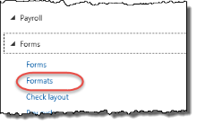



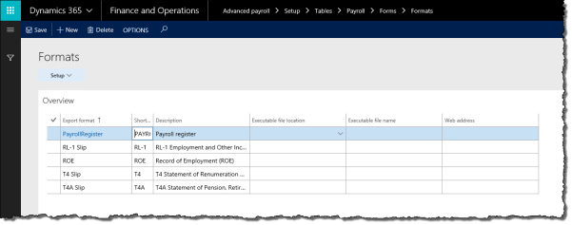

1. Select the ROE Export format record.

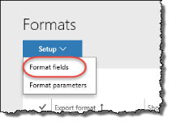



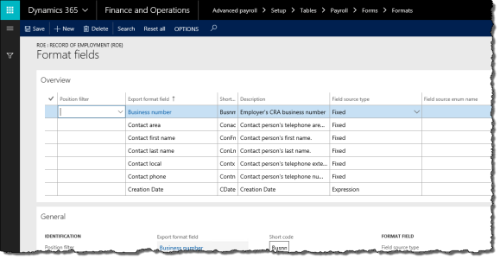

1. Click Setup > Format fields to open the Format fields form.

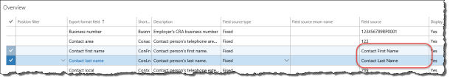

1. On the Format fields form, locate the Contact first name and Contact last name Export format fields.
2. Scroll to the right and enter the appropriate values for these fields in the Field source field.
3. You may also wish to change other fields such as:
   * Contact area: area code
   * Contact local: local extension
   * Contact phone: phone number
4. Click Save to save your changes.

8.7.2 Create Record of Employment

To create an ROE:

1. In the navigation pane, click Periodic > Other > Record of employment (ROE) > Record of employment (ROE) to open the Worker record of employments form.

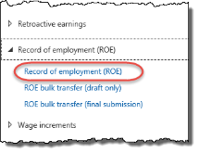

1. On the Overview tab, click New to create a new record.

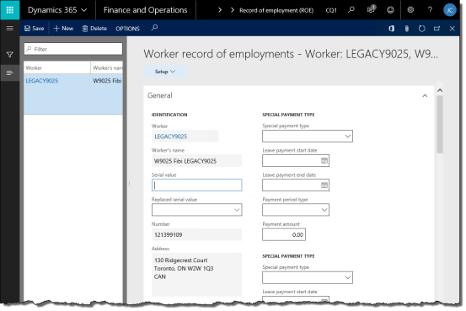

1. On the General tab, specify the Worker. The Employment dates are automatically updated.
2. If required to report, enter an amount for Vacation pay included with the worker's severance. Service Canada does not require the vacation code to be reported on the ROE.
3. Select the appropriate ROE reason for the worker's termination.
4. Verify the Issuer information. Change the Issuer name as required.

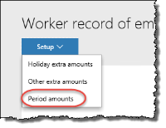

1. Click Setup > Period amounts to open the Worker record of employment period amounts form. On this form, you can view the worker's earnings per pay period.
2. Click Save to save your changes.

8.7.3 View Record of Employment Listing Report

The ROE listing report shows a summary of worker ROE data for a specified time period. The report can be reviewed and printed as desired. Successfully running the listing report is also a good indication that ROEs can be properly run.

To view a report of all ROEs:

1. In the navigation pane, click Reports > Other > Record of employment listing to open the Record of employment listing pane.

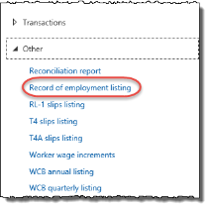



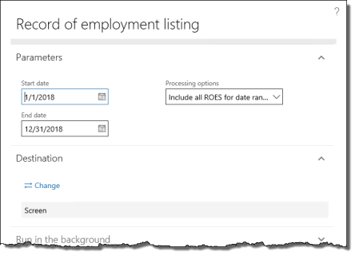

1. Specify the Start date and End date of the calendar year for the report. All workers terminated within the year are displayed.
2. Click OK to open the report in a new browser window.

8.8 Upload ROE to Services Canada

Before you upload ROEs to Services Canada, you can generate a draft submission file and preview it on Services Canada to verify correctness. After verifying, you can generate and upload the final ROE.

8.8.1 Create and Submit a Draft Record of Employment Submission File

To generate and upload a draft ROE submission file:

1. In the navigation pane, click Periodic > Other > Record of employment (ROE) > ROE bulk transfer (draft only) to open the ROE bulk transfer (draft only) pane.

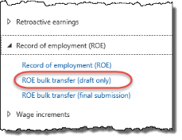



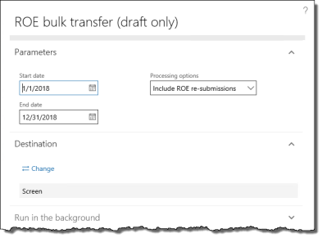

1. Change the Start date and End date to the appropriate calendar year.
2. Specify the Processing options to filter the ROEs that are generated.
3. Click OK to generate a draft ROE submission file.

To download the RoE file to your local computer, see section 5.1.11.

To upload and view the RoE file on Service Canada:

1. Open a new browser window and navigate to:

<https://www.canada.ca/en/employment-social-development/programs/ei/ei-list/ei-roe.html>

1. Open a ROE Web session and log in with your organization's credentials.
2. Upload the draft ROE submission file and view it in the browser.

8.8.2 Create and Submit a Final Record of Employment

To generate and upload the final ROE submission file:

1. In the navigation pane, click Periodic > Other > Record of employment (ROE) > ROE bulk transfer (final submission) to open the ROE bulk transfer (final submission) pane.

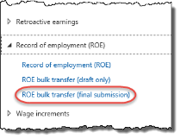



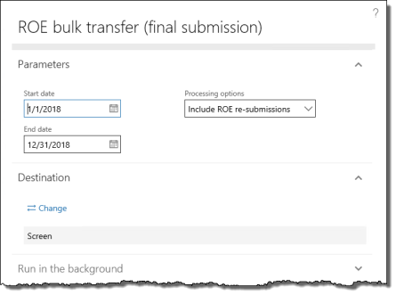

1. Change the Start date and End date to the appropriate calendar year.
2. Specify the Processing options to filter the ROEs that are generated.
3. Click OK to generate the final ROE submission file.

To download the RoE file to your local computer, see section 5.1.11.

To upload and view the RoE file on Service Canada:

1. Open a new browser window and navigate to:

<https://www.canada.ca/en/employment-social-development/programs/ei/ei-list/ei-roe.html>

1. Open a ROE Web session and log in with your organization's credentials.
2. Upload and submit the final ROE submission file.

8.8.3 Resubmit a Record of Employment

If an error or update was made to a previously submitted ROE, you may resubmit it to Service Canada. This procedure assumes that you have completed any modifications to a worker's ROE (see section 8.7.2) and only need to resubmit it.

You cannot resubmit a record of employment that has not been submitted to Service Canada at least once.

To resubmit a record of employment:

1. In the navigation pane, click Periodic > Other > Record of employment (ROE) > Record of employment (ROE) to open the Worker record of employments form.
2. On the Overview tab, select the record to modify.

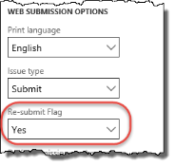

1. On the General tab, specify Yes for the Re-submit Flag.
2. Repeat as required for other ROEs to modify.

Note: if you receive a warning about a serial number being required, it can be ignored. This was a previous requirement for ROEs. This warning does not prevent the ROE from being saved.

1. Click Save to save your changes.
2. In the navigation pane, click Periodic > Other > Record of employment (ROE) > ROE bulk transfer (final submission) to open the ROE bulk transfer (final submission) pane.
3. Change the Start date and End date to the appropriate calendar year.
4. Select one of the following Processing options depending on your requirements:
   * Include ROE re-submissions: to submit new and previously submitted ROEs, provided that you have not already resubmitted the modified ROEs once.
   * Only include ROE re-submissions: to submit only previously submitted ROEs that you have modified. Use this option if you have previously submitted ROEs that have only been submitted once and not yet resubmitted.
   * Include all ROES for date range whether submitted or not: to submit previously submitted ROEs that have been resubmitted once already (i.e.: second resubmission). See below for an additional manual procedure to remove unwanted ROEs from the submission file.
5. Click OK to generate the ROE submission file. To download the RoE file to your local computer, see section 5.1.11.
6. Open a new browser window and navigate to:

<http://www.servicecanada.gc.ca/eng/ei/employers/roeweb/index.shtml>

1. Open a ROE Web session and log in with your organization's credentials.
2. Upload and submit the final ROE submission file.

If ROE records have been resubmitted once already and you need to use the Include all ROES for date range whether submitted or not processing option, you may include ROEs into the resubmission file that you do not want to resubmit. These ROE records can be deleted manually from the submission file before uploading to Service Canada.

To delete unwanted ROE records from the submission file:

1. Open the *.blk submission file created from the ROE bulk transfer process (above) in Notepad. To download the file to your local computer, see section 5.1.11.
2. Locate any worker ROEs that should be removed. Each record begins with the following tag:

<Roe PrintingLanguage="E" Issue="S">

1. Save the *.blk submission file and resubmit it to Service Canada. See above for the procedure.

9 Appendices

9.1 Appendix A: List of Benefit/deductions

All garnishment benefit/deductions are listed in 9.3 Appendix C: List of Garnishment Benefit/deductions.

| Rule Group | Benefit/deduction | Description | Enrolments | Applicable to |
| --- | --- | --- | --- | --- |
| Standard ded'n rules | AB Provincial Tax | Alberta provincial tax | _Not Enrolled; Enrolled | AB workers |
| Standard ded'n rules | AB WCB | Alberta WCB contributions |  | AB workers |
| Standard ded'n rules | ADD | Accidental death and dismemberment | _Not Enrolled; Enrolled | Individual, as needed |
| Standard ded'n rules | Additional Life | Additional life insurance | _Not Enrolled; Enrolled | Individual, as needed |
|  | Advance Recovery | Recovery of advances |  | Automatic |
| Standard ded'n rules | BC Provincial Tax | British Columbia provincial tax | _Not Enrolled; Enrolled | BC workers |
| Standard ded'n rules | BC WCB | British Columbia WCB contributions |  | BC workers |
|  | CAN Fed Add Tax | Additional federal tax |  | Individual, as needed |
| Standard ded'n rules | CAN Federal Tax | Federal tax | Outside Quebec; Quebec | All workers |
|  | CAN Shares | Approved shares of capital stock |  | Individual, as needed |
|  | Charity | Charity donations |  | Individual, as needed |
|  | CIP Shares | Cooperative Investment Plan shares | Individual, as needed | Individual, as needed |
| Standard ded'n rules | CPP | Canada Pension Plan |  | All workers |
| Standard ded'n rules | Dental Plan | Dental plan | _Not Enrolled; Couple; Family; Single | Individual, as needed |
| Standard ded'n rules | Dependent Life | Dependent life insurance | _Not Enrolled; Couple; Family | Individual, as needed |
| Standard ded'n rules | EI | Employment Insurance | Outside Quebec; Quebec | All workers |
|  | Employee Purchases | Employee purchases from company store or cafeteria |  | Individual, as needed |
| Standard ded'n rules | Extended Health | Extended health insurance | _Not Enrolled; Enrolled | Individual, as needed |
|  | FTQ Shares | Quebec Federation of Labour shares |  | Individual, as needed |
| Standard ded'n rules | Group Life | Group life insurance | _Not Enrolled; Enrolled | Individual, as needed |
| Standard ded'n rules | Long Term Dis | Long-term disability | _Not Enrolled; Enrolled | Individual, as needed |
| Standard ded'n rules | MB Provincial Tax | Manitoba provincial tax | _Not Enrolled; Enrolled | MB workers |
| Standard ded'n rules | MB WCB | Manitoba WCB |  | MB workers |
|  | Misc Deductions 1 | Miscellaneous deductions 1, to be modified |  | Individual, as needed |
|  | Misc Deductions 2 | Miscellaneous deductions 2, to be modified |  | Individual, as needed |
|  | Misc Deductions 3 | Miscellaneous deductions 3, to be modified |  | Individual, as needed |
|  | Misc Deductions 4 | Miscellaneous deductions 4, to be modified |  | Individual, as needed |
|  | Misc Deductions 5 | Miscellaneous deductions 5, to be modified |  | Individual, as needed |
| Standard ded'n rules | NB Provincial Tax | New Brunswick provincial tax | _Not Enrolled; Enrolled | NB workers |
| Standard ded'n rules | NB WCB | New Brunswick WCB |  | NB workers |
|  | Negative Net Recover | Negative net recovery |  | Automatic |
| Standard ded'n rules | NL Provincial Tax | Newfoundland and Labrador provincial tax | _Not Enrolled; Enrolled | NL workers |
| Standard ded'n rules | NL WCB | Newfoundland and Labrador WCB |  | NL workers |
| Standard ded'n rules | NS Provincial Tax | Nova Scotia provincial tax | _Not Enrolled; Enrolled | NS workers |
| Standard ded'n rules | NS WCB | Nova Scotia WCB |  | NS workers |
| Standard ded'n rules | NT Provincial Tax | Northwest Territories provincial tax | _Not Enrolled; Enrolled | NT workers |
| Standard ded'n rules | NT WCB | Northwest Territories WCB |  | NT workers |
| Standard ded'n rules | NU Provincial Tax | Nunavut provincial tax | _Not Enrolled; Enrolled | NU workers |
| Standard ded'n rules | NU WCB | Nunavut WCB |  | NU workers |
| Standard ded'n rules | ON Provincial Tax | Ontario provincial tax | _Not Enrolled; Enrolled | ON workers |
| Standard ded'n rules | ON WCB | Ontario WCB |  | ON workers |
| Standard ded'n rules | PE Provincial Tax | Prince Edward Island provincial tax | _Not Enrolled; Enrolled | PE workers |
| Standard ded'n rules | PE WCB | Prince Edward Island WCB |  | PE workers |
|  | QC Fed Add Tax | Quebec additional federal tax |  | Individual, as needed |
| Standard ded'n rules | QC Provincial Tax | Quebec provincial tax | _Not Enrolled; Enrolled | QC workers |
|  | QC Remote Travel | Quebec remote travel |  | Individual, as needed |
| Standard ded'n rules | QC WCB | Quebec WCB |  | QC workers |
| Standard ded'n rules | QCHSF | Quebec Health Services Fund |  | QC workers |
| Standard ded'n rules | QPIP | Quebec Parental Insurance Plan | _Not Enrolled; Enrolled | QC workers |
| Standard ded'n rules | QPP | Quebec Pension Plan | _Not Enrolled; Enrolled | QC workers |
|  | RET Comp | Retirement compensation agreement |  | Individual, as needed |
|  | Revised Pymt Recover | Revised payment recovery |  | Automatic |
|  | RPP | Registered pension plan |  | QC workers |
| Standard ded'n rules | RRSP | Registered retirement savings plan |  | Individual, as needed |
| Standard ded'n rules | Short Term Dis | Short-term disability | _Not Enrolled; Enrolled | Individual, as needed |
| Standard ded'n rules | SK Provincial Tax | Saskatchewan provincial tax | _Not Enrolled; Enrolled | SK workers |
| Standard ded'n rules | SK Shares | Approved shares of capital stock in Saskatchewan |  | SK workers |
| Standard ded'n rules | SK WCB | Saskatchewan WCB |  | SK workers |
|  | T4A Fed Tax | Federal withholding amount on T4A earnings |  | Individual, as needed |
|  | T4A Prov Tax | Provincial withholding amount on T4A earnings |  | Individual, as needed |
|  | Taxable Benefit 1 | Taxable benefit (non-cash) 1, to be modified |  | Individual, as needed |
|  | Taxable Benefit 2 | Taxable benefit (non-cash) 2, to be modified |  | Individual, as needed |
|  | Taxable Benefit 3 | Taxable benefit (non-cash) 3, to be modified |  | Individual, as needed |
| Standard ded'n rules | Union Dues | Union dues | _Not Enrolled; Enrolled | Individual, as needed |
| Standard ded'n rules | YT Provincial Tax | Yukon Territories provincial tax | _Not Enrolled; Enrolled | YT workers |
| Standard ded'n rules | YT WCB | Yukon Territories WCB |  | YT workers |

9.2 Appendix B: List of Calculation Variables

For garnishment-related calculation variables, the # refers to one of 1, 2 or 3.

| Calculation Variable | Calculation Variable Item | Override? | Item Description |
| --- | --- | --- | --- |
| Allowance 1 PPd Amt | Allowance 1 PPd Amt | Override amount | Custom allowance amount |
| Allowance 2 PPd Amt | Allowance 2 PPd Amt | Override amount | Custom allowance amount |
| Allowance 3 PPd Amt | Allowance 3 PPd Amt | Override amount | Custom allowance amount |
| Allowance 4 PPd Amt | Allowance 4 PPd Amt | Override amount | Custom allowance amount |
| Allowance 5 PPd Amt | Allowance 5 PPd Amt | Override amount | Custom allowance amount |
| CAN Add Fed Tax | CAN Add Fed Tax | Override amount | Canadian additional federal tax |
| CPP Pensionable | CPP Pensionable | Use default | Customize |
| Dependent Partner | Dependent Partner | Override amount | Number of dependent partners/spouses the individual supports |
| Dependents | Number of Dependents | Override amount | Number of dependents |
| EI Insurable | EI Insurable | Use default | Eligiblity for EI |
| Garn_NL Marital Stat | Married | Use default | Married status for garnishments in Newfoundland and Labrador |
| Garn_NL Marital Stat | Single | Use default | Single status for garnishments in Newfoundland and Labrador |
| Garn# Initial balance | Garn# Initial balance | Override amount | Initial amount payable when garnishment # is initiated |
| Garn# Monthly Amount | *MONTHLY* Deduction | Override amount | Garnishment # deduction amount, monthly |
| Garn# PP Amt | *PAY PERIOD* Deducti | Override amount | Garnishment # deduction amount, per pay period |
| Garn# Rate | Percent to deduct | Override amount | Garnishment # deduction amount, percentage |
| Garn#_AB_lowr ovride | Non-zero overide amt | Override amount | Use if court has eliminated lower exemption amount to zero. Alberta only. |
| Garn#_AB_lowr ovride | Overide amount of 0 | Use default | Override amount for lower exemption amount (cannot be zero). Alberta only. |
| Garn#_AB_uper ovride | Manual overide amt | Override amount | Override amount of upper exemption amount. Alberta only. |
| Garn#_Arears Balance | Garn#_Arears Balance | Override amount | Initial Arrears amount for garnishment # |
| Garn#_Arears Fixed | *MONTHLY* amount | Override amount | Deduction amount for arrears garnishment, monthly |
| Garn#_Arears Rate | Garn#_Arears Rate | Override amount | Deduction amount for arrears garnishment, percentage |
| Garn#_BC_exmt ovride | Garn#_BC_exmt ovride | Override amount | Garnishment exemption override rate (must not exceed 90%) in BC |
| Garn#_MB_exmt ovride | Garn#_MB_exmt ovride | Override amount | Garnishment exemption override rate (must not exceed 90%) in MB |
| Garn#_NS_Suport Exmt | Garn#_NS_Suport Exmt | Override amount | Exemption amount per pay period for support payments in NS |
| Garn#_ON_exmt ovride | Garn#_ON_exmt ovride | Override amount | Garnishment exemption override rate in ON |
| Garn#_PE Garn Exmt | Garn#_PE Garn Exmt | Override amount | Exemption amount per pay period in PEI |
| Garn#_PE Garn ExWE | Garn#_PE Garn ExWE | Override amount | Minimum amount of income earned in PEI according to Welfare Assistance Act if debtor is sole earner |
| Garn#_SK_exmt ovride | Garn#_SK_exmt ovride | Override amount | Garnishment exemption override amount in SK |
| Garn#_YT_exmt ovride | Garn#_YT_exmt ovride | Override amount | Garnishment exemption override amount per pay period in YT |
| QC RQT Reduction | QC RQT Reduction | Override amount | Revenu Quebec provincial tax reduction |
| QC RQT WVR | QC RQT WVR | Override amount | Revenu Quebec provincial tax waiver |
| QC Tax Credit | QC Tax Credit | Use default | Tax credit for workers in Quebec |
| QPIP Insurable | QPIP Insurable | Use default | Eligibility for QPIP |
| QPP Pensionable | QPP Pensionable | Use default | Eligibility for QPP |
| RCPT Reduction | Prov Tax Reduction A | Override amount | Revenue Canada provincial tax reduction amount |
| RCT Reduction | Fed Tax Reduction Am | Override amount | Revenue Canada federal tax reduction amount |
| RCT Waiver | Waiver Amount | Override amount | Revenue Canada federal tax waiver |
| Remote Allowance | Remote Allowance Amt | Override amount | Deduction for living in a prescribed remote zone |
| Retirement Lookup | Retiree | Use default | Yes/No flag to indicate the worker is a retiree feligible for retirement tax calculation |
| RRSP Percent | RRSP Percent | Override amount | Percentage of regular RRSP-able earnings to withhold |
| RRSP PPd Amount | RRSP PPd Amount | Override amount | Amount per pay period to withhold for RRSP |
| RRSP TFR | RRSP Transfer | Override amount | RRSP transfer |
| Sick annual hrs | Sick annual hrs | Override amount | Annual accrual in hours for sick leave |
| T4A QC RQT Reduction | T4A RQT Reduction | Override amount | Revenue Quebec Provincial Tax Reduction for retirement income |
| T4A RCPT Reduction | T4A RCPT Reduction | Override amount | Revenue Canada Provincial Tax Reduction for retirement income |
| T4A RCT Reduction | T4A RCT Reduction | Override amount | Revenue Canada Federal Tax Reduction for retirement income |
| TD1 | Age amount | Override amount | TD1 Age amount |
| Basic Exemption | Use default | TD1 Basic exemption amount |
| Pension Income amount | Override amount | TD1 Pension income amount |
| TD1AB | Basic Tax Exemption | Use default | Personal tax credit in AB |
| TD1BC | Basic Tax Exemption | Use default | Personal tax credit in BC |
| TD1MB | Basic Tax Exemption | Use default | Personal tax credit in MB |
| TD1NB | Basic Tax Exemption | Use default | Personal tax credit in NB |
| TD1NL | Basic Tax Exemption | Use default | Personal tax credit in NL |
| TD1NS | Basic Tax Exemption | Use default | Personal tax credit in NS |
| TD1NT | Basic Tax Exemption | Use default | Personal tax credit in NT |
| TD1NU | Basic Tax Exemption | Use default | Personal tax credit in NU |
| TD1ON | Basic Tax Exemption | Use default | Personal tax credit in ON |
| TD1ON Exemptions | Dep. under 18 amount | Use default | TD1 Dependent under 18 amount in ON |
| Disabled Dep. amount | Use default | TD1 Disabled dependent amount in ON |
| TD1PE | Basic Tax Exemption | Use default | Personal tax credit in PE |
| TD1SK | Basic Tax Exemption | Use default | Personal tax credit in SK |
| TD1YT | Basic Tax Exemption | Use default | Personal tax credit in YT |
| Vacation annual hrs | Vac annual hrs | Override amount | Annual accrual in hours for vacation leave |

9.3 Appendix C: List of Garnishment Benefit/deductions

** XX is the two-character identifier for each Canadian jurisdiction.

| Benefit/deduction | Benefit/deduction enrolment | Applicable Calculation Variables | Calculation |
| --- | --- | --- | --- |
| Garnishment Admn Fee | _Not Applicable | None | No Pay |
| Garn Admin Fee XX | None | Garn Admin XX |
| Garnishment Order 1 | _Not Applicable | None | No Pay |
| CRA Federal Order | Garn1 Initial Balance; Garn1 Monthly Amount or Garn1 Rate | Garn1 CRA Final |
| Support Order XX | Garn1 Monthly Amount or Garn1 Rate; Garn1_Arears Balance; Garn1 Arears Fixed | Garn1 SupportXX Fin |
| Garnishment Order XX | Garn1 Initial Balance; Garn1 Monthly Amount or Garn1 Rate; Dependents; Garn1_XX_uper ovride; Garn1_XX_lowr ovride | Garn1 GarnXX Fin |
| Garnishment Order 2 | _Not Applicable | None | No Pay |
| CRA Federal Order | Garn2 Initial Balance; Garn2 Monthly Amount or Garn2 Rate | Garn2 CRA Final |
| Support Order XX | Garn2 Monthly Amount or Garn2 Rate; Garn2_Arears Balance; Garn2 Arears Fixed | Garn2 SupportXX Fin |
| Garnishment Order XX | Garn2 Initial Balance; Garn2 Monthly Amount or Garn2 Rate; Dependents; Garn2_XX_uper ovride; Garn2_XX_lowr ovride | Garn2 GarnXX Fin |
| Garnishment Order 3 | _Not Applicable | None | No Pay |
| CRA Federal Order | Garn3 Initial Balance; Garn3 Monthly Amount or Garn3 Rate | Garn3 CRA Final |
| Support Order XX | Garn3 Monthly Amount or Garn3 Rate; Garn3_Arears Balance; Garn3 Arears Fixed | Garn3 SupportXX Fin |
| Garnishment Order XX | Garn3 Initial Balance; Garn3 Monthly Amount or Garn3 Rate; Dependents; Garn3_XX_uper ovride; Garn3_XX_lowr ovride | Garn3 GarnXX Fin |
| Garn 1 Arrears | _Not Applicable | None | No Pay |
| Garn Arrears XX | Garn1_Arears Balance; Garn1 Arears Fixed | Garn1 SuprtXX Arears |
| Garn 2 Arrears | _Not Applicable | None | No Pay |
| Garn Arrears XX | Garn2_Arears Balance; Garn2 Arears Fixed | Garn3 SuprtXX Arears |
| Garn 3 Arrears | _Not Applicable | None | No Pay |
| Garn Arrears XX | Garn3_Arears Balance; Garn3 Arears Fixed | Garn3 SuprtXX Arears |

9.4 Appendix D: List of Earnings Import File Fields

| Field name | Description | Required |
| --- | --- | --- |
| Worker ID | The worker identifier in Anthology Payroll. | Yes |
| External Worker ID | The worker identifier in Human Resources. Ignored if Worker ID exists. | No, if Worker ID exists. Otherwise, Yes. |
| Last Name | The worker's last name. Ignored if Worker ID exists. | No, if Worker ID exists. Otherwise Yes. |
| First Name | The worker's first name. Ignored if Worker ID exists. | No, if Worker ID exists. Otherwise, Yes. |
| Middle Name | The worker's middle name. Ignored if Worker ID exists. | No, if Worker ID exists. Otherwise, Yes. |
| National ID | The worker's government-issued identification number. Ignored if Worker ID exists. | No, if Worker ID exists. Otherwise, Yes. |
| Position | The worker's position ID that identifies the position that the earning applies to. | No |
| Position Description | The worker's position description that identifies the position that the earning applies to. Ignored if Position exists. | No |
| Position Title | The worker's position description that identifies the position that the earning applies to. Ignored if Position exists. | No |
| Date | The date for the earnings record. | Yes |
| Year | The year component of the date for the earnings record. Ignored if Date exists. | No, if Date exists. Otherwise, Yes. |
| Month | The month component of the date for the earnings record. Ignored if Date exists. | No, if Date exists. Otherwise, Yes. |
| Day | The day component of the date for the earnings record. Ignored if Date exists. | No, if Date exists. Otherwise, Yes. |
| Earning | The earning code that the worker's earning is charged to. | Yes |
| Earning Description | The description of the earning code that the worker's earning is charged to. Ignored if Earning exists. | No, if Earning exists. Otherwise, Yes. |
| Amount | The earning amount to be paid to the worker. | Yes |
| Amount Sign | Indicator of whether the amount is being accumulated or reversed. | No |
| Ledger | The ledger code that the earning is charged to. | No |
| Ledger Description | The description of the ledger that the earning is charged to. Ignored if Ledger exists. | No |

Please refer to the Import Earnings Guide document or the Anthology Payroll Help System for further description on the validation rules of each field and for the full list of import fields.

9.5 Appendix E: List of Time Import File Fields

| Field name | Description | Required |
| --- | --- | --- |
| Worker ID | The worker identifier in Anthology Payroll. | Yes |
| External Worker ID | The worker identifier in Human Resources. Ignored if Worker ID exists. | No, if Worker ID exists. Otherwise, Yes. |
| Last Name | The worker's last name. Ignored if Worker ID exists. | No, if Worker ID exists. Otherwise Yes. |
| First Name | The worker's first name. Ignored if Worker ID exists. | No, if Worker ID exists. Otherwise, Yes. |
| Middle Name | The worker's middle name. Ignored if Worker ID exists. | No, if Worker ID exists. Otherwise, Yes. |
| National ID | The worker's government-issued identification number. Ignored if Worker ID exists. | No, if Worker ID exists. Otherwise, Yes. |
| Position | The worker's position ID that identifies the position that the time applies to. | No |
| Position Description | The worker's position description that identifies the position that the time applies to. Ignored if Position exists. | No |
| Position Title | The worker's position description that identifies the position that the time applies to. Ignored if Position exists. | No |
| Date | The date for the time record. | Yes |
| Year | The year component of the date for the time record. Ignored if Date exists. | No, if Date exists. Otherwise, Yes. |
| Month | The month component of the date for the time record. Ignored if Date exists. | No, if Date exists. Otherwise, Yes. |
| Day | The day component of the date for the time record. Ignored if Date exists. | No, if Date exists. Otherwise, Yes. |
| Start Time | The time the worker started. | No |
| Start Hour | The hour component of the time that the worker started. Ignored if Start Time exists. | No, if Start Time exists. |
| Start Minute | The minute component of the time that the worker started. Ignored if Start Time exists. | No, if Start Time exists. |
| End Time | The time the worker finished the shift. | No |
| End Hour | The hour component of the time that the worker finished the shift. Ignored if End Time exists. | No, if End Time exists. |
| End Minute | The minute component of the time that the worker finished the shift. Ignored if End Time exists. | No, if End Time exists. |
| Hours | The number of hours the worker worked, as a decimal number. | No, if Start Time and End Time exist. Otherwise, Yes. |
| Shift | The shift code to which the worker's time is charged. | No |

NOTE: ensure that the last line in your import file is an empty row or the last record may not import correctly.

Please refer to the Import Time Guide document or the Anthology Payroll Help System for further description on the validation rules of each field and for the full list of import fields.

9.6 Appendix F: List of Benefit/deduction Amounts Import Fields

| Field name | Description | Required |
| --- | --- | --- |
| Worker ID | The worker identifier in Anthology Payroll. | Yes |
| External Worker ID | The worker identifier in Human Resources. Ignored if Worker ID exists. | No, if Worker ID exists. Otherwise, Yes. |
| Last Name | The worker's last name. Ignored if Worker ID exists. | No, if Worker ID exists. Otherwise Yes. |
| First Name | The worker's first name. Ignored if Worker ID exists. | No, if Worker ID exists. Otherwise, Yes. |
| Middle Name | The worker's middle name. Ignored if Worker ID exists. | No, if Worker ID exists. Otherwise, Yes. |
| National ID | The worker's National Insurance number. Ignored if Worker ID exists. | No, if Worker ID exists. Otherwise, Yes. |
| Benefit/deduction | The Benefit/deduction code in Anthology Payroll for the imported amount. | Yes |
| Benefit/deduction description | Description of the specified benefit/deduction code. Ignored if Benefit/deduction exists. | No |
| Worker amount | The benefit/deduction amount paid by or a deducted from the worker. | Yes, if Employer amount is not specified. |
| Worker amount sign | Indicator of whether the amount is positive or negative. | No |
| Employer amount | The benefit/deduction amount paid by the employer on the worker's behalf. | Yes, if Worker amount is not specified. |
| Employer amount sign | Indicator of whether the amount is positive or negative. | No |
| Worker calculation | Calculation, if applicable, that determines the worker amount. Must match existing calculation in Anthology Payroll. | No |
| Worker calculation description | Description of the specified worker calculation. | No |
| Employer calculation | Calculation, if applicable, that determines the employer amount. Must match existing calculation in Anthology Payroll. | No |
| Employer calculation description | Description of the specified employer calculation. | No |
| Payment type | Type of payment (e.g.: Regular, Cancellation, etc.) associated with this benefit/deduction amount. | No |
| Payment type description | Description of the specified payment type. | No |

Please refer to the Import Benefit/deductions Guide document or the Anthology Payroll Help System for further description on the validation rules of each field and for the full list of import fields.

9.7 Appendix G: List of Wage Increment Import Fields

Ensure that all non-numeric fields are encapsulated in double-quotes (") in the import file. E.g.: "Last Name", "First Name", etc.

| Field name | Description | Required |
| --- | --- | --- |
| Worker ID | The worker identifier in Anthology Payroll. | Yes |
| External Worker ID | The worker identifier in Human Resources. Ignored if Worker ID exists. | No, if Worker ID exists. Otherwise, Yes. |
| Last Name | The worker's last name. Ignored if Worker ID exists. | No, if Worker ID exists. Otherwise Yes. |
| First Name | The worker's first name. Ignored if Worker ID exists. | No, if Worker ID exists. Otherwise, Yes. |
| Middle Name | The worker's middle name. Ignored if Worker ID exists. | No, if Worker ID exists. Otherwise, Yes. |
| National ID | The worker's government-issued identification number. Ignored if Worker ID exists. | No, if Worker ID exists. Otherwise, Yes. |
| Position | The worker's position ID that identifies the position that the wage increment applies to. | No |
| Position Description | The worker's position description that identifies the position that the wage increment applies to. Ignored if Position exists. | No |
| Date | The date for the wage increment record. | Yes |
| Year | The year component of the date for the wage increment record. Ignored if Date exists. | No, if Date exists. Otherwise, Yes. |
| Month | The month component of the date for the wage increment record. Ignored if Date exists. | No, if Date exists. Otherwise, Yes. |
| Day | The day component of the date for the wage increment record. Ignored if Date exists. | No, if Date exists. Otherwise, Yes. |
| Salary type | The period type of the worker's salary. Acceptable values are: Pay period, Monthly, Annual, Weekly, Daily. | No, if Salary grid and Salary step number exist. Otherwise, Yes. |
| Salary amount | New amount the worker earns per period (Salary type) including the wage increment. | No, if Salary grid and Salary step number exist. Otherwise, Yes. |
| Hourly rate | New hourly rate the worker earns including the wage increment. | No, if Salary grid and Salary step number exist. Otherwise, Yes. |
| Salary grid | The worker's salary grid. | No |
| Salary step number | New salary step to assign to the worker. If specified as zero, the step defaults to the worker's next highest salary step in their salary grid. | No |

9.8 Appendix H: List of Gross-up Payment Amount Import Fields

Ensure that all non-numeric fields are encapsulated in double-quotes (") in the import file. E.g.: "Last Name", "First Name", etc.

| Field name | Description | Required |
| --- | --- | --- |
| Worker ID | The worker identifier in Anthology Payroll. | Yes |
| External Worker ID | The worker identifier in Human Resources. Ignored if Worker ID exists. | No, if Worker ID exists. Otherwise, Yes. |
| Last Name | The worker's last name. Ignored if Worker ID exists. | No, if Worker ID exists. Otherwise Yes. |
| First Name | The worker's first name. Ignored if Worker ID exists. | No, if Worker ID exists. Otherwise, Yes. |
| Middle Name | The worker's middle name. Ignored if Worker ID exists. | No, if Worker ID exists. Otherwise, Yes. |
| National ID | The worker's government-issued identification number. Ignored if Worker ID exists. | No, if Worker ID exists. Otherwise, Yes. |
| Net amount | The gross-up payment amount to be paid to the worker after deductions are applied. This amount must be greater than zero. | Yes |